ЎЗБЕКИСТОН РЕСПУБЛИКАСИ ОЛИЙ ВА ЎРТА
МАХСУС ТАЪЛИМ ВАЗИРЛИГИ
САМАРҚАНД ДАВЛАТ ЧЕТ ТИЛЛАР ИНСТИТУТИ
ИНГЛИЗ ТИЛИ НАЗАРИЯСИ ВА АМАЛИЁТИ КАФЕДРАСИ

БОШЛАНҒИЧ СИНФЛАРДА ЧЕТ ТИЛИ ЎҚИТИШ МЕТОДИКАСИ
(танлов фан)
(4 курс)

Билим сохаси: 100 000 – Гуманитар соҳа
Таълим сохаси: 120 000 – Гуманитар фанлар
Таълим йўналиши: 5120100 – Филология ва тилларни ўқитиш
(инглиз тили)

САМАРҚАНД - 2019
Фаннинг ўқув услубий мажмуаси Ўзбекистон Республикаси Олий ва ўрта махсус таълим вазирлиги томонидан 2015 йил 29 апрель 4-сонли буйруғи билан тасдиқланган фан дастури асосида ишлаб чиқилди.

Тузувчи:
Эркинов Суҳроб Эркинович - инглиз тили назарияси ва амалиёти кафедраси мудири в.в.б.

Тақризчилар:

Н.Я.Турдиева –СамДЧТИ, “Таржима назарияси ва амалиёти” кафедраси мудири, ф.ф.н.

Ш.Ж.Шомуродова –СамДЧТИ, “Инглиз тили ўқитиш методикаси ва амалиёти” кафедраси мудири, ф.ф.н.

Фаннинг ўқув услубий мажмуаси Самарқанд давлат чет тиллар институти илмий кенгашининг 2019 йил ___ ___________ № ___- сонли йиғилишида кўриб чиқилди ва ишлатишга тавсия этилди.

МУНДАРИЖА
1. Ўқув материаллари............................. …………………………….………….........4
2. Мустақил таълим бўйича кўрсатмалар.........………..………………….............175
3. Глоссарий………………………………………………………….………..... ....176
4. Иловалар………………………………………………………………….............185
4.1. Фан дастури.........................................................................................................186
4.2. Ишчи ўқув дастур...............................................................................................194
4.3. Тарқатма материаллар........................................................................................204
4.4. Тестлар.................................................................................................................230
4.5.Баҳолаш мезонларини қўллаш бўйича услубий кўрсатмалар.........................252

1.Мавзуга оид асосий назарий материаллар
Lesson 1
Importance of teaching English language in primary schools.
Questions to be discussed:
1. What important ways of teaching English do you know?
2. What is language teaching process?
3. Some instructions for teaching young learners.
Key terms: teaching process, the unconscious acquisition process, mastering the phonetic system, grammar accuracy, stimulative techniques.
Children starting to learn English in the first grade improve their listening, comprehension and pronunciation very well. It enables them to become communicatively competent regardless of some inaccuracy in grammar structures. An early start in learning foreign languages, particularly English, could mean, in the long run, bilingualism for the entire population.
The language teaching process is divided into three phases over eight years of learning English. At early age, the unconscious acquisition process is superior to the learning one due to the child’s cognitive development, so especially in the beginning mechanistic approach prevails, while cognitive approach is introduced around puberty.
The intellectual and linguistic development of the child requires different approaches at different ages. Pre-puberty groups are far superior in mastering the phonetic system. Younger groups can reach a considerably higher standard of pronunciation using authentic English phonemes and intonation patterns because "language learning blocks" are frequent at and after puberty. Only later will they be prepared to continue with more complex and abstract structures.
Mastering the phonetic system at an early age is crucial because this factor is hard to be achieved satisfactorily at an older age, when the language mastering process requires a great conscious effort since the imitative capacity is lost and language cannot be acquired by mere exposure to it. Natural acquisition by exposure to the foreign language disappears because of the biological process of maturation of the brain and it becomes fixed around puberty. This is why foreign accent cannot be overcome after this time.
First phase (I - IV grade).
The primary task in this phase is to teach the learners the phonological system by imitation, since this is the most favorable period for imitating pronunciation. It is practiced using the most frequent grammar drill to practice a pattern or a group of patterns which occur in the context of dialogue presentation. Grammatical features are practiced, but without any linguistic explanation.
Some problems and performance difficulties in learning English can be expected in pronunciation, the command of structures and the use of vocabulary. Young learners can master the phonetic system provided they have good models to imitate. This is why complete accuracy in pronunciation, rhythm and intonation should be insisted upon, but as far as grammar accuracy is concerned we should not insist. In songs, riddles or nursery rhymes they will, in a parrot-like way, correctly memorize and repeat the lines, while in producing their own sentences they will leave out whatever they feel redundant (Mum cooking in the kitchen) since their primary communicative intention is to convey meaning.
Grammar is taught following contrastive analysis, using positive transfer from the mother tongue. At this age, structures are incorporated into everyday situations close to the learners, and in other cases mechanical drills are used, sometimes in the form of games including the learners’ activity as much as possible. At a young age children need to be active and methodology should use it during the teaching process, allowing them to participate orally and physically as much as possible in dialogues, role playing, dramatizing. As a basis for further language learning is being laid in this phase, it is very important to stimulate the learners’ interest applying attractive methodology, to make them feel happy and conscious of their progress.
Unlike adults, children are not self-motivated to learn English, their world is their daily games, events of interest to them, and teachers should capitalize their curiosity, the desire to play and explore. Teaching must be planned in such a way that learning becomes an interesting, at times even entertaining process. Developing such interest will lead children to a spontaneous use of language forms. The teacher’s participation in games and activities helps children to overcome any inhibitions they may have. If we want teaching to be successful we should consider the learners’ interests and motivations, because they will pay more
attention if they are motivated.
Young learners can be aware of some rules about language as a system and draw conclusions about rules in the English language. For example, awareness of He played football yesterday expressing a past action may bring to deductions like He goed to school by bus. They may notice the -ed being added to express the past, but since young learners do not know about verbs as a word category, about auxiliaries, endings, etc., any metalinguistic explanations must be avoided.
The acquisition of the imperative is not a problem since they give orders and respond to them in different games and other activities. Children at this age are very much interested in their belongings (their toys, clothes...), so expressing their possession should not be a problem (my ball, my daddy, my bike...), but they are not that interested in or close to other people’s properties, so we should not insist upon other forms of possessive adjectives or pronouns.
In introducing pronominalization we can notice the learners’ preference in using nouns instead of he or she. They understand the question Where is your sister? but instead of answering She is.. , they would rather give full answers using nouns: My sister is... They seem not to have problems in using the personal pronoun I (I’m hungry). It probably looks less abstract.
Different dynamic exercises should be introduced to practice grammar in a very spontaneous way, in order to give the learners enough input to memorize structures. Nursery rhymes, riddles, songs, story-telling, role-plays, games; crossword puzzles could be very helpful and efficient in introducing and practicing any grammar structures. It is an amusing way to learn just about everything (articles, plural nouns, adjectives, pronouns, tenses, irregular verbs...), as metal language is not to be used in this phase. Putting toys around the classroom could be an interesting and funny way to practice prepositions (Timmy is on the floor, behind the door, on the shelf, under the desk...). Physical activity combined with oral performance is an ideal solution as young learners enjoy being physically active. Total physical response or says, total emotional response’s very important in teaching young learners because they learn spontaneously, with all their senses included, so saying and at the same time doing it is far more effective than just producing something orally. Since young learners may easily get bored or tired, making them physically active can help to keep their concentration and energy.
The national curriculum gives a frame of the fourth graders’ abilities in language performance. At the ends of the first phase learners are supposed to have acquired and be able to use spontaneously:
- the present of the verbs to be and to have / have got
- the present simple / present continuous
- understanding and expressing requests and orders using the imperative
- using can to express ability
- personal pronouns
- asking questions with the question words who, whose, what, which, where
- correctly using there is / there are
- demonstrative pronouns/adjectives this/that
- distinguishing singular and plural nouns and the irregular plural
- expressing possession using the Saxon genitive
- nouns with indefinite and definite articles
- possessive adjectives
- prepositions and adverbs of place and time (on, in, into, under, behind, in front of, at, to, between, here, there, always, every...)
- cardinal numbers 1-100
Learners should be able to just recognize:
- the simple past tense, the present perfect simple to express the results of a completed action (Have you written /bought...?)
- the use of the verb must to express orders
- phrasal verbs, comparison of adjectives
- the indefinite articles a/an and the definite article at a global level
Second phase (V, VI grade)
Any grammar course should begin with tenses to be introduced one by one, taking into account that children have not yet learnt the grammar of their own native language quite well. Introducing grammar should be concentrated on the very basic and elementary structures, with concrete, simple and clear explanations, with definitions in the mother tongue, using formulas when necessary.
Some difficulties appear especially in this phase because learners still have difficulties in mastering grammar terminology in their mother tongue. Very often, before being introduced, some grammar subjects should be explained in Croatian first and then the application continued in English. In the present simple they always have problems with the third person singular, because it is impossible to deal with specific grammar terminology when they are not sure about it in Croatian.
Although verbs and tenses are introduced from the very beginning of teaching English, some problems seem to "survive" through years of learning. A typical example is the -s/-es added in the third person singular of the present simple. Teachers can introduce, as a kind of reminder, some funny and stimulative techniques and activities whenever their learners forget about it. Very often the difference between the present simple and the present continuous causes lots of trouble and mistakes. It represents a real difficulty, but being very frequent, it is taught at the beginning of the second phase. Drill exercises can help a lot in the acquisition of these structures, because frequency and correct usage in speaking is done by repetition of a given structure. The teacher must decide which structures are to be taught first, to achieve progression in later phases.
In this phase teachers should, little by little, start insisting on the accuracy of grammar structures and metalanguage is used to explain, for example, the rules and the use of the present simple and the present continuous. Croatian learners face problems because there is just one present tense in the Croatian language. Anyway, we should not insist on learning rules and definitions, as it may turn out to be demotivating, so effective learning should be done in a child-friendly approach because the main goal is to help children to be able to speak and write English with a reasonable degree of accuracy and fluency.
Articles are spontaneously introduced in the first phase, but since there is no equivalent to this category in the Croatian language, our learners continue being insecure about it. We should keep turning their attention to articles in a variety of exercises to give them enough input to overcome this problem.
Questions tags, those little questions stuck at the end of a sentence usually asking for confirmation of what has just been said require some time to be mastered because of transfer from the mother tongue (It’s an interesting movie, isn’t it?).
Children, by a series of exercises, are exposed to sentence structures and they learn them by analogy, thus becoming able to make hundreds of sentences similar to those produced by the teacher. Children learn by analogy, they listen to adults and try to produce their own sentences. Only much later do they begin to learn language consciously acquiring grammar rules.
Teachers can use different exercises to integrate language skills and give children the opportunity to work individually, in small groups, or with the class as a whole. Workbooks give a variety of exercises. Language and grammar acquisition, at this level, starts with oral and written mechanical techniques. Fill-in-the-blank and various completing exercises are very useful at this level in practicing pronouns, the verb to be, the present simple, the present continuous, etc. Replacement exercises are used to avoid monotony. Substitution tables and substitution drills are good for familiarizing learners with the correct tense forms, plural forms, and possessives. Many situations for asking questions can be created in the classroom. Describing pictures is very useful in individual work.
At this level, the most important and elementary grammar requiring the use of metalanguages should be introduced slowly and structures avoided. Lots of practicing and continuous repetition of grammar structures in a variety of different exercises is necessary.
Rivers gives a list of six types of exercises for learning:
- grammar structures in the beginning phases of language learning.
- repeating sentences imitating the model
- replacement exercises
- conversion or transformation of structures
- changing sentences by extension and fill-in-the-blank exercises
- response practice
- translation exercises
At this level learners have to face the problem of tenses because all the basic tenses are presented in the textbooks for the VI grade. Structures are given in situational settings and then practiced in a variety of exercises. Elements of the direct method can be found in transposition, substitution, dictation and narrative, and free composition exercises. Some of the characteristics of the AL method can be very useful at this level of language learning: the use of dialogues, the emphasis on practice techniques and pattern drills (structural drills). Question-answer exercises and substitution drills are used to practice tenses, especially the past simple.
Learners should be able to make dialogues, descriptions, retell some text or event on the basis of vocabulary, grammar structures and communication patterns. Learners are expected to use the introduced structures in creative oral and written exercises.
Workbooks are used to make the learning process more efficient, to give learners the possibility to do exercises at home. Good functional drawings and pictures, crossword puzzles etc. stimulate children and intensify their motivation. The variety of exercises stimulates and develops logical and cognitive activity. Compared to any other simple or ordinary notebook, a workbook is more attractive, efficient and saves time.
Drill exercises and creativity lead to good results, none of them is to be neglected or excluded. Therefore this combination should be used more and more as learners proceed on their way towards communicative competence and performance. Approach to grammar is explicit, with gradual use of metalanguage, but mechanistic drill in memorizing rules is avoided.
At the end of this phase the learners should master the following structures:
- verbs to have / have got / to be
- the present simple and the present continuous (positive, interrogative and negative forms)
- phrasal verbs
- the going to future to express a planned future action
- the simple future to predict a future action
- can and may to ask for permission
- must/have to to express obligations
- the past simple of regular and irregular verbs to refer to a past action
- would to express requests
- possessive pronouns (mine, yours...)
- plural nouns, countable and uncountable nouns
- some, any, much, many to express indefinite quantity
- the gerund (I like listening to music.)
- comparison of adjectives (short/long, irregular)
- possessive adjectives (my, your...)
- prepositions of place and time
- frequency adverbs, adverbs of time
- cardinal and ordinal numbers (1-1000)
Learners are introduced to the present perfect simple to express the result of a completed action, but just at the level of recognition.
Third phase (VII, VIII grade)
Teaching grammar precedes in concentric circles spreading always more and more the knowledge of the precedent phases. At the age of puberty oral and mechanical acquisition is replaced by a cognitive learning process. A conscious activity principle is always the final goal in language teaching. Starting with mechanical imitation, it should end in conscious generalization. At this level good learners, when adequately led, are capable of generalization and they feel happy and satisfied in doing it successfully. Besides induction, deduction is to be used as these two methods are complementary. Deduction is suitable in explaining analogies and similarities since induction was applied in introducing basic notions.
Activity is very important because learners will remember those they have been actively involved in. It involves learners in grammar by making them analysts and problem solvers as they inductively discover rules and generalizations.
After a series of examples given in context, grammar rules can be practiced in isolated sentences leading learners to the ability of making even sentences they have never heard before. Stimulating the learners’ activity is very important as they have overcome the phase of mechanical drill. They have to be able to express their opinions, feelings, describe events and situations. Learning grammar helps them to master communicative and functional structures faster and successfully because grammar knowledge is a very important element for good understanding and successful communication.
Learners often think that their problem is grammar because they think that language is grammar, while often their problem has nothing to do with grammar. It might have more to do with the socio-cultural domain than it has with the correct sequence of tenses or tenses in general. Therefore grammar should be demystified, and whenever it is possible and necessary knowledge of the mother tongue should be used to stress similarities or difficulties in language structures and to explain differences in the socio-cultural background.
This is the phase of systematization, consolidation and practical application of all grammar material in different oral or written exercises in the textbook or workbook. All the material of the first two phases is repeated constantly, including, little by little, less frequent but not less important grammar units. More complicated grammar exercises are used and, in cases of interference, drill exercises are intensified. Conversion or transformation exercises are applied in changing the sentence type, in combining two sentences into one, in moving from one mood or tense to another, etc. In completion exercises, part of the sentence is given as a clue and learners have to finish it with some semantic or syntactic segment. Question-answer exercises are useful for tense revision. Translation exercises are used as review exercises when some grammatical features have already been mastered and are well known. In grammar exercises new vocabulary is not used, in order to avoid distraction and let learners concentrate on the structures.
A majority of primary school learners have some problems in using tenses, especially simple and progressive, and we should keep it in mind in tense systematization. As people can talk about their present life, make plans for the future, or talk about their past, it is evident that tense usage is one of the crucial elements of language. That is why teachers point out all the most important factors about tenses, because elements of English tenses sometimes change according to the time and the speaker’s point of view.
The teaching material should be motivating and stimulating so that learners find themselves involved in a variety of language learning activities. Teachers should avoid making them feel mostly passive and uninterested in what is going on. The emphasis is on a functional and communicative approach. The need to use English in various activities should be so naturally aroused that learners are constantly being challenged to listen, speak, read or write something in English. Learners become interested in their lessons and take an active part in classroom activities. They see communication in English as a pleasant experience and enjoy it. The teacher’s role is minimized to that of an initiator, guide and helper.
Grammar is introduced and practiced in communicative patterns, repeated and reinforced in concentric circles, metalanguage is used in explaining rules, and grammar structures in English are compared with structures in Croatian. At the end of primary education learners are supposed to have acquired the following structures:
- the present simple / the present continuous / the present perfect (form, use and differences)
- the past simple / the past continuous (form and use)
- the simple future / the going to future / the present simple / the present continuous to express a future action
- modal verbs (can/could, be able to, may/might, must/have to, ought to, shall/should, will/would)
- the passive: the present simple / the future / the past simple (form and use)
- personal pronouns: subject and object forms
- relative pronouns
- indefinite pronouns
- nouns: singular/plural, countable/uncountable nouns
- articles: rules for using and not using articles
- comparison of adjectives: comparison of equality, superiority and minority
- adverbs of manner, place, time (form and use)
- question tags
- reported speech / questions with the main verb in present tenses
- indirect requests/commands
- word order (SVO)
- subject and object questions
In this phase learners are introduced to conditional clauses (the first and the second types)and temporal clauses, at a recognition level.
Questions:
1. Are children self-motivated to learn English?
2. How can we use question-answer exercises and translation exercises?
3. What problem do young learners have during learning English?
ТHEME№1 | Importance of teaching English language in primary schools.
Model of teaching
Time – 2 h. | Number of students from 15 to 25
Plan of the lesson | 1. What young learners want?  2. What to focus on?  3. Some instructions for teaching young learners. How to proceed.
Aim of the lesson: to give information about “young learners”, to show main requirements of the up- to-date FL teachers, to explain innovative technologies in FLT.
Tasks of the lesson:
- To define the term “young learners”
- To clarify the term “competency”
- To explain the importance of innovative technologies in FLT
Methods of teaching |  | Discussion, dispute
Form of teaching |  | Group
Means of teaching |  | Projector, text of lesson
Place of teaching |  | Classroom;
Type of assessment |  | Oral answering
Pedagogical technology |  | Expert list, brainstorming.

TECHNOLOGICAL MAP OF THE LESSON
 | Teacher | Student
Stages | - Prepares for the content of the lesson.  - Prepares slides for the lesson.  - Gives the list of used literature.
1. Introduction (15 min) | 1.1. Name of the lesson, key-words and plan.  1.2. Explains aims and tasks of the lesson.  1.3. Asks questions in order to recall previous knowledge. | Listens  Answers to the questions
2. Main stage(50 min) | 2.1. Gives the main part of the theme, demonstrates and explains all the key-words and theoretical part.  2.2. Explains features competency  2.3. Names main requirements for up-to-date FL teachers  2.4.Explains importance of using innovative technologies during the FLT | Listens, reads and discusses
3. Conclusion  (15 min) | 3.1. Answers to the students questions  3.2. Gives sources of additional information, makes conclusion. | Asks questions. Writes tasks.

Презентация

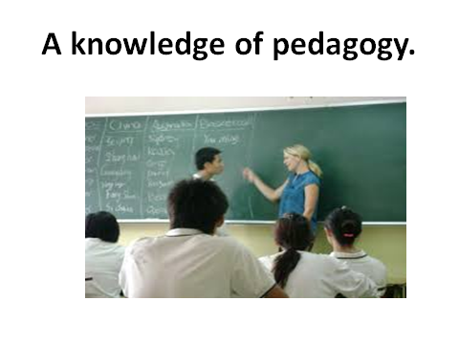
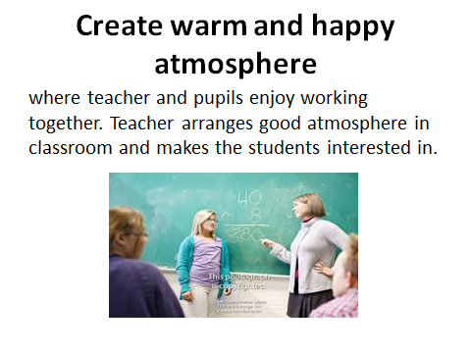
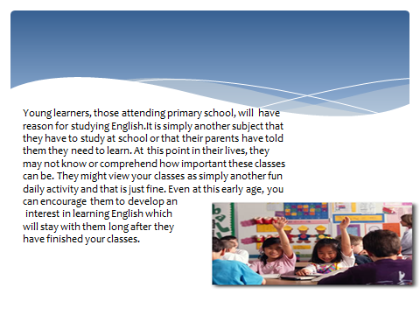

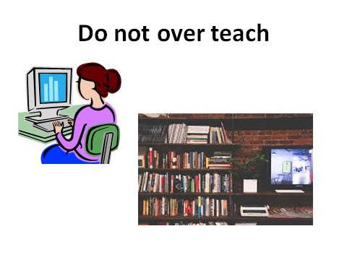
Lesson 2
Teacher education, curriculum and materials for primary English language education

Questions to be discussed:
1. What teaching-learning materials do you know?
2. What is initial teacher training?
3. Some instructions for teaching young learners.
Key terms: Initial or pre-service teacher training, pedagogical skill, professional learning community, the primary cycle
Initial or pre-service teacher training has to be at the heart of successful primary English teaching for the long term. This requires forward planning, especially in systems where governments are considering lowering the age at which English language teaching begins, and even more so when this involves the introduction of English into the primary cycle for the first time. Thus, the teacher education curriculum for primary class teachers should have a focus on age-appropriate foreign language teaching methods as well as teachers’ own language proficiency. Ideally, teachers should have a master’s degree as a basic qualification for teaching. This would help to ensure that teaching is a high-status profession attracting high-performing students.
As indicated, teachers need not only to have the necessary pedagogical skill to teach primary-age children, but also a high degree of competence in the language, with C1 on the CEFR descriptors as the target level so that teachers are able to cope with the complexity of informal and incidental language required in the primary classroom. Popular perceptions that teachers in primary schools do not themselves need high levels of English, as children are only learning simple English, are completely invalid. Initial teacher training must either (a) set an appropriate English proficiency level as an entry qualification, or (b) provide adequate scope for language improvement during the course. This will often require extensive reconfiguration of existing primary teacher education provision. Also important in this reconfiguration is recognition that secondary English language teaching methods cannot simply be transported into the primary sector makes clear: We need to understand what happens in child foreign language learning, so that teachers can be trained effectively, and so that later learning can build on the early stages. Teacher education and secondary foreign language teaching that take TEYL seriously may look quite different from earlier models that served a system in which language learning began around 11 years of age.
Effective primary English language teacher training will need to equip teachers with an understanding of how children think and learn in general, and how they learn languages in particular, as well as with the skills and knowledge to conduct whole lessons orally (given that children will not be literate in the early primary years) and the skills and knowledge to teach initial literacy in English in the later primary years.
In-service teacher training and continuing professional development (CPD).In-service teacher training (INSET), seen within a model of continuing professional development (CPD)for teachers, has a powerful role to play in the success of primary English language teaching worldwide. This is particularly true for primary class teachers who may have no experience of language teaching but who are expected to begin to teach English, often at short notice. Governments traditionally use cascade INSET models to introduce new curricula, teaching methods and materials to teachers throughout the education system but research worldwide indicates that there is often little classroom take-up from traditional, one-off INSET courses. To be effective, INSET/CPD needs to be classroom focused (but not necessarily to take place in the classroom).
For instance, they learned how to use stories in their classes, practicing techniques with their peers in the safe and supportive environment of the training center and, during the week before the next course, tried out these techniques in their own classes. They were then able to report back on their experience, their successes and any issues they faced, at the beginning of the next course. In this way the direct, practical relevance of the training was apparent even though teachers had to leave their classrooms in order to receive training; contrasting with traditional lecture modes of training where classroom techniques were neither demonstrated by trainers nor tried out by teachers.
Wherever possible, research also indicates the importance of offering in-school support to teachers to assist them in coming to terms with what they have been exposed to on courses within their professional learning community. It is noted that many programs aimed to improve teachers’ classroom skills but they “found that few participants actually received assistance and feedback in their classrooms during the critical and difficult implementation phase when they were trying out new practices,” in spite of the fact that: “Follow-up support to teachers during the implementation phase of change has long been identified as an important feature of more effective programs”.
They concluded that: Policy-makers and school administrators need to give equal attention to building the conditions that will enable schools to provide fertile ground for professional learning on an ongoing basis and as a routine part of the job. This study indicates that a substantial level of professional community is vital to significant change. The key ingredients here are time to think, analyze and talk about the specifics of what is going on in classrooms and what students are doing and learning.
These points are also included in list of key concepts for successful INSET for teachers (which also hold for CPD):
- INSET should be thought of as part of lifelong learning.
- Long-term, holistic approaches to in-service teacher development are more likely to be effective than short-term skills-based, training approaches.
- Effective INSET is school focused but not necessarily school based.
- Best practice in INSET goes beyond training and development for teachers to include training and development for in-service trainers.
- Effective INSET practice is reflexive2.
- INSET should not always focus on “new «methods, rather its central concern should be with effective methods in terms of their impact on student learning.
- INSET programs should incorporate evaluation components that go beyond reactions to the programs themselves to encompass classroom implementation of what has been learnt by teachers on the programs as well as institutional development.
- Time and opportunities to reflect on one’s own teaching and to share practice with colleagues are important means of professional development, but working conditions in many educational systems often militate against providing space for these types of INSET.
Clearly, substantial resources are needed for these factors to be realized in practice and governments must decide their priorities. However, teachers cannot be expected to teach English successfully without adequate training and, if they have not received it on a pre-service course, they must of necessity do so through in-service provision.
The primary English curriculum, instructional time and intensity of instruction Evidence indicates that if instruction is organized in small periods of time over an extended period (the usual school drip-feed approach) it takes learners much longer to achieve target levels than if instruction is organized in more concentrated periods of time. Further, there are inevitable challenges for teachers in sustaining students ‘motivation over longer periods when progressions so limited. Research evidence indicates that students learn a language best when instructional time is concentrated. Light brown found that: “The intensity of the exposure and the opportunity to continue using the language over a long period of time is as important as the starting age in the effectiveness of classroom instruction.”Her research concluded that “students who have intensive exposure to the second language near the end of elementary school have an advantage over those whose instruction was thinly spread out over a longer period of time”. Rather than starting earlier in primary school it is more effective to begin instruction nearer the end of the cycle and to concentrate the input children receive. However, school curricula are not organized to allow for concentrated instruction for a single subject in this way: learning of all subjects is expected to be incremental over an extended period of time. This is one area in which research is unlikely to have an impact on practice, making success in realization of other factors all the more important.
If instructional time during the school week is limited to two or three lessons of 40-45 minutes each, the curriculum needs to allow for adequate recycling of language in a variety of ways and situations of use. This may not be achieved if the curriculum takes a traditional lock-step, linear approach, as is common with secondary English language teaching. Primary English language teaching is better served by taking an activity-based, experiential approach in which language development is more organic.
Cameron recommends taking themes as the organizational unit, as these allow the greatest scope for opportunities for “realistic and motivating uses of the language with meaning and purpose for children». They also allow scope for linking English to other areas of the primary curriculum. Finally, they “open up the language classroom by bringing in the world outside and linking into children’s interests and enthusiasms, not just those that materials writers suppose them to have”.
An example of themes as the basis for an interdisciplinary curriculum (which could include English as a foreign language) is to be found in the “International Baccalaureate Primary Years Program”, in which the over-arching themes are:
- Who we are - an inquiry into the nature of the self; beliefs and values; personal, physical, mental, social and spiritual health; human relationships, including families, friends, communities and cultures; rights and responsibilities; what it means to be human.
-Where we are in place and time - an inquiry into orientation in place and time; personal histories; homes and journeys; the discoveries, explorations and migrations of humankind; the relationship between and the interconnectedness of individuals and civilizations, from local and global perspectives.
- How we express ourselves - an inquiry into the ways in which we discover and express ideas, feelings, nature, culture, beliefs and values; the ways in which we reflect on, extend and enjoy our creativity; our appreciation of the aesthetic.
- How the world works - an inquiry into the natural world and its laws, the interaction between the natural world (physical and biological) and human societies; how humans use their understanding of scientific principles; the impact of scientific and technological advances on society and on the environment.
- How we organize ourselves - an inquiry into the interconnectedness of human-made systems and communities; the structure and function of organizations; societal decision-making; economic activities and their impact on humankind and the environment.
-Sharing the planet - an inquiry into rights and responsibilities in the struggle to share finite resources with other people and other living things; communities and the relationship within and between them; access to equal opportunities; peace and conflict resolution. These themes provide immense scope for teachers and children to engage in activity-based, experiential learning beyond the confines of subject boundaries, learning which provides opportunities for language use that is predicated on genuine communicative needs and is thus intrinsically motivating for children. However, it must also be recognized that theme-based teaching is very demanding and dependent on skilled, well-trained teachers, underlining the need for effective pre- and in-service teacher education as the foundation of the system.
Teaching-learning materials. In many school systems pre-packaged teaching learning materials are provided. In some systems they are thought to help counter any deficiencies in teaching or language skills that a teacher might have. Textbooks are, of course, not a panacea for other failures in the system - i.e. they cannot replace qualified, skilled teachers - and, in some instances, may themselves be a source of problems if they are not founded on a basic understanding of how children learn languages.
Arnold and Roxon (2008) make a number of suggestions for high-quality materials for young learners. Hayes points about continuity between educational levels, they stress the need for an effective bridge between primary and secondary English, with secondary school teachers being more informed about what has happened in the primary classroom. They also maintain that principles behind materials need to be clear and exemplified to teachers, that there needs to be more training to enable teachers to choose and use materials, and those models of language appropriate to the context and goals of instruction need to be considered. Further, with respect to issues within materials, they highlight the need for greater consideration of the order in which skills are introduced for different ages of children, for age-appropriate, child-friendly assessment methods and, to avoid trivialization of the English curriculum, materials that ‘support big moral and intellectual themes and promote educational values appropriate to the age and context of the children concerned’. This endorses Cameron’s (2001) recommendation for theme-based teaching.
Questions:
1. What do you know about teacher education for primary English language education?
2. What do you know about curriculum for primary English language education?
3. What do you know about materials for primary English language education?

ТHEME№2 | Teacher education, curriculum and materials for primary English language education
Model of teaching
Time – 2 h. | Number of students from 15 to 25
Plan of the lesson | 1. What is teacher education?  2. What to focus on?  3. Some instructions for teaching young learners. How to proceed.
Aim of the lesson: to give information about “young learners”, to show main requirements of the up- to-date FL teachers, to explain innovative technologies in FLT.
Tasks of the lesson:
- To define the term “curriculum and materials”
- To clarify the term “teacher education”
- To explain the importance of innovative technologies in FLT
Methods of teaching |  | Discussion, dispute
Form of teaching |  | Group
Means of teaching |  | Projector, text of lesson
Place of teaching |  | Classroom;
Type of assessment |  | Oral answering
Pedagogical technology |  | Expert list, brainstorming.

TECHNOLOGICAL MAP OF THE LESSON
 | Teacher | Student
Stages | - Prepares for the content of the lesson.  - Prepares slides for the lesson.  - Gives the list of used literature.
1. Introduction (15 min) | 1.1. Name of the lesson, key-words and plan.  1.2. Explains aims and tasks of the lesson.  1.3. Asks questions in order to recall previous knowledge. | Listens  Answers to the questions
2. Main stage(50 min) | 2.1. Gives the main part of the theme, demonstrates and explains all the key-words and theoretical part.  2.2. Explains features competency  2.3. Names main requirements for up-to-date FL teachers  2.4.Explains importance of using innovative technologies during the FLT | Listens, reads and discusses
3. Conclusion  (15 min) | 3.1. Answers to the students questions  3.2. Gives sources of additional information, makes conclusion. | Asks questions. Writes tasks.

Презентация



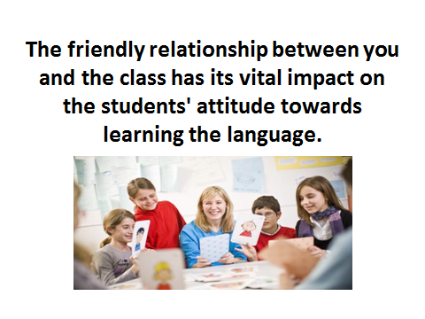

Lesson 3
Methods of teaching English language in primary school.

Questions to be discussed:
1. What methods of teaching English language in primary school do you know?
2. What is Common European Framework of Reference?
3. Some instructions for teaching young learners.
Key terms: Common European Framework of Reference, previous research, proficiency, speaking in chorus, noting the hegemony of English.
International comparisons of English language teaching-learning and proficiency outcome sat the school level are generally absent from the research literature. A 1995 study by the International Association for the Evaluation of Educational Achievement (IEA) had originally intended to assess student achievement but was cancelled after its Phase 1 data collection on the policy context due to lack of funding (see Dickson and Cumming, 1996, for details of Phase 1). However, in response to the growing importance of English for economic globalization, IEA has just launched a new comparative study focusing specifically on English in the participating countries, though the target population is Grade 10 students, and reports will not be available. Earlier research (Gika, 1997) compared primary foreign language teaching across Italy, Spain, England and Greece, noting the hegemony of English (which also led to the failure to focus on other languages in England), but did not report on language outcomes for students, though teachers ‘concern with their own language levels was noted.
Other previous research (Martin, 2000) also focused on foreign language teaching across Europe with a view to improving provision in the UK, but again did not assess language proficiency. Instead, general conclusions were made about the ability of children to learn languages under certain conditions, which have relevance for effective primary English teaching, that: children of primary age can effectively learn [original emphasis] aspects of a foreign language; that the teaching approaches must be appropriate to their age group; that continuity of foreign language into the secondary school is important and that the quality of the teaching must be high.
Lack of information on English language outcomes is surprising, given the importance attached to increasing English language skills by national governments, who would be expected to be concerned about the return on their investment in education, and particularly so in light of the trend towards lowering the age at which English is taught in schools. This trend towards ever-earlier introduction of English can be clearly seen in Roxon’s (2013) international survey of policy and practice in primary English teaching, which noted that one-third of countries had lowered the starting age since the first iteration of the survey some ten years previously, with 30 of 64 countries surveyed now teaching English from Grade 1.
Some cross-national comparative research has focused on limited aspects of classroom behavior, such as in Hardman’s (2007) study of pupil participation and engagement in Kenyan and Nigerian primary English classes, where English is the medium of instruction; or on related teacher factors as in Butler’s (2004) study of self-perceptions of actual and desired English proficiency levels that primary school teachers have in Korea, Taiwan and Japan. This research has important outcomes that may be of relevance to other countries, such as the need to “focus on the school as the best level of intervention for improving the quality of teaching and learning, and the necessity “to identify what kinds and levels of English proficiency elementary school teachers need to teach English” as well as ‘to better understand what types of competencies (regarding both knowledge and the ability to use such knowledge) elementary school EFL teachers must have”.
Other comparative research has focused on the impact of language policy and planning, notably Baldauf (2011), both within the Asia-Pacific region, while Kaplan et al. (2011) discuss general reasons for the failure of policy decisions to introduce English at the primary level. Kaplan (2011) noted two major “urban legends”, which require analysis with respect to English teaching:
People in many polities have come to believe that their children would be guaranteed better economic opportunities if they had English as part of their linguistic repertoire. This belief has supported the addition of English to the school curriculum - initially at the secondary school level and then at the intermediate school level. A decade or more of experimentation demonstrated that English at intermediate school was not sufficient to develop proficiency, so another legend -that early introduction to English would be the panacea - spurred an international belief that English language education should begin at the first grade, or even better in kindergarten.
They assert that these legends have two inherent fallacies, that:
- being English-knowing is not a guarantee of an improvement in economic opportunity
-early English learning is not a guarantee of near-native English proficiency.
Nunan came to the conclusion that the accelerating trend towards earlier English language instruction in the region was ill-considered and having no positive effect. He said, “The single most pervasive outcome of this study is that English language policies and practices have been implemented, often at significant cost to other aspects of the curriculum, without a clearly articulated rationale and without a detailed consideration of the costs and benefits of such
policies and practices on the countries in question. Furthermore, there is a widely articulated belief that, in public schools at least, these policies and practices are failing”.
Nunan also noted that the decision to introduce English at the primary level was largely political and based on folk wisdom that “the younger the better was axiomatic in language learning, irrespective of the context of learning. Other problems noted were inequity regarding access to effective language instruction, inadequately trained and skilled teachers, and a disjunction between curriculum rhetoric and pedagogical reality”, all of which lead to the conclusion that governments wishing to introduce English into the primary curriculum need first of all to establish pre-conditions for success by tackling the problems Nunan has identified.
Eight years later the review by Baldauf revealed little different in a wider range of countries: Bangladesh, China, Japan, Malaysia, Nepal, Singapore, Taiwan, Timor-Leste and Vietnam, with the exception of Singapore, where English was increasingly being used as a first language in many households and was displacing local first languages, Mandarin and Tamil. The trend towards the early introduction of English had: …intensified under the pressure of economic competition… despite the fact that such teaching requires massive commitments of funds (i.e. resourcing policy), special early childhood teacher training, teachers with excellent language skills(i.e. personnel policy), and books and materials(i.e. curriculum, materials and methods policy).
The challenges of inequitable access to effective English language teaching, poorly trained teachers with limited language skills and officially mandated curricula that did not match with actual classroom practice, or were impossible to implement in the classroom conditions, were all reiterated in this review and are illustrative of many of the “12reasons for educational language plans sometimes
Failing” discussed in Kaplan (2011) and collated in Table 1.
Table 1: Reasons for the failure of educational language plans:
1 | The time dedicated to language learning is inadequate.
2 | Indigenous teacher training is not appropriate or effective.
3 | Native speakers cannot fill the proficiency and availability gap.
4 | Educational materials may not be sufficient or appropriate.
5 | Methodology may not be appropriate to desired outcomes.
6 | Resources may not be adequate for student population needs.
7 | Continuity of commitment may be problematic.
8 | Language norms may be a problem.
9 | International assistance programs may not be useful.
10 | Primary school children may not be prepared for early language learning.
11 | Instruction may not actually meet community and/or national objectives.
12 | Language endangerment may increase.

These 12 causes for failure may be reformulated as pre-conditions for success in the implementation of English in primary schools, as in Table 2.

Table 2: Pre-conditions for success in the implementation of educational language plans:
1 | The time dedicated to language learning must be adequate.
2 | Indigenous teacher training must be appropriate and effective.
3 | Native speakers should not be used to fill the proficiency and availability gap.
4 | Educational materials must be sufficient and appropriate.
5 | Methodology should be appropriate to desired outcomes.
6 | Resources must be adequate for student population needs.
7 | Continuity of commitment should be ensured.
8 | Language norms should not be a problem.
9 | International assistance programs, if present, should be useful.
10 | Primary school children must be prepared for early language learning.
11 | Instruction should meet community and/or national objectives.
12 | Language endangerment should not be increased.

The necessity of establishing pre-conditions such as these when introducing English into primary schools, or lowering the starting point to earlier primary grades, is widely acknowledged by educational researchers. Hayes presented a similar list of factors that needed to be taken into account when discussing this kind of educational innovation, based on his work on primary English provision:
Changes are, however, not just necessary in the new grade levels in which English is introduced but throughout the entire system as earlier introduction of a subject inevitably requires adjustment to the curriculum and materials in all subsequent grades.
The follow-on implications of a decision to teach English earlier in the school cycle are profound …all manner of other factors come into play which are common to systemic educational reform for any subject area in the curriculum. These are, primarily:
- ensuring that there are adequate numbers of teachers to teach the subject to the particular grades;
- ensuring that these teachers are well trained for the task;
- ensuring that instructional time is available in the curriculum for the teaching of the subject;
- ensuring that curriculum materials and teaching-learning approaches are appropriate to the age group;
- ensuring that adequate time has been allowed for the preparation of new curriculum materials;
- ensuring that appropriate and timely in-service training is given to teachers in the use of the materials and teaching-learning approaches;
- ensuring that adequate in-school advisory support is available to teachers as they implement the curriculum;
- ensuring that appropriate evaluation procedures are in place to evaluate the effectiveness of the innovation;
- ensuring that adequate material and financial resources are available to implement all of the above;
- and, of course, ensuring that necessary adjustments are made to the curriculum and materials for all subsequent grades, and that teachers are given training to introduce them to these changes in the higher grades.
Elsewhere, Duff notes that a number of variables related to the child learner, classroom organization of teaching and the school curriculum are essential variables to take into account when considering earlier English instruction:
The age at which FL learning commences and the intensity, duration, and quality of FL instruction, the status of the FL course itself within the school curriculum, and students’ met linguistic efficiency are all variables that must be taken into account when changing policies of this nature and evaluating the effectiveness of earlier FL instruction.
Nevertheless, despite all of these policy prescriptions and analyses listing various factors to take into account for success in primary English teaching, it seems that decisions to introduce or lower the starting age for the teaching of English remains remarkably immune to research evidence and are primarily political rather than educational. Even more troubling, given the fact that teaching English in primary schools is predicated on the belief (or fallacy) that it will lead to enhanced proficiency, is that there remains a paucity of research focusing on students’ English language outcomes at the end of primary schooling. Of the few studies that measured language proficiency, the Barcelona Age Factor (BAF) project, as its name implies, dealt with a very restricted context in Spain and focused primarily on determining the impact of age of onset of learning on attainment.
The results of this study indicated that there was no advantage to an early start to learning English but that, in contrast, older learners (starting at age 14) progressed faster than younger learners(whether starting at age eight or 11) and younger learners did not catch up over the six-year time span of the research. The conclusion drawn was that ‘second language learning success in a foreign language context may be as much a function of exposure as of age, reinforcing the notion that an earlier starting age as a panacea for English language learning in school contexts is indeed a fallacy. A later study remains one of the few major transnational research undertakings to include measurement of students’ language proficiency at the primary level among its research goals.
Factors determining the efficacy of the primary education system as a whole underpin specific factors determining the efficacy of primary English education in particular. The list of characteristics that follows must be interpreted within particular socio-educational contexts and not thought of as prescriptive or being universally applicable without local adaptation. With that caveat, to sum up, the following characteristics are desirable for effective primary English language education within national education systems:
1. Teaching by generalist primary class teachers with training in primary English language teaching methods.
2. Teachers with an English language level of at least B2, but preferably C1 on the CEFR.
3. A pre-service teacher training system in which school teachers are required to have master’s degrees.
4. A school-focused system of continuing professional development which allows teachers adequate time to reflect on new information about teaching-learning and to incorporate it into existing knowledge structures, both by themselves and in collaboration with colleagues.
5. An education system in which teachers are respected, trusted and given the freedom to organize instruction according to the needs of their pupils within a guiding national framework.
6. Teachers who have positive attitudes towards English and teaching the language. This in turn will influence children’s motivation to learn, their enjoyment of their English classes and, ultimately, their achievement.
7. A curriculum which allows teachers and children opportunities to engage in meaningful language use, which also provides opportunities for considerable recycling of target language in new contexts and which is age-appropriate; theme-based teaching is strongly recommended.
8. A realistic language target for children of A1–A2on the CEFR by the end of the primary cycle.
9. Ideally, instructional time should be concentrated towards the end of the primary cycle rather than provided in smaller amounts over a longer time span, though it is recognized this may be difficult to implement in practice.
10. Ideally, materials should be prepared by teachers to respond to the specific needs of their own classes; where materials are prepared by others, they should be founded on an understanding of how young children learn languages and provide stimulating, theme-based activities promoting genuine communicative language use.
11. Considerable out-of-school exposure to English in the local environment, including through films and television programs in English which are subtitled rather than dubbed into learners’ L1.Underpinning all of the above are the following characteristics, which relate to the education system as a whole and, thus, are also desirable for effective primary English language education.
12. An equitable education system in which socio-economic status is not linked to academic achievement.
13. An education system in which private tuition is not regarded as essential for academic success.
14. An education system in which high-stakes testing is not seen as a means to promote academic achievement. It was designed specifically:
To explore contexts for foreign/second language learning in state-funded primary schools in Europe with the aim of clarifying what can realistically be achieved in classroom contexts where relatively limited amounts of curriculum time are available for language learning (as is commonly found across Europe).
The sampling of schools was based on convenience of access for the researchers, rather than randomized to ensure that there was no bias in the sample selected, which detracts somewhat from the generalizability of the results, even though they attempted to control for variables such as socioeconomic background and geographical location - urban, semi-urban and rural.
As would be expected, over the lifetime of the research gave rise to a number of presentations and publications, both country-specific and thematic, which explores learning environments and motivation among young learners. Since the rationale for teaching English in primary schools is based on putative enhanced proficiency from starting earlier, it is interesting to examine the language outcomes for children involved in the Ellie. The broad characterization of outcomes in the Executive Summary of the final research is somewhat vague, as follows these language achievements:
-Outcomes are moderate at this stage;
-The range of outcomes varies substantially across countries;
-Higher levels are achieved by learners of English, particularly where English is used more widely in social contexts;
-Speaking skills develop only gradually under conditions of limited curriculum time;
-By the fourth year of learning, most children are able to read short comic strip stories;
-As children develop a larger vocabulary, they begin to syntactically complexity their language.
Participating countries use the level descriptors in the Common European Framework of Reference (CEFR) as targets for language outcomes in the primary cycle, in spite of the fact that these were not developed for use with young learners but ‘were formulated drawing from a corpus of adult language use, failing to capture the essential features of children‘s early foreign language (FL) learning experiences. Though the ELLIE concludes that CEFR level descriptors are inappropriate, they remain in use and of necessity influenced the project’s language assessment instruments, which were based on the ‘can do’ statements developed by the Association of Language Testers in Europe for each CEFR level.
The actual CEFR targets set by each of the participating countries are given in Table 3.
Table 3: Intended language outcomes for primary children in ELLIE countries:
Country | CEFR target/age
England | A1 by 11 years
Croatia | A1 by ten/11 years
Italy | A1+ by 11 years
Netherlands | A2 by 12 years
Poland | A1 by 11 years
Spain | A1 by 12 years
Sweden | A1 by nine years  A2.1 by 12 years

Within the CEFR, the descriptors for levels A1 and A2 on the ‘global scale’ are as follows (Council of Europe):
Table 4: CEFR descriptors for A1 and A2 levels
Basicuser | A2 | Can understand sentences and frequently used expressions related to areas of most immediate relevance (e.g. very basic personal and family information, shopping, local geography, employment). Can communicate in simple and routine tasks requiring a simple and direct exchange of information on familiar and routine matters. Can describe in simple terms aspects of his/her background, immediate environment and matters in areas of immediate need.
Basicuser | A1 | Can understand and use familiar everyday expressions and very basic phrases aimed at the satisfaction of needs of a concrete type. Can introduce him/her and others and can ask and answer questions about personal details such as where he/she lives, people he/she knows and things he/she has. Can interact in a simple way provided the other person talks slowly and clearly and is prepared to help.

Both A1 and A2 on the CEFR levels are characterized as ‘basic user’. In terms of these levels, Evener assesses language outcomes among participating learners as follows: The average ELLIE learners have approached A1 level (as described by the CEFR) in their oral and aural skills during the first four years of instruction
One teacher pointed out difficulties in pronunciation: “Pronunciation is a bit difficult because most first graders are missing front teeth. This problem is usually solved by speaking in chorus”.
Instruction is organized in a variety of ways indifferent countries (see Table 5, below, which excludes England as the foreign language taught there is not of concern in this qualification paper).

Table 5: Organization of instructional hours in primary schools:
Country | Typical number of lessons per week | Lesson duration
Italy | Year 1 - one lesson;  Year 2 - two lessons;  Years 3-5 - three lessons per week | Recommendation of 60 minutes per week but may  vary at individual schools
Netherlands | No specified number. Typically one to  three lessons per week | Typically Years 1-2 -  20 minutes;  Years 3-8 - 30-60 minutes
Poland | Two | 45 minutes
Spain | No specified number; may be  anything from one to four lessons  per week | Typically 45-60 minutes
Sweden | Years 1-3- one lesson  Year 4 - two lessons | 20-30 minutes  40 minutes
Croatia | Two | 45 minutes

There is little difference in the intensity of instruction, with the ‘drip feed’ approach (a little instruction on a frequent basis) prevailing. What is noticeable is that, with the typical number of lessons per week, children take as much instructional time to reach A1 level as is often expected to reach A2[16].
For example, in Croatia, two x 45-minute lessons for 35 weeks per year over four years results in 210 instructional hours; whereas most publishers and English teaching websites give figures of around 180 to 200 instructional hours to reach A2. Of course, learning is not simply a response to the number of hours spent in a classroom and other variables must be taken into account such as out-of-class exposure to English, the context of learning, learning purpose, and so on.

Questions.
1. Discuss CEFR descriptors for A1 and A2 levels.
2. Discuss CEFR descriptors for B1and B2levels.
3. Discuss CEFR descriptors for C1and C2levels

ТHEME№3 | Methods of teaching English language in primary school
Model of teaching
Time – 2 h. | Number of students from 15 to 25
Plan of the lesson | 1. What young learners want?  2. What to focus on?  3. Some instructions for teaching young learners. How to proceed.
Aim of the lesson: to give information about “young learners”, to show main requirements of the up- to-date FL teachers, to explain innovative technologies in FLT.
Tasks of the lesson:
- To define the term “young learners”
- To clarify the term “competency”
- To explain the importance of innovative technologies in FLT
Methods of teaching |  | Discussion, dispute
Form of teaching |  | Group
Means of teaching |  | Projector, text of lesson
Place of teaching |  | Classroom;
Type of assessment |  | Oral answering
Pedagogical technology |  | Expert list, brainstorming.

TECHNOLOGICAL MAP OF THE LESSON
 | Teacher | Student
Stages | - Prepares for the content of the lesson.  - Prepares slides for the lesson.  - Gives the list of used literature.
1. Introduction (15 min) | 1.1. Name of the lesson, key-words and plan.  1.2. Explains aims and tasks of the lesson.  1.3. Asks questions in order to recall previous knowledge. | Listens  Answers to the questions
2. Main stage(50 min) | 2.1. Gives the main part of the theme, demonstrates and explains all the key-words and theoretical part.  2.2. Explains features competency  2.3. Names main requirements for up-to-date FL teachers  2.4.Explains importance of using innovative technologies during the FLT | Listens, reads and discusses
3. Conclusion  (15 min) | 3.1. Answers to the students questions  3.2. Gives sources of additional information, makes conclusion. | Asks questions. Writes tasks.

Презентация

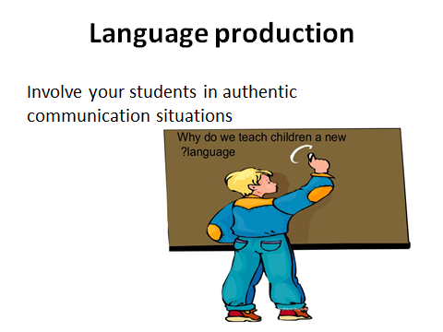

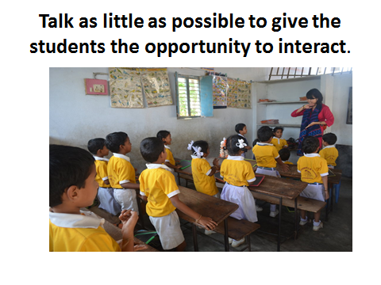

Lesson 4
Analysis of the effectiveness of the usage of methods of teaching English language in Primary schools.

Questions to be discussed:
3. Which techniques of teaching language will you use?
4. What methods can I use to teach an effective lesson?
5. What classroom activities for teaching a foreign language do you know?
Key terms: commercial language schools, linguistics, modern languages, self-employed, encourage the students to communicate.
Teaching English as a foreign language (TEFL) involves teaching adults and children whose first or main language is not English. This can be done in the UK or abroad and the students may be learning English for either business or leisure reasons.
Teaching English to speakers of other languages (TESOL) is also a widely used term and often means the same thing as TEFL. It's sometimes specifically used to refer to teaching English to people who are living in the UK but who do not speak English as a first language. These students are most commonly refugees and immigrants and need to learn the language in order to help them settle into UK society. Their courses are often government funded.
Teaching English as a second language (TESL) or teaching English as an additional language (TEAL) may also be terms that are used, but they generally all refer to the same thing - teaching English to someone whose native language is not English. Teachers of English as a foreign language can work in a variety of settings with different age ranges. This can include commercial language schools, schools and institutions of further and higher education throughout the UK and overseas. Some may also teach in industry, while others are self-employed. Classes are usually taught in English, even with beginners.
Responsibilities.EFL teachers use a range of course books and materials, plus a variety of audio-visual aids. A strong emphasis is placed on dialogue and role-playing, but more formal exercises, language games and literature are also used. The content of lessons varies depending on the reason why the students are learning English, e.g. whether it's for business use for adults, school work for children and so on.
The aim of each lesson is to encourage the students to communicate with each other using the structures and vocabulary they've learnt and to improve the four basic language skills of listening, speaking, reading and writing.
Typical tasks that may be carried out include:
- classroom management;
- planning, preparing and delivering lessons to a range of classes and age groups;
- preparing and setting tests, examination papers and exercises;
- marking and providing appropriate feedback on oral and written work;
- devising, writing and producing new materials, including audio and visual resources;
- organizing and getting involved in social and cultural activities such as sports competitions, school parties, dinners and excursions;
- attending and contributing to training sessions;
- participating in marketing events for the language school;
- preparing information for inspection visits and other quality assurance exercises;
- freelance teaching on a one-to-one basis;
- basic administration, such as keeping student registers and attendance records.
Teachers are based in classrooms for the majority of the time but may be expected to take part in social activities, sometimes in the evenings and at weekends, especially on summer courses for teenagers.
Teaching English to speakers of other languages is open to all graduates, but the following subjects are particularly useful:
- education;
- English;
- linguistics;
- modern languages.
An important aspect of these courses is the teaching practice in classrooms, which many employers will look for. Most employers tend to favor courses that have a minimum of 100 hours' input and are validated by a reputable examination body or university. You should look into all of this before deciding on a course.
Distance learning courses are also available, although they do not usually include teaching practice, so you'll need to arrange that aspect yourself to get some relevant experience. Cambridge ESOL does offer an online CELTA course; however, that incorporates teaching practice into the distance learning.
As well as having a good command of English and the relevant qualifications, teachers will need to show evidence of the following:
- a friendly and confident manner;
- good planning and organization skills;
- the ability to work under pressure;
- flexibility and an adaptable teaching style;
- creative skills and ideas for planning practical and interesting lessons;
- excellent spoken and written communication skills;
- effective listening skills;
- sensitivity, tolerance and patience.
In the fifth century B. C. the early stages of language were written down as a set of rules in ancient India. This was a grammar of Sanskrit which effects went far beyond the original intentions of the authors. According to Hewitt (1984) a thorough education consists not only of the acquisition of knowledge, but the physical, mental, emotional, moral and social development of the individual.
Language study and language teaching was to be promoted through the fields of philosophy, logic, rhetoric, sociology, and religion, among others, providing the framework for the main task of linguistic scholars. This was basically to study and understand the general principles upon which all languages are built and in doing so, teach them better.
Some of those methodological and theoretical principles and ideas are still used in modern linguistics nowadays. Developments in such fields as linguistics, psychology, anthropology and sociology have been the source of many methods and approaches which searched the most effective methods for students to study a new language.
A central concept of this process was defined by Hewitt as “the notion of a systematic set of teaching practices based on a particular theory of language and language learning”. Henry Sweet was a key figure in establishing the applied linguistics tradition in language teaching. Applied linguists Jean Maniacs, Heinrich Gottfried Ollendorff, Henry Sweet, Otto Jespersen and Harold Palmer worked on setting language teaching principles and approaches based on linguistic and psychological theories, but they left many of the specific practical details for others to devise.
The search for innovations in teaching languages preoccupied teachers and applied linguistics throughout 20th century. Many countries have been putting enormous importance on foreign language learning, especially the English language. There are many methods and technologies of teaching languages. Some have fallen into relative obscurity and others are widely used; still others have a small following, but offer useful insights.
Those looking at the history of foreign-language education in the 20th century might be tempted to think that it is a history of failure. Older methods and approaches such as the grammar translation method or the direct method are dismissed and even ridiculed as newer methods and approaches are invented and promoted as the only and complete solution to the problem of the high failure rates of foreign language students.
Most books on language teaching list the various methods that have been used in the past, often ending with the author's new method. But the authors generally give no credence to what was done before and do not explain how it relates to the new method.
New efforts are aimed at improving foreign language education in the Russian Federation nowadays. There is the need to strengthen foreign language skills among the students of non-linguistic higher educational establishments. Knowledge of one or several foreign languages becomes an integral part of professional training.
Higher education teachers are forced to encourage and subject communities to consider the role of creativity in students’ learning and their experiences of learning. In teaching English in Primary schools demands creativity, which is an integral part of modern foreign languages. Languages are not always creative, but they have enormous potential to be so. They are used deliberately to create works of art, and for spontaneous communication.
Learning a language may be a creative exercise because languages are so vast and complex, and each user needs to use and combine elements of knowledge in new ways constantly. The discipline of Foreign Languages carries these associations, and uses them, without necessarily truly promoting creativity. Language study also lends itself to creativity as it can be seen to embrace other disciplines with endless scope for doing so in new ways. In relation to the discipline of foreign language teaching and learning, everything potentially embodies creativity. Language teaching is one of those very open and flexible areas where creative activities can be easily embedded in both the teaching activities as well as in the language curriculum.
It is like having different ingredients to cook and being able to combine them differently each time in order to create as succulent a dish as one can manage to. Thus, creativity lies in the ability to construct meaningful language from the building-blocks available and to express ideas using the resources available; but also, recognizing that the resources can be adapted and that the language learner can often be in control of resources, rather than subject to their limits and restrictions. On another level, creativity also means the scope to play with language and ideas for their own sake.
To have better results we can use innovative technologies and media. They provide interaction with speakers of other languages, and improve foreign language teaching in the classroom. This is a way to increase access to information and entertainment in a foreign language. We need specific research on how technology can best be used to increase students' proficiency in other languages. The importance of the Internet and specialized databases for information retrieval is of special importance.
There are television programs, films, computer games, and music videos and teachers try to develop successful strategies for integrating their students' informal foreign language exposure into classroom teaching. The use of new information technologies, especially networked computers, has contributed to increased communication among foreign language teachers and students in many countries. Through e-mail, mailing lists, discussion groups, and chat rooms, the Internet has increased access to and communication in the foreign language with speakers.
There are other notable methods which include the sole use of the foreign language in the classroom; a modular approach to teaching in which students are grouped according to proficiency level and project-oriented learning that emphasizes the use of authentic materials through technology and integrates learning about English-speaking countries with language and content learning.
Learning content-area subjects through the medium of a foreign language has become an essential part of learning professional English. In some cases, a foreign language is used as the medium of instruction in non-language subjects.
There is also a great number of online and self-study courses which help the learners of foreign languages very much. Hundreds of languages are available for self-study, from scores of publishers, for a range of costs, using a variety of methods.
The course itself acts as a teacher and has to choose a methodology, just as classroom teachers do. Thus, teachers of foreign languages have additional support in their teaching activities. We agree with the opinion that a contender for a methodology as central to the world of technology and language learning is that of blended learning.
We see this methodology still being developed, but when handled it is the most likely candidate for a starting point for getting teachers to work with technology in their practice. It is still the case that most teachers work in physical classrooms and looking at ways that these spaces can be augmented with digital technologies is a very good starting point.
There is an idea of the extended classroom is one of that allows learners to engage in material beyond the regular class period. According to many researchers and practitioners, innovations, as any meaningful introduction of new elements for qualitative changes of educational situation, help to successfully prepare future specialists for cross cultural professional communication.
We believe that the teacher should be responsible for the selection, organization and exploration of the materials and technologies which are brought to class. They must be creative, provocative, meaningful, allow for the active, critical exploration of both students and the teacher.
There are given five interactive teaching styles that make a difference:
1. Brainstorming - various techniques.
Interactive brainstorming is typically performed in group sessions. The process is useful for generating creative thoughts and ideas. Brainstorming helps students learn to pull together. Types of interactive brainstorming include:
- Structured and unstructured
- Reverse or negative thinking
- Nominal group relationships
- Online interaction such as chat, forums and email
- Team-idea mapping
- Group passing
- Individual brainstorming
2. Think, pair and share.
Establish a problem or a question. Pair the students. Give each pair sufficient time to form a conclusion. Permit each participant to define the conclusion in his or her personal voice. You can also request that one student explain a concept while the other student evaluates what is being learned. Apply different variations of the process.
3. Buzz session.
Participants come together in session groups that focus on a single topic. Within each group, every student contributes thoughts and ideas. Encourage discussion and collaboration among the students within each group. Everyone should learn from one another’s input and experiences.
4. Incident process.
This teaching style involves a case study format, but the process is not so rigid as a full case study training session. The focus is on learning how to solve real problems that involve real people. Small groups of participants are provided details from actual incidents and then asked to develop a workable solution.

Questions.
- What does interactive brainstorming include?
- How do television programs, films, computer games, and music videos influence to learning language?
ТHEME№4 | Analysis of the effectiveness of the usage of methods of teaching English language in Primary schools.
Model of teaching
Time – 2 h. | Number of students from 15 to 25
Plan of the lesson | 1. What young learners want?  2. What to focus on?  3. Some instructions for teaching young learners. How to proceed.
Aim of the lesson: to give information about “young learners”, to show main requirements of the up- to-date FL teachers, to explain innovative technologies in FLT.
Tasks of the lesson:
- To define the term “young learners”
- To clarify the term “competency”
- To explain the importance of innovative technologies in FLT
Methods of teaching |  | Discussion, dispute
Form of teaching |  | Group
Means of teaching |  | Projector, text of lesson
Place of teaching |  | Classroom;
Type of assessment |  | Oral answering
Pedagogical technology |  | Expert list, brainstorming.

TECHNOLOGICAL MAP OF THE LESSON
 | Teacher | Student
Stages | - Prepares for the content of the lesson.  - Prepares slides for the lesson.  - Gives the list of used literature.
1. Introduction (15 min) | 1.1. Name of the lesson, key-words and plan.  1.2. Explains aims and tasks of the lesson.  1.3. Asks questions in order to recall previous knowledge. | Listens  Answers to the questions
2. Main stage(50 min) | 2.1. Gives the main part of the theme, demonstrates and explains all the key-words and theoretical part.  2.2. Explains features competency  2.3. Names main requirements for up-to-date FL teachers  2.4.Explains importance of using innovative technologies during the FLT | Listens, reads and discusses
3. Conclusion  (15 min) | 3.1. Answers to the students questions  3.2. Gives sources of additional information, makes conclusion. | Asks questions. Writes tasks.

Презентация

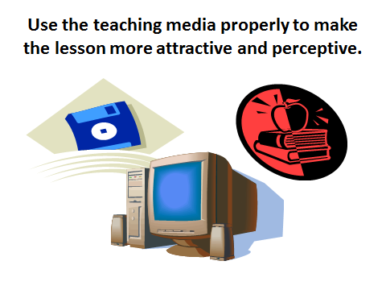

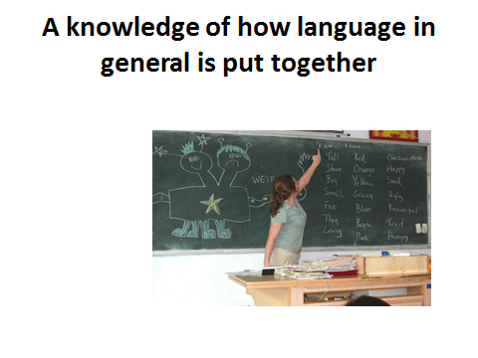

Lesson 5
Teaching primary level children.
Questions to be discussed:
1. What young learners want?
2. What to focus on?
3. Some instructions for teaching young learners.
Key terms: Comprehend young learners, subject, basic material, constructive learning, games, and focus on.
Young learners, those attending primary school, will have reason for studying English. It is simply another subject that they have to study at school or that their parents have told them they need to learn. At this point in their lives, they may not know or comprehend how important these classes can be. They might view your classes as simply another fun daily activity and that is just fine. Even at this early age, you can encourage them to develop an interest in learning English which will stay with them long after they have finished your classes.
How to understand and teach young learners better.
Students at this level are just starting their academic careers. School may be intimidating for some of the students in your class so, in order to encourage everyone to participate, it is important to make your lessons relaxed and fun. Students will be learning very basic material but you can design creative lessons that get students moving around and speaking with one another. Young learners are generally very enthusiastic about songs, especially if they can sing along, and active games. You want to create a safe, stress-free environment that everyone can enjoy learning in.
Keep exercises fun and short because these students have short attention spans and are easily distracted. Overacting and projection will help keep the focus on you. Teach students how to behave in a classroom by asking them to be quiet while you are talking and raise their hands if they have questions or want to answer a question. This may not be directly related to ESL but it is important that students learn good behavior early on; it will make their transition to primary school easier. Teach them to respond to basic classroom English phrases such as “Please sit down.” because these are expressions that they will hear repeatedly throughout their study of English. For students at this age, you are responsible not only for starting to teach them English, but also for preparing them for their next level of education. Students will perform better in their classes if they behave well and have a good understanding of basic principles.
The primary focus of these lessons will be on communication and laying a solid foundation for further English coursework. Students should practice the different sounds of the English language and learn material such as the alphabet, numbers, colors and shapes. You will introduce vocabulary words gradually and may choose to study some simple structures that relate to everyday life too. It could be that reading and writing never enter into your classes but a focus on speaking and listening will help students become more comfortable and confident with English.
There are many other things you can do to ensure that students succeed in class. There is no need to assign homework at this stage but be sure to track individual and class progress so that students can visually see what they have learned and how they are doing. Encourage students to try their best and create a constructive learning environment where students do not need to worry about making mistakes. Create activities and exercises that are entertaining. Help students learn how to interact with one another as well as how to speak English. Students will also feel more comfortable if you stick to a regular schedule so if you decide to make changes, implement them over a period of time rather than all at once. Avoid introducing too much new vocabulary at a time. Students may not remember material from one day to the next so repetition. The more students are exposed to certain material, the faster they will learn it. This is how native speakers learn English, by listening to people around them and expanding their range of vocabulary gradually.
You play an important role in helping them develop into lifelong learners. Foster a love of learning by creating lesson plans that appeal to them, suit their maturity level, and focus on what will help them excel in future English courses.
Teaching children can be immensely rewarding, anyone who has taught children can tell you that. But it’s not fun and games all the time, and sometimes it’s just not that easy. English teachers who wish to teach children must be aware of the challenges and difficulties they may encounter, and prepare accordingly.
10 things to consider if you’re serious about teaching kids English:
1.If you want to teach kids English because you think it’s easy, then this is not the job for you. Teaching children demands a great deal of creativity and energy. Kids will always keep you on your toes! They will amaze you and surprise you, but don't think that just because you'll be teaching colors and animals, it'll be a breeze. You'll most likely feel exhausted after every class, but so happy!
2. A little preparation goes a long way
Never make the mistake of showing up for class with little or no ideas, and thinking that you’ll figure it out as you go along. Preparation is essential, mostly because you’ll need to gather lots of teaching materials. Seasoned teachers may be able to improvise an entire lesson with only a whiteboard and some markers, but why risk having a class that turns out to be a hellish nightmare? You can plan an entire week of lessons or a full month, but make sure you have a lesson plan for every class.
3. Try to cater to multiple intelligences
Young ESL students have strengths and weaknesses and the best way to take advantage of their strengths and help them learn effectively is to cater to their learning styles or multiples intelligences, namely Visual – Spatial, Logical – Mathematical, Bodily – Kinesthetic, Musical – Rhythmic, Intra-Personal, Inter-Personal, Naturalist, and Spiritual. How can we accomplish this?
Let’s see some examples:
- For musical – rhythmic intelligence learners, teach an ESL element with a song, like Rock Around the Clock for telling time.
- For bodily – kinesthetic intelligence learners, teach body parts with a game of Simon Says, or sing Head, Shoulders, Knees, and Toes. For visual – spatial intelligence learners, use maps, charts, and all types of visual aids. Teach them the different types of stores and locations they may find around town with a big map-like board game, and have them “visit” the different locations by throwing the dice.
4. Don’t let them get bored
If children are bored they won’t pay attention, and they won’t learn. You don’t have to clown around all the time, either; they're in class to learn, not to be entertained by you. Your job is to make learning engaging and fun. Here are some ways to do this:
- Once they’ve been sitting and focused on a task for a while, get them out of their seats for a more active game. They should never remain seated for the duration of the class, unless they’re teens.
- Use realia, or real life objects in class. No matter how colorful or big, students sometimes get tired of learning everything through flashcards.
5. Mix it up
ESL classes may include singing, dancing, and jumping, as well as writing, reading, or listening. The best ESL lessons combine the right mix of teaching strategies. You may begin class with a short song, then move on to a reading exercise. The best rule of thumb is to switch between quiet, independent tasks to those that require action and movement.
6. Be prepared to deal with parents
Unlike teaching adult students, when you teach the little ones you have to interact with their parents as well.
These must be informed about:
- Your goals, i.e., what you hope to accomplish throughout the year
- The children’s learning goals, i.e., the syllabus for the school year
- Their children’s progress, i.e., if they have achieved their learning goals satisfactorily
It is also recommended to encourage parents’ active participation in their children’s English learning. Even if they don’t speak English themselves, they should be encouraged to ask the kids what they’ve learned, share songs, etc.
7. Gather an arsenal of materials
When you teach children English it is essential to have a box of materials that can be adaptable to any game or activity.
Must-have items are:
- a pair of dice
- flashcards.
- blank bingo sheets (that can be filled in by students with either words or pictures)
- small toys – balls in several sizes, toy vehicles, animals, etc...
- beanbags
- puppets
8. Remember it’s not all about the games
Each game or activity you propose should target a specific learning goal or ESL element. It’s not about coming to class to play. ESL games are highly effective teaching strategies as long as you know how to fully utilize their potential.
9. Teach in context
Lessons should be planned in accordance with learning goals. And vocabulary, grammar, and language should be taught in context. For example, when teaching children foods in English, it should be within a meal context like breakfast, lunch or dinner, and should never be a list of items they must study or memorize.
10. Keep them motivated
As kids get older and reach their pre-teen years, some ESL games and activities may not interest them as much as they did in the past. Find out what does interest them. What kind of music do they like? What do they enjoy reading? What sports do they play? Which sports stars do they admire? The moments shared with your young learners will far outweigh any of the difficulties or disadvantages commonly associated to teaching children.
Questions.
1. Think about core of the FL teaching as the subject.
2. Are there any differences between teaching the FL to young learners and adult learners?
3. What do we mean by the requirements to teaching to young learners?
4. Discuss the role of FL teaching to young learners.
ТHEME№5 | Teaching primary level children.
Model of teaching
Time – 2 h. | Number of students from 15 to 25
Plan of the lesson | 1. What young learners want?  2. What to focus on?  3. Some instructions for teaching young learners. How to proceed.
Aim of the lesson: to give information about “young learners”, to show main requirements of the up- to-date FL teachers, to explain innovative technologies in FLT.
Tasks of the lesson:
- To define the term “young learners”
- To clarify the term “competency”
- To explain the importance of innovative technologies in FLT
Methods of teaching |  | Discussion, dispute
Form of teaching |  | Group
Means of teaching |  | Projector, text of lesson
Place of teaching |  | Classroom;
Type of assessment |  | Oral answering
Pedagogical technology |  | Expert list, brainstorming.

TECHNOLOGICAL MAP OF THE LESSON
 | Teacher | Student
Stages | - Prepares for the content of the lesson.  - Prepares slides for the lesson.  - Gives the list of used literature.
1. Introduction (15 min) | 1.1. Name of the lesson, key-words and plan.  1.2. Explains aims and tasks of the lesson.  1.3. Asks questions in order to recall previous knowledge. | Listens  Answers to the questions
2. Main stage(50 min) | 2.1. Gives the main part of the theme, demonstrates and explains all the key-words and theoretical part.  2.2. Explains features competency  2.3. Names main requirements for up-to-date FL teachers  2.4.Explains importance of using innovative technologies during the FLT | Listens, reads and discusses
3. Conclusion  (15 min) | 3.1. Answers to the students questions  3.2. Gives sources of additional information, makes conclusion. | Asks questions. Writes tasks.

Презентация

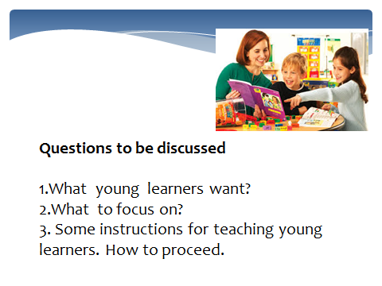

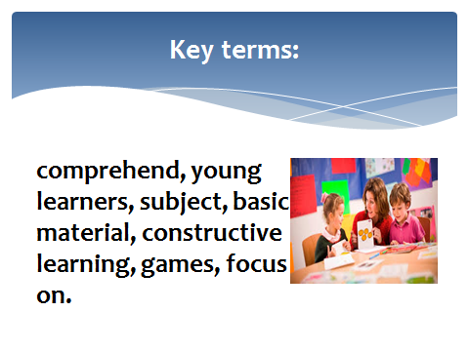
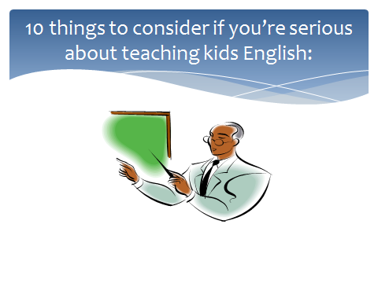

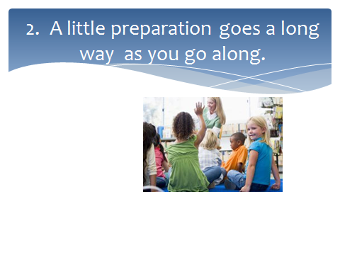
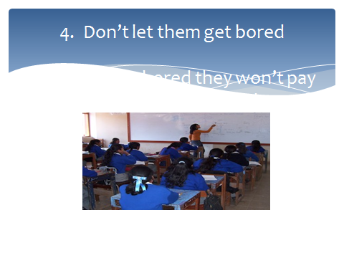

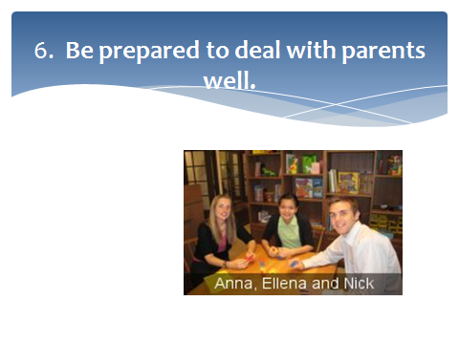
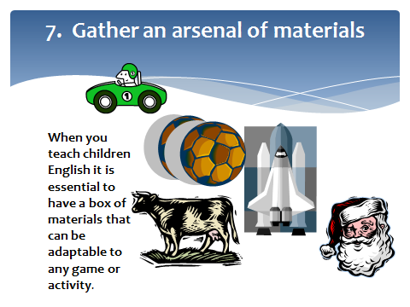

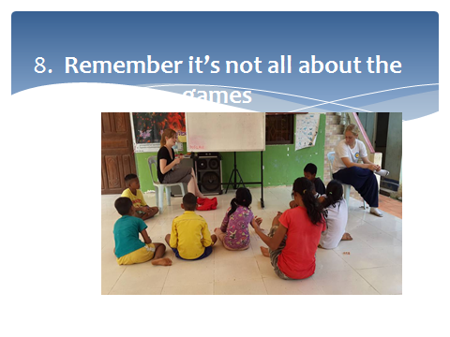

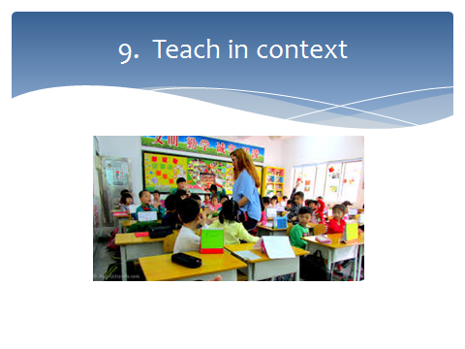

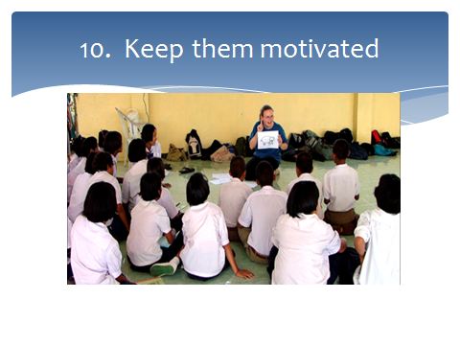
Lesson 6
Main requirements in teaching primary school level children.
Questions to be discussed:
1. What kind of advices for effective teaching do you know?
2. Do you prefer activities for teaching a foreign language?
3. What is a classroom management?
Key terms: competency in science, young learners, subject, classroom management, teacher's approach, language production, professional conduct
Drilling Activities for Your English Classroom. There are many ways to drill new material. Using a variety of drilling methods in your classes will help make this portion of the lesson more interesting and keep students focused.
Choral Repetition
Choral repetition is a commonly used method of drilling. Students simply have to repeat words or phrases after you. This is a good method because it means that students are given excellent model pronunciation immediately before they are asked to respond. Going through vocabulary this way many times in a single lesson will be boring for your students and they will be less inclined to perform well. Break up the monotony by changing the speed or volume you use and have students change their responses accordingly. Using this method, students are not called on individually to pronounce words therefore you will need to check individual pronunciation and comprehension separately. Integrating these checks into your drill activities will keep students alert because they will never know when you may call on them.
Drilling with Flashcards
Drilling using flashcards can be useful as well. In the introduction, show students both the image and word sides of each flashcard. When you start drilling words for the first time, show students the word side of the flashcard so they can practice reading and pronouncing it. Later on, rather than show students the word you want them to pronounce, show them the image. This will help check their comprehension of the material. With flashcards, you can also challenge your students when they become more familiar with certain vocabulary by flipping through the cards at a faster rate.
Comprehension
Asking for volunteers or calling on students to give you a synonym antonym, or translation of a new vocabulary word will check individual comprehension. It is always nice to ask for volunteers as opposed to calling on students individually but generally a volunteer will be more confident in his answer so this will not properly show whether or not the class understands the material. When you find it necessary to single out particular students who are not participating in drill activities, calling on them for answers is an easy method of focusing their attention on the lesson. Doing comprehension checks is also a good way to break up the drill activities a bit.
Drilling in Pairs
As material becomes more familiar, you may want to conduct short pair activities where a student’s comprehension is tested by his partner. To do this with a vocabulary list for instance, have student a read the translation of each word in random order while the student B says the word in English. Student A can then place a checkmark next to all the words student B got correct and then the students can switch roles. With this method students can check each other and have visual proof of how well they performed afterwards which they can refer to when practicing material on their own or preparing for exams. Conducting an activity such as this on a regular basis will help students review vocabulary often and should not take more than five minutes even with fifteen to twenty vocabulary words. It may still be necessary to practice using choral repetition before performing pair activities so that students are reminded of the proper pronunciation of the vocabulary.
Games
Breaking your classroom up into sections where each section says one portion of a new structure is another way of drilling material. In small classes you can conduct some drilling activities in a circle. The more variation there is to an activity, the more students have to pay attention but it is best to start off with the simplest, easiest variation of a game and build on it as opposed to trying to explain a complex activity from the very beginning. Challenging students but not overwhelming them is important in maintaining their attention and participation.
Unfortunately, it is common for teachers to be asked by their institution to teach young learners even though they don't have specific training. Those first lessons with the class, which are quite probably in a different institution to your regular work, can seem daunting.
Top ten classroom management tips for successful teaching. Before you begin to teach:
- Find out who your pupils are, practicalities
- Talk to the class teacher and find out if the children are complete beginners in English or have already learnt a little.
- Are there any bilingual children in the class? If so, use them as your helpers.
- Do any of the children speak another language?
You will find that the children will be highly motivated and excited about learning a foreign language. Your main aim is to maintain this initial motivation and sustain their curiosity and interest so that they develop a real desire to learn the language, even if you don't feel they are learning very fast. You need to be realistic and so do the children about how much they can learn in the relatively short time you will spend with them.
It is quite normal for children to take some time before they actually start producing much language as they will need time to familiarize themselves with you - very probably the first speaker of English they have met - and assimilate the language before they feel ready and confident enough to produce any.
Be patient and don't be afraid of repeating things again and again - children need and enjoy lots of opportunities to hear the language. Just remember to be natural.
• Practicalities
- Get to know the class teacher and how they can help you.
- How many pupils in your class?
- What can you and can you not do in the classroom, for example, move furniture around?
- Will the class teacher stay with you during the English lesson.
- Find out about your school's etiquette?
- How long are your lessons? 45 minutes, one hour?
- Are you allowed to display children's work on the classroom walls?
- Can you create an English corner?
- What resources does the school have that you can use?
- How many photocopies are you allowed making?
- Can you take the children into the playground?
- Can you use a computer?
Plan what you are going to do in advance step by step and have clear aims so you and your pupils know exactly where you are going throughout a lesson. This is the only way you will be able to control up to 30 children in one class - and they will be the first to know if you haven't prepared and respond by becoming disruptive.
• Start your year by being firm and be consistent in your own actions and behavior - children expect a disciplined, structured classroom environment and respond well to routines. Check with the class teacher what acceptable and unacceptable behavior is and make it clear to the pupils that you expect the same behavior.
• Learn your pupils' names and address them directly.
• Be mobile and walk round the class.
• Have a clear signal for stopping activities or when you want children to be quiet. Get silence and wait for their full attention before you start speaking and give clear instructions or demonstrations. Make sure children understand what they have to do.
• Never underestimate children's abilities or intelligence. They may have very limited English but they still have the same interests and aspirations as any other child of their age. Keep them interested by providing stimulating content and meaningful activities.
• Always ensure that children have some English 'to take away' with them at the end of a lesson. Children will feel proud and have a sense of achievement if they leave the classroom being able to ask, for example, a new question in English, say something about themselves, or sing a song. This means (see the first point above) that your aims will be clear to the children.
• Avoid activities that over-excite - it is often difficult to return to a calm and controlled learning environment after a noisy game. Avoid activities that require a lot of movement as you will find that there is often very little space in a classroom for this type of activity. Also avoid activities that require a lot of cutting and pasting unless there is a clear linguistic outcome, as these can cut into valuable time, apart from creating a great deal of mess.
• Make positive comments about the children's work and efforts and let them see that you value their work.
• Have additional material prepared to cope with faster and slower pupils' needs and don't let activities go on too long.
Questions.
1. What is a method?
2.Will the method make the best use of time?
3.Which techniques of teaching language will you use?
4.What methods can I use to teach an effective lesson?
5. What classroom activities for teaching a foreign language do you know?
ТHEME№6 | Main requirements in teaching primary school level children.
Model of teaching
Time – 2 h. | Number of students from 15 to 25
Plan of the lesson | 1. What young learners want?  2. What to focus on?  3. Some instructions for teaching young learners. How to proceed.
Aim of the lesson: to give information about “young learners”, to show main requirements of the up- to-date FL teachers, to explain innovative technologies in FLT.
Tasks of the lesson:
- To define the term “young learners”
- To clarify the term “competency”
- To explain the importance of innovative technologies in FLT
Methods of teaching |  | Discussion, dispute
Form of teaching |  | Group
Means of teaching |  | Projector, text of lesson
Place of teaching |  | Classroom;
Type of assessment |  | Oral answering
Pedagogical technology |  | Expert list, brainstorming.

TECHNOLOGICAL MAP OF THE LESSON
 | Teacher | Student
Stages | - Prepares for the content of the lesson.  - Prepares slides for the lesson.  - Gives the list of used literature.
1. Introduction (15 min) | 1.1. Name of the lesson, key-words and plan.  1.2. Explains aims and tasks of the lesson.  1.3. Asks questions in order to recall previous knowledge. | Listens  Answers to the questions
2. Main stage(50 min) | 2.1. Gives the main part of the theme, demonstrates and explains all the key-words and theoretical part.  2.2. Explains features competency  2.3. Names main requirements for up-to-date FL teachers  2.4.Explains importance of using innovative technologies during the FLT | Listens, reads and discusses
3. Conclusion  (15 min) | 3.1. Answers to the students questions  3.2. Gives sources of additional information, makes conclusion. | Asks questions. Writes tasks.

Презентация

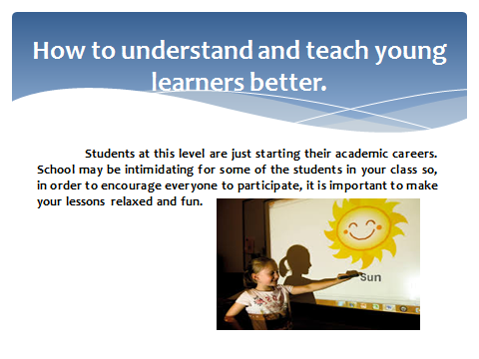
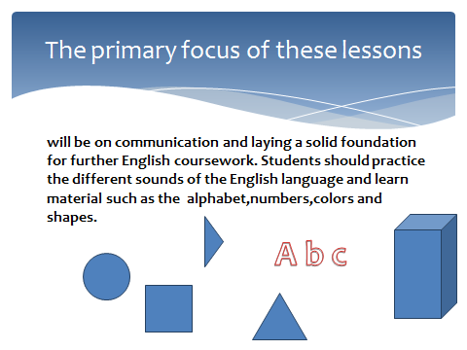

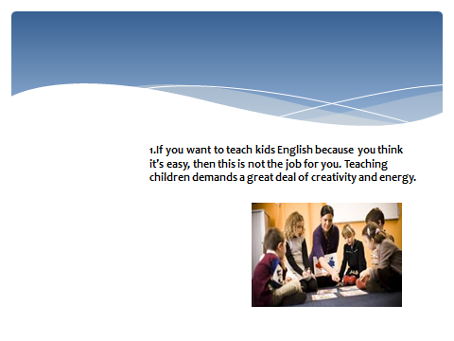
Lesson 7
Pedagogical competence of the teacher in teaching children
Questions to be discussed:
1. Classroom management.
2. Teacher's approach.
3. Professional conduct.
Key terms: competency in science, young learners, subject, classroom management, teacher's approach, language production, professional conduct.
Before we determine the professional skills expected of teachers, we must define the term “competent teacher”. Thus, in particular, competent teachers are teachers who deploy their knowledge, abilities, skills, talents, values, attitudes and behavior patterns to meet the challenge of educating their students. They possess the professional skills needed and adequate to perform their assigned duties and attain the educational goals that the law requires.
Competency is the conscious use of one's own knowledge, abilities, skills, talents, values, attitudes and behavior patterns, in order to resolve issues and problems, overcome challenges, fulfilling one's duties and achieving the aims proposed.
Teachers’ competency in science means the teachers’ conscious use of their cognitive abilities in order to acquire, deploy and manage the knowledge specific to the field, subject or topic in which they specialize and to their knowledge of teaching. It involves skill at searching, processing, evaluating, assimilating, integration and use of information and knowing as well as reflection, research and knowledge creation.
Teaching competency means knowing how to combine goals, contents, activities, methodology, materials, resources and assessment in order to ensure that one's students acquire the prescribed basic sets of skills. Seven aspects of teaching competency can be distinguished. They are outlined below:
• Designing curricula. • Applying teaching methods specific to certain fields, subjects and topics. • Methodology and activities. • Diversity awareness. • Classroom management (learning space). • Curriculum resources and materials. • Assessment.
Competency in group harmony management. Teachers’ competency in managing group dynamics means their conscious use of their abilities, knowledge, values, attitudes and behavior patterns to encourage an enabling educational environment within the school, fostering an appropriate relationship in order to attain the educational goals the school has set. This implies that teachers must be capable of resolving issues and problems arising from community life and that may ensue from personal relationships among members of the educational community. Skill at: • Maintaining leadership by encouraging enthusiasm, interest and effort. • Plan, manage and resolve conflicts or issues. • Create a suitable emotional atmosphere. • Drive group efforts and create environments characterized by mutual trust and respect. • Early detection of problems.
Competency in innovation and improvement is the practical application of new ideas, proposals and educational practices in order specifically to improve, the development of students’ skills and the educational system in general. Every innovation implies changes and induces a quest for betterment. We should combine effectiveness, efficiency and authenticity for innovations to succeed.
The main requirements to the FL specialists are followings: the information, cultural and professional literacy. Cultural literacy is communicative culture on the FL as a set of personal communicative properties and skills characterized by conventions, norms and requirement for professional communication. Communicative culture fulfills the following functions: informative, affective, regulative, motivational and reflexive. Information literacy is closely connected with cultural one. It includes the following skills: 1) to define the possible sources of information and strategies for its searching; 2) to analyze the received information and to fix it with the help of schemes, tables, words, etc.; 3) to evaluate the information from the position of reliability, precision, sufficiency; 4) to realize the need in additional information and to receive it if it is possible; 5) to use the results of the searching process for analysis and evaluation of the information; 6) to create the new solution; 7) to see alternative ways of problem-solving; 8) to be ready to interact with colleagues, to take the critics and the advices and offers.
Becoming a foreign language teacher means becoming a member of a professional community. In turn, becoming a member of a community means acquiring the common knowledge and shared values of that community. Beginning teachers should aim to acquire the following:
1. A knowledge of the spoken and written language.
2. A knowledge of how language in general is put together.
3. A knowledge of pedagogy.
These three types of knowledge translate into different professional abilities. For example, the first knowledge area means that the teacher can speak and write the foreign language with a high level of proficiency. The second knowledge area implies that the teacher can explain the workings of grammar and vocabulary to naive learners in a way that is both logical and informative. The third knowledge pedagogy is crucial for putting things into practice. In other words, applying this knowledge to your own classroom means knowing how to create an environment conducive to learning. Currently, what professional activities do you participate in? How often do you talk to other teachers about your own teaching? Where do you get new ideas for your classroom practice? What does it mean to be a professional? What does it mean to "professionalize" the field of foreign language teaching? A foreign language professional understands that he or she is a member of a larger "community of practice," that is, a group of people who share interests, values and behaviors. According to Lave and Wenger (1991), two cognitive anthropologists who coined the term community of practice, it is through the sharing of information and experience that individuals develop themselves personally and professionally. In fact, to be a professional requires the teacher to take part in activities outside his or her classroom such as attending workshops or conferences. Finally, to be a professional requires that the teacher keep up-to-date by reading about recent pedagogical developments currently, what professional activities do you participate in? How often do you talk to other teachers about your own teaching? Where do you get new ideas for your classroom practice?
Professional literacy of FL teachers includes the following components: 1) linguistic (lexical, grammatical, and phonetic); 2) communicative (speaking, listening, reading, writing); 3) lingo-cultural; 4) social-cultural; 5) subjective (informative-thematic, conceptual) and 6) methodological.
Humanitarian approach has become priority in organization of teaching and further development of the modern education. The main attention here focuses on the individuals’ interests, needs and their intellectual potential. Under these conditions the topical matter for teachers is to choose the suitable and effective methods and aids of teaching which can provide to achieve the purpose of the education.
Be prompt and punctual because promptness and punctuality lead to systematic work.
You are bound by the virtue of your professional growth to change and modify your approach to fit the ever-changing factors in the fields of learning and teaching. Therefore, seek the best ways to improve and brush up your English.
Evaluate your teaching tactics occasionally through self-criticism, which is highly constructive and leads to perfection.
Question:
1. Give appropriate definition of the term “Competence”.
2. Speak about teacher`s approaches.
3. Classroom management.
ТHEME №7 | Pedagogical competence of the teacher in teaching children
Model of teaching
Time – 2 h. | Number of students from 15 to 25
Plan of the lesson | 1. Classroom management.  2 .Teacher's approach.  3. Professional conduct. Teaching primary level children. Main requirements in teaching.
Aim of the lesson: Teacher’s approach in teaching, to explain innovative technologies in FLT.
Tasks of the lesson:
- To define the term “Classroom management.”
- To clarify the term “primary level”
- To explain the importance of innovative technologies in FLT
Methods of teaching |  | Discussion, dispute
Form of teaching |  | Group
Means of teaching |  | Projector, text of lesson
Place of teaching |  | Classroom;
Type of assessment |  | Oral answering
Pedagogical technology |  | Expert list, brainstorming.

TECHNOLOGICAL MAP OF THE LESSON
 | Teacher | Student
Stages | - Prepares for the content of the lesson.  - Prepares slides for the lesson.  - Gives the list of used literature.
1. Introduction (15 min) | 1.1. Name of the lesson key-words and plan.  1.2. Explains aims and tasks of the lesson.  1.3. Asks questions in order to recall previous knowledge. | Listens and reads  Answers to the questions
2. Main stage(50 min) | 2.1. Gives the main part of the theme, demonstrates and explains all the key-words and theoretical part.  2.2. Explains the role of teaching in primary level.  2.3. Names main requirements for up-to-date FL teachers  2.4.Explains importance of using innovative technologies during the FLT | Listens and writes
3. Conclusion  (15 min) | 3.1. Answers to the students questions  3.2. Gives sources of additional information, makes conclusion. | Asks questions. Writes tasks.

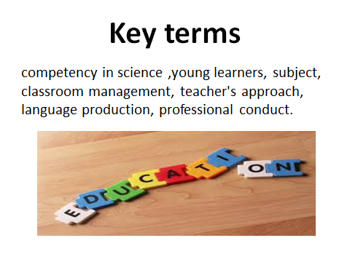

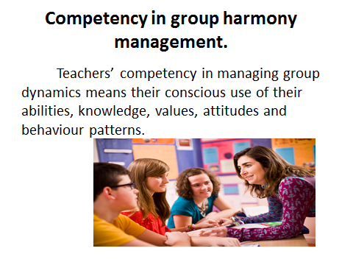

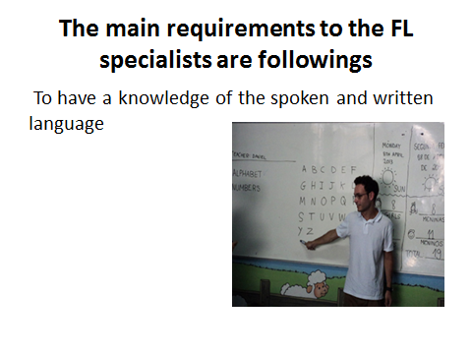
Lesson 8
Classroom management and teacher's approach
Questions to be discussed:
1. What is the presentation of language?
2. What professional skills are needed?
3. Will the creativity give the best result?
Key terms: competency in science, young learners, subject, classroom management, teacher's approach, language production, professional conduct
Create a relaxed atmosphere in the classroom to achieve full student participation. Discipline and firmness are of paramount importance especially when students practice group work. The friendly relationship between you and the class has its vital impact on the students' attitude towards learning the language.
Be creative because much of the teacher's success depends upon his/her imaginative power, originality and creativity. Teaching is more an art than a science. Be an example of a good planner and organizer. By doing so, you encourage your students to develop their planning and organizational abilities.
Preparing the lessons regularly and adequately makes you surefooted in the classroom. It sets your mind at ease and makes you realize the main aim of the lesson. Do not over-plan. Make your lesson plan brief, informative, clear and purposeful. Include various activities to suit the individual differences in the classroom. Be active. An active teacher means an active lesson. Avoid being indifferent because this creates a sort of boredom in the classroom.
Make your lesson enjoyable because the ability to enjoy is the key to effective learning. Remember that what one learns through enjoyment, one never forgets and its effect on the memory never fades. Lack of interest means lack of response.
Language production
Involve your students in authentic communication situations, which encourage a continuous flow of speech. In fact, the acquisition of the language depends on practicing it naturally.
Give your students every possible chance to use the language. Talk as little as possible to give the students the opportunity to interact. Do not over teach. Make the lesson student centered, not teacher centered. Teach the language in appropriate social contexts. Relate the word to a sentence, the sentence to a situation and the situation to real life. Use the teaching media properly to make the lesson more attractive and perceptive. They save time and effort. Use effective means to eradicate errors. Always look at what they have achieved rather than at what they have failed to achieve.
Be accurate in evaluating your students' achievement. The marks given should be in conformity with the real standard of the class.
2. Advices for effective teaching
If you want to influence learners for good, you should not only love to teach; you should love each person you teach. As you show your love for those you teach, they become more open to learning from you and more aware of their eternal worth. Seek to understand those you teach. As you do, you will be better able to teach lessons that meet individual needs. Search for ways to help new members and those who have been less active feel welcome in your class. Invite them to come, and introduce them to other class members. Invite them to participate by asking them questions you know they can answer and otherwise helping them feel comfortable in class.
Do all you can to know class members’ interests and needs?
Learn class members’ names and call them by name.
Listen attentively to class members and express sincere appreciation for their participation.
No teacher should fall into a monotonous pattern of presenting the same kind of lesson week after week. When you teach with variety, learners tend to understand gospel principles better and retain more. As you strive to choose effective teaching methods, ask yourself: Will the method invite the Spirit? Will the method help learners better understand the gospel principle? Will the method invite students to participate in the lesson? Will the method make the best use of time?
It is important to begin your lesson in a way that prepares others to learn. You can do such things as present an object lesson, write questions on the board, or have someone read a story or scripture.
It is also important to conclude your lesson in a way that invites learners to live what they have learned. You can review the main principles taught and ask learners how to apply them, ask an individual to summarize the main points of the lesson, and bear testimony of the principles.
As a gospel teacher, you should do all you can to create an atmosphere that contributes to learning. Preparing a comfortable and inviting classroom is important to encouraging learning. Helping class members respect you and each other will also contribute to a learning atmosphere.
One of the most important things you can do is to promote reverence. Begin by being a good example of reverent behavior. Set limits that define what behavior is acceptable and unacceptable in your class. If you teach children, take time to explain clearly what reverent behavior is. Using music in the lessons you teach will help learners feel reverent.
If you have students who disrupt your lessons, seek to understand why they are being disruptive and pray for the Spirit’s guidance. Try to help the person participate in positive ways, and if necessary speak privately with the person. As you seek to resolve the problem, do all you can to show the person you care about him or her.
- Make sure the classroom is neat and organized.
- Encourage learners to respect you and each other by inviting them to listen to others, speak in turn, and respond positively to others’ comments.
- To encourage reverence, prepare your lessons carefully so that there is little confusion and you can vary your lesson as necessary to restore a reverent atmosphere.
- When learners are disruptive, move closer to them or invite them to participate in the lesson
What methods can I use to teach an effective lesson?
3. Classroom activities for teaching a foreign language
There are many methods that can be used to teach the gospel. You should select methods carefully, always keeping in mind the principles you are teaching and the needs of the learners. Teaching provides the following teaching methods:
ActivityVerses | Likening
ApplicationTechniques | Maps
AttentionActivities | Memorization
AudiovisualMaterials | Music
Brainstorming | MusicwithNarratives
BuzzSessions (SmallGroups) | PanelDiscussions
CaseStudies | PaperStand-UpFigures
Chalkboards | Pictures
ChoralReadings | Puppets
ComparisonsandObjectLessons | Readers’ Theaters
Demonstrations | Recitations
Diagrammes | RolePlaying
Dramatizations | RollerBoxes
DrawingActivities | Scriptures, Teachingfrom
Examples | Stations
FlannelBoards | Stories
Games | Visuals
GuestSpeakers | WorkSheets
Question:
1.What is the presentation of language?
2.What professional skills are needed?
3.Will the creativity give the best result?
4.What techniques will we use?
5.What methods can I use to teach an effective lesson?
6.Should the lesson plan be informative ,brief, purposeful?
ТHEME №8 | Classroom management and teacher's approach
Model of teaching
Time – 2 h. | Number of students from 15 to 25
Plan of the lesson | 1. Classroom management.  2 .Teacher's approach.  3. Professional conduct. Teaching primary level children. Main requirements in teaching.
Aim of the lesson: Teacher’s approach in teaching, to explain innovative technologies in FLT.
Tasks of the lesson:
- To define the term “Classroom management.”
- To clarify the term “primary level”
- To explain the importance of innovative technologies in FLT
Methods of teaching |  | Discussion, dispute
Form of teaching |  | Group
Means of teaching |  | Projector, text of lesson
Place of teaching |  | Classroom;
Type of assessment |  | Oral answering
Pedagogical technology |  | Expert list, brainstorming.

TECHNOLOGICAL MAP OF THE LESSON
 | Teacher | Student
Stages | - Prepares for the content of the lesson.  - Prepares slides for the lesson.  - Gives the list of used literature.
1. Introduction (15 min) | 1.1. Name of the lesson key-words and plan.  1.2. Explains aims and tasks of the lesson.  1.3. Asks questions in order to recall previous knowledge. | Listens and reads  Answers to the questions
2. Main stage(50 min) | 2.1. Gives the main part of the theme, demonstrates and explains all the key-words and theoretical part.  2.2. Explains the role of teaching in primary level.  2.3. Names main requirements for up-to-date FL teachers  2.4.Explains importance of using innovative technologies during the FLT | Listens and writes
3. Conclusion  (15 min) | 3.1. Answers to the students questions  3.2. Gives sources of additional information, makes conclusion. | Asks questions. Writes tasks.

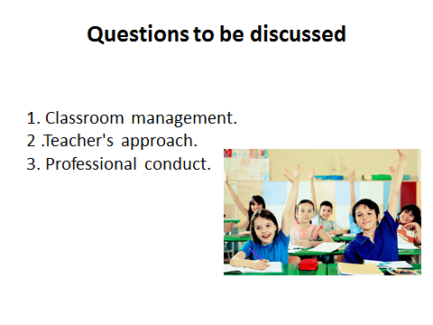


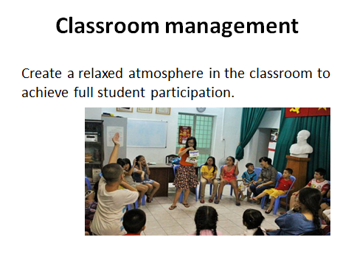

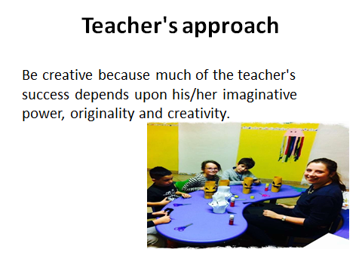

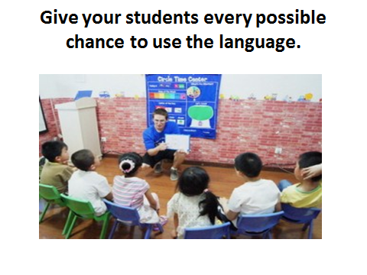
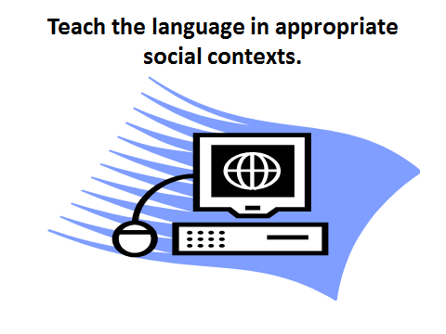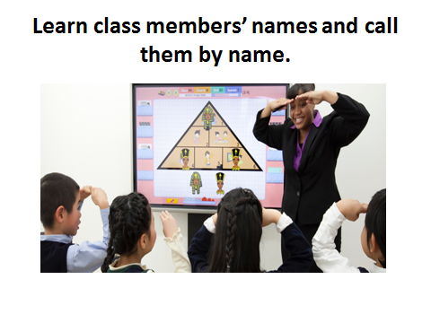
Lesson 9
LESSON PLANNING

Questions to be discussed:
1. Principles of lesson planning
2. Structure of the EL lesson plan
3. Materials and equipment
Key terms: stages of the lesson, types of the lesson, forms of classroom interaction, approaches to organizing the lesson, language atmosphere, types of plans.
Principles of lesson planning
A teacher should be able to identify an overall purpose or goal that he will attempt to accomplish by the end of the class period. This goal may be quite generalized, but it serves as a unifying theme for him. Thus, in the sample lesson plan, understanding telephone conversation generally identifies the lesson topic.
Objectives
It is very important to state explicitly what a teacher wants students to gain from the lesson. Explicit statements will help to:
a) be sure that you indeed know what it is you want to accomplish
и) preserve the unity of your lesson
с) predetermine whether or not you are trying to accomplish too much
в) to evaluate students’ success at the end of the lesson.
Objectives are the most clearly captured in terms of stating what students will do. However, many language objectives are not overtly observable and therefore you may need to depart from strictly behavioral terms for some objectives.
We distinguish between terminal and enabling objectives. Terminal objectives are final learning outcomes that you will need to measure and evaluate. Enabling objectives are steps that build upon each other and lead to a terminal objectives.
For example, terminal objective: students will successfully request information about airplane arrivals and departures
Enabling objectives: students will comprehend new vocabulary on this topic, read and understand airline schedules, produce appropriate polite forms of requesting.
Materials and equipment
All things which are used by teachers and students in teaching process are called materials and equipment. Here we can list text-books, dictionaries, newspapers, magazines, chalk, blackboard, charts, schemes, pictures, cards, etc. Technical equipment includes computers, tape recorder, cameras, video recorders, DVD players, TV, projectors, Internet sources, etc. it is important to know how and when to use this or that teaching material.
Procedures
A foreign language lesson should consist of the following steps:
1) Organization moment – when a teacher notes presence of students, asks the date, day, weather, and other question to open the lesson – usually up to 5 minutes
2) Warming up – any game or revision activity which loads students with a new energy and readiness for a lesson – 5-10 minutes. As the class begins, give students a broad outline of the day’s goals and activities so they know what to expect. Help them focus by eliciting their existing knowledge of the day’s topics.
Use discussion or homework review to elicit knowledge related to the grammar and language use points to be covered
Use comparison with the native language to elicit strategies that students may already be using. Use discussion of what students do and/or like to do to elicit their knowledge of the topic they will address in communication activities
3) Checking home task – individual or frontal – 10-15 minutes.
4) Explaining new material - a teacher explains new grammar rule or topic with the help of board, charts, pictures or other techniques - 15-20 minutes
5) Practice of new material– takes place with the help of text-books, exercises, tasks, questions, debates, etc. – 15-20 minutes
6) Extra class activity - independent work of students when the can demonstrate their integrated skills. For example, a short presentation, dialogue, group work or crossword, game or pair works. - 10-15 minutes
7) Evaluation – evaluation need to be a separate part of a lesson when a teacher concludes the results of students’ success by giving the marks. Evaluation can be oral or in written form and should be just. Motivation is also very important in evaluation as it inspires students for better learning – up to 5 minutes
8) Home task assessment – a teacher should explain home task, write it on the board. The volume of home task depends on the age, level of students and period of time between this lesson and the next one - 2-3 minutes
9) End of the lesson – a teacher and students say ‘good bye’ to each other and the lesson is over.
There are different principles of lesson planning. The most important among them are variety, flexibility, examining the subject matter from the learners’ point of view, considering individual differences, language backgrounds and past experience.
1. Variety means involving learners in a number of different types of activities and using a wide selection of material to motivate learners.
2. Flexibility comes into play, when dealing with the plan in the classroom, for a number of reasons a teacher should have an opportunity to change the plan in accordance with the situation which can take place during teaching.
3. Examination of the subject matter from the learners’ point of view – the teacher should examine teaching material and reveal its appropriateness to learners and difficulties for acquiring this material by learners. During planning a teacher adapt material and defines ways of overcoming these difficulties.
4. Consideration of individual differences presupposes that learners have different abilities to learn the language under apparently the same conditions of learning. This fact should be taking into consideration in planning. This principle is known in the domestic methodology as individualization and differentiation of teaching.
5. Language backgrounds and past experience – before designing a teacher should reveal what prior knowledge, abilities and skills the learners have.
Designing the lesson and outlining its plan is an essential part of the teaching process. All EL teachers – regardless of training, experience, or competency – need a carefully drawn lesson plan in order to assist their learners in attaining learning objectives, both on a daily basis as well as the long-term. Having a lesson plan is like having a complete and clear visualization of how a learning session is to take place and how learners are able to grasp and retain the lesson concepts.
If a teacher is new to teaching, a lesson plan is basically just a step-by-step guide on how the teacher intends to present a lesson and the ways by which learners are expected to learn and appreciate the lessons various concepts. An excellent lesson plan is one that can be easily and effectively used by another teacher in a job place. This means that the ideal lesson plan is both clear and comprehensive.
Unless a specific lesson plan format is required by the learning type of institution, most EL practitioners tailor their lesson plans according to the teaching philosophies or techniques they believe in or are most comfortable with.
Questions:
1. What steps should a foreign language lesson consist of?
2. How much does the teacher explain new grammar rule or topic with the help of board, charts, pictures or other techniques?
3. Organization moment – what does a teacher usually ask to open the lesson up to 5 minutes?
4. What teaching materials or equipments do you know?

ТHEME №9 | LESSON PLANNING
Model of teaching
Time – 2 h. | Number of students from 15 to 25
Plan of the lesson | 1.Principles of lesson planning  2.Structure of the EL lesson plan  3. Materials and equipment
Aim of the lesson: Principles of lesson planning, to explain innovative technologies in FLT. Materials and equipment.
Tasks of the lesson:
Structure of the EL lesson plan
- To clarify the term “lesson plan”.
- To explain the importance of innovative technologies in FLT.
Methods of teaching |  | Discussion, dispute
Form of teaching |  | Group
Means of teaching |  | Projector, text of lesson
Place of teaching |  | Classroom;
Type of assessment |  | Oral answering
Pedagogical technology |  | Expert list, brainstorming.

TECHNOLOGICAL MAP OF THE LECTURE
 | Teacher | Student
Stages | Prepares for the content of the lesson.  Prepares slides for the lesson.  Gives the list of used literature.
1. Introduction (15 min) | 1.1. Name of the lesson, key-words and plan.  1.2. Explains aims and tasks of the lesson.  1.3. Asks questions in order to recall previous knowledge. | Listens, reads.  Answers to the questions
2. Main stage(50 min) | 2.1. Gives the main part of the theme, demonstrates and explains all the key-words and theoretical part.  2.2. Explains the role of teaching in primary level.  2.3. Names main requirements for up-to-date FL teachers  2.4.Explains importance of using innovative technologies during the FLT | Listens, reads and writes
3. Conclusion  (15 min) | 3.1. Answers to the students questions  3.2. Gives sources of additional information, makes conclusion. | Asks questions. Writes tasks.

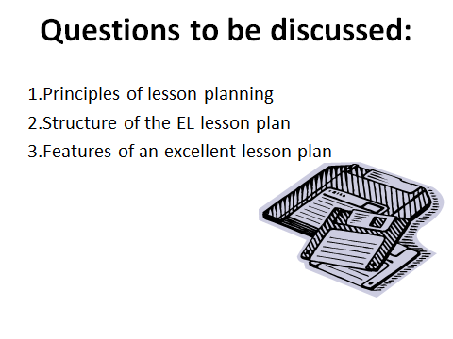

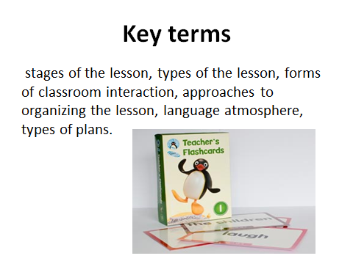

Lesson 10
Features of an excellent lesson plan
Questions to be discussed:
1. Principles of lesson planning
2. Structure of the EL lesson plan
3. Features of an excellent lesson plan
Key terms: stages of the lesson, types of the lesson, forms of classroom interaction, approaches to organizing the lesson, language atmosphere, types of plans.
In general, however, excellent EL lesson plans have common characteristics that a teacher should integrate in his/her own teaching strategies:
1) Ideal lesson plans have a concise summary that fits on a single page. The detailed plan proper may – and often – exceeds this number, but the idea is to allow anyone to have a quick overview of the lesson.
2) Great lesson plans are organized in a way that is easy and a delight to follow.
3) Lesson plans should be strongly aligned with the needs and learning competencies of their intended audience.
4) Each individual lesson plan should adhere to a continuity of lesson concepts and should not only fit in the curriculum but also reflect the overall vision of the subject.
5) EL Lesson plans should establish platforms for learners to apply language learning to real-world situations.
In EL education lesson plans are crucial even in purely conversational classes. In order to establish an environment that encourages high quality learning and draws non-native speakers to articulate themselves extensively, adequate preparation is of paramount importance. Having a haphazardly designed plan is also inexcusable.
The most important for teachers is to define aims and objectives of a lesson. At the beginning of the lesson planning a teacher should answer the following questions: 1) what language and speech material will students learn within this lesson? 2) What do they know and are able or unable to do before the beginning of the lesson and what results they are able to achieve at the end of the lesson?
A lesson is normally devoted to more than one type of activity, and teachers often have a “script” or preferred sequence that they follow when teaching a particular type of a lesson (speaking, listening, reading or writing lessons). A common lesson sequence found in many traditional language classes consists of a sequence of activities referred to as PPP and other approaches.
In communicative language teaching lessons often begin with accuracy-based activities and move toward fluency-based activities.
Reading lessons often follow a format consisting of Pre-reading, While-reading, and Post-reading activities. Listening lessons follow a similar format.
Conversation lessons often begin with controlled practice activities, such as dialogue practice, and move toward open-ended activities, such as role plays. Lessons based on a task-based approach often follow a sequence consisting of Pre-task activities, a task cycle, the language focus, and a Follow-up task.
The lesson sequence depends on principles such as “easier before more difficult activities,” “receptive before productive skills,” or “accuracy activities before fluency activities.” Planning a lesson a teacher should handle the transitions between the different sequences of the lesson.
The closing phase of a lesson is also an important part of a lesson sequence. Ideally, it should leave the students with a feeling that they have successfully achieved the goal they set for themselves or that had been established for the lesson, and that the lesson was worthwhile and meaningful. At the end of a lesson, it is usually valuable to summarize what the lesson has tried to achieve, to reinforce the points of the lesson, to suggest a follow-up work as appropriate, and to prepare students for what will follow. It is always important to praise the students for their effort and performance. During the closing stage, students may raise issues or problems that they would like to discuss or resolve; at this time, a teacher may also encourage them to ask him/her for suggestions concerning how they can improve.
Planning for transitions involves thinking about how the momentum of the lesson will be maintained during a transition – for example, while moving from a whole-class activity to a group-work activity; another issue that teachers need to consider is what students should do between transitions – for example, if some students complete an activity before the others.
Teachers generally enjoy their time in the classroom, and teaching from one perspective is a kind of performance. One way of increasing the amount of students’ participation during a lesson is to vary the grouping arrangements that a teacher uses; in this way, the teacher does not always dominate the lesson. The use of pair work and group work is one method that has been shown to ensure that students participate actively at a lesson.
Some examples of lesson plans on several skills.

Entry 1 Listening task
The theme: Domestic animals
Learning outcomes
By the end of the lesson pupils will be able
- to name the domestic animals
- to practice activities for developing listening skills
Target language
- Key language: a dog, a cow, a horse, a pig, a duck, a chick
- Several activities can be designed using one listening passage.
Plan
1 | Warmer | Introducing with the names of the domestic animals in FL | 2 min | Flashcards  Handout 1
2 | Listen, say and point | eliciting the names of the animals and pointing to them in the flashcards | 4 min | Flashcards  Handout 1
3 | Listen and sing | Practicing an activity for developing listening skills | 10min | CD, Tape-recorder
4 | Listen and circle | Checking pupils’ listening skills | 4 min | Flashcards  Handout 2
5 | A Game “What’s missing” | Checking pupils’ comprehension and revising the learned words. | 4 min | Flashcards  Handout 1
6 | Home assignment | Drawing the animals | 1 min | none
Warmer
Objective: to help pupils saying the names of domestic animals in English
Time: 2 minutes
Materials: Flashcards (a dog, a horse, a pig, a duck, a chick)
Interaction: individual, the whole class
Procedure:
- Warmer: Try to elicit the words a dog, a cow, a horse, a pig, a duck and a chick by making their sounds. Pupils say the names of domestic animals in their mother tongue.
- Each time after saying a correct word show the picture of the animals.
For example:
T: Which animal says “vow, vow”?
PP: It or sobaka. And so on. Then repeat for other animals.
Presentation:
Teach the animals using the flashcards. Show each flashcard in turn and elicit or say the word. Pupils repeat. Put the flashcards on the blackboard. Make a circling motion with your hands. Say “They are domestic animals”. Ask the pupils to repeat the words after you: a dog, a dog, a dog. And so on.
Activity 1 Listen, say and point.
Objectives: to elicit the names of domestic animals in English and point them
Time: 4 minutes
Materials: Flashcards (a dog, a horse, a pig, a duck, a chick)
Interaction: group work.
Procedure:
- Listen, say and point. Make groups in five. For example. Give five coloured pieces of paper to each pupil (white, pink, blue, green, red). Say “Who has white colour of the paper make one group” and so on.
- Give the flashcards of the animals to each group.
- Say “Listen and point”. Say “a dog”. Pupils point to the flashcard of a dog. And so on.
Activity 2 Listen and sing.
Objectives: Practicing the activity for developing listening skills
Time: 10 minutes
Materials: CD, tape-recorder
Interaction: Group work and the whole class.
Procedure:
- Listen and sing. Ask the pupils to listen to the CD and point the animals. Play the CD. Pupils listen and point to the animals.
- Play the CD again in small sections. Pupils repeat.
- Play the whole CD again. Teach the song to the pupils. When pupils know the song, they repeat the whole song altogether.
CD 1
Old MacDonald had a farm, e-i-e-i-o
And on his farm he had a cow, e-i-e-i-o
With a moo-moo here and a moo-moo there
Here a moo there a moo, everywhere a moo-moo
Old MacDonald had a farm, e-i-e-i-o
Old MacDonald had a farm, e-i-e-i-o
And on his farm he had a pig, e-i-e-i-o
With an oink-oink here and an oink-oink there
Here an oink, there an oink, everwhere an oink-oink
Old MacDonald had a farm, e-i-e-i-o
Old MacDonald had a farm, e-i-e-i-o
And on his farm he had a duck, e-i-e-i-o
With a quack-quack here and a quack-quack there
Here a quack, there a quack, everywhere a quack-quack
Old MacDonald had a farm, e-i-e-i-o
Old MacDonald had a farm, e-i-e-i-o
And on his farm he had some chickens, e-i-e-i-o
With a cluck-cluck here and a cluck-cluck there
Here a cluck, there a cluck, everywhere a cluck-cluck
Old MacDonald had a farm, e-i-e-i-o
Old MacDonald had a farm, e-i-e-i-o
Activity 3 Listen and circle.
Objectives: Checking pupils’ listening skills
Time: 4 minutes
Materials: Flashcards of the animals (Card 1.a dog and a cow, Card 2. a horse and a duck, Card 3. a duck and a chick, Card 4. a pig and a dog, Card 5. a horse and a chick.)
Interaction: Individual and group work.
Procedure:
- Listen and circle. Distribute flashcards to the groups. In each group one pupil takes one card.
- Say “Listen and circle”. Say “Card 1. A dog.”. The pupil who has a Card 1.(with the picture a dog and a cow) circles a dog. If the pupil hesitates the other members of the group help him. And so on.
Activity 4 A Game. “Who is missing?”
Objectives: Checking pupils’ comprehension and repeating the learned words.
Time: 4 minutes
Materials: Flashcards of the animals (a dog, a cow, a horse, a pig, a duck, a chick)
Interaction: Individual, the whole class or group work.
Procedure:
- A Game. “Who is missing?” The teacher puts the flashcards of the animals on the blackboard.
- The teacher asks the pupils to close their eyes and takes away one of the animals from the blackboard.
- Then the teacher asks the pupils to open their eyes and find out which animal is missed from the blackboard.
- Pupils can say individually or the whole class or they can discuss in the group then say. (It depends on the teacher). If they call the right name of the animal the teacher shows the picture of the animal to the class. And so on.
- Encourage your students with scores or cards for their giving right answer.
Home assignment:
Ask the pupils to draw the animals. (a dog, a cow, a horse, a pig, a duck, a chick)
Reference:
Songs :http:// kids-songs. tv/free music.com
Old Mac Donald had a farm.
Additional songs about animals: http:// kids-songs. tv/free music.com
Mary had a little lamp. / Baa-baa black sheep.

Pictures: a cow, a horse, a pig - http://www.123rf,com
A duck: http://www. robertjacksonbennett.wordpress.com
A chick:- http://www.artsyesque.wordpress.com
A dog: http://www.animal.discovery.com
2 TASK


Cards 


New words: a sheep, a cock, a dog, a horse , a goat
http://www.eslkidslab.com/flashcards/set2/animalcards/animalcardsmallsized.pdf
Handout 1

 |  | 
 |  | 
 |  | 
 |  | 
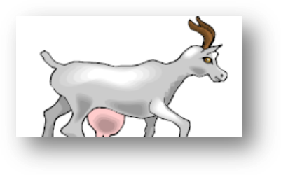 |  | 

http://www.eslkidslab.com/flashcards/set2/animalcards/animalcardsmallsized.pdf

Handout 2

http://www.anglomaniacy.pl/songs.htm ; http://www.anglomaniacy.pl/wordgames.htm

Entry 2 Reading Task
The Theme: Domestic animals
Learning outcomes
By the end of the lesson pupils will be able
- to practice new vocabulary about domestic animals
- to practice activities for developing reading skills
Target language
- Key language: a rooster, a goat, a sheep, a horse and a dog.
- Several activities can be designed using one reading passage.
Plan
1 | Look, point and say | Eliciting the names of the domestic animals in English | 8 min | Flashcards
2 | Count and say | Developing pupils reading skills | 6 min | Handout
3 | Match the animals and the colors | Practicing revising the previous materials | 4 min | Handout
4 | Match the parts of the body of animals | Checking pupils’ comprehension and revising the learned words. | 5 min | Handout 1
5 | Home assignment | Coloring the animals. | 2 min | Handout 2

Activity 1 Look and point.
Objective: to help pupils saying the names of the domestic animals in English
Time: 8 minutes
Materials: Flashcards, handout. (a rooster, a goat, a sheep, a horse and a dog).
Interaction: individual, the whole class
Procedure:
- Look and point. Teach or elicit the words: a dog, a sheep, a horse, a goat, a rooster using the flashcards. Show each flashcard and say the word clearly. Pupils repeat.
- Display the flashcards on the blackboard. Point to each one in turn. Elicit the word. Pupils say the words in chorus.
- Make a circling motion with your hands. Say “They are domestic animals”.
- Ask pupils to look at the activity one. Go to several pupils’ desks point to the animals and ask the pupils to say the names of the animals.
- Divide pupils in two groups and ask them to stay in a row near the blackboard. Explain them when you say one of the animal’s name the first pupils from the rows must run to the blackboard and point to the picture. Demonstrate the game. Say “a dog” and point to the picture of a dog.
- Show the pictures on the blackboard and say; “a sheep.” Which group’s pupils point the pictures correctly and show more pictures they are the winners.
Activity 2. Count and say.
Objectives: Developing pupils reading skills
Time: 6 minutes
Materials: Handout
Interaction: individual work, pair work.
Procedure:
- Count and say. Practice with the whole class the numbers from 1 to ten. Say the pupils they should work individually.
- Ask the pupils to count the animals. Give the pupils more thinking time but don’t elicit the answers. Remind them that the plural of sheep will be sheep and the plural of dog will be dogs. One dog, two dogs, three dogs and etc. Repeat. one sheep, two sheep, three sheep and etc.
- Make new pairs. Tell pupils to sit facing one another, holding their handouts. Pupils work in pairs and take it in turns to ask about amounts of animals. Pupils check together their answers.
Activity 3. Match the animals and colours.
Objectives: Practicing revising the previous materials
Time: 4 minutes
Materials: Handout
Interaction: individual work, pair work.
Procedure:
- Match the animals and the colors. Revise the colors with the pupils. Ask pupils: “What color is it?” Check comprehension by asking “What color is the dog?”
- Demonstrate the game. Match one animal and the colour.
- Ask pupils to work individually and match the animals and colours.
- Ask pupils to work in pairs. Pupils check their answers in pairs. Check around the class.
Activity 4. Match the animals and the parts of the body.
Objectives: Developing pupils reading skills.
Time: 5 minutes
Materials: Handout 1.
Interaction: individual work, pair work.
Procedure:
- Match. Demonstrate the game. Match one animal and the parts of its body.
- Ask pupils to work individually and match the animals and parts of their bodies.
- Ask pupils to work in pairs. Pupils check their answers in pairs. Check around the class.
- Encourage your students with scores or cards for their giving right answer.
Home assignment:
Ask the pupils to colour the animals. Handout 2 (a dog, a goat, a horse, a sheep, a rooster). Demonstrate the activity if necessary.

References:
http://www.eslkidslab.com/flashcards/set2/animalcards/index.html
http://h2g2.com/approved_entry/A782516
http://www.anglomaniacy.pl/domesticAnimalsDictionary.htm.
Teachers:
InogamovaKlara
YusupovaDilrabo.
Entry 4 Lesson planning
The theme: Have you got a … ?
Learning outcomes
By the end of the lesson pupils will be able
- To speak about domestic animals
- To ask and answer about domestic animals
- To develop their oral speech
Target language
- Key language: a dog, a cow, a horse, a cat, a duck, a hen
- I have got a …. Have you got a …? Yes, I have /No, I haven’t.
Plan
1 | I have got a … | Reminding the pupils about the structure “I have got a … .” | 5 min | Flashcards
2 | Listen and sing | Practising the activity for developing listening skills | 5 min | CD, Tape-recorder
3 | Chain Drill | Introducing with the structure “Have you got a … ?” | 15min | Flashcards
4 | Listen and circle | Checking pupils’ listening and writing skills | 6 min | Handout 1
5 | A Game “Have you got a…?” | Checking pupils’ comprehension and revising the learned words. | 10 min | Handout 1
6 | Home assignment | Drawing the animals | 4 min | none

Activity 1 I have got a ….
Objectives: to revise the names of domestic animals and the structure “I have got a ….”
Time: 5 minutes
Materials: Flashcards (a dog, a horse, a cow, a duck, a hen)
Interaction: individual, the whole class
Procedure: I have got a … .The teacher revises all the animals from the previous lesson.
Teacher shows the picture of a horse and says: It is a cow. Pupils: No, it is a horse. Then teacher shows the picture of a goat and says: It is a duck. Pupils: No, it is a goat. Then teacher shows the picture of a hen and says: It is a hen. Pupils: Yes, it is a hen. And so on.
Then the teacher says to one pupil “I have got a dog. What about you?” The pupil answers, “I have got a dog too”. Then the teacher comes to another pupil and says “I have got a cow. And you?” The pupil answers “No. I have got a cat.”In this way the teacher revises the structure “I have got a ….”
Activity 2 Listen and sing.
Objectives: to develop pupils speaking skills
Time: 5 minutes
Materials: CD, tape-recorder
Interaction: the whole class and individual work.
Procedure:
- Listen and sing. Listen and sing. Play CD. Ask the pupils to listen to the tape-recorder attentively.
- Ask the questions: “What kind of animals can you see?”, “What color is the horse?” and so on.
Activity 3 Chain Drill. Have you got a …?
Objectives: to introduce pupils with the question form of the structure “Have you got a …?”
Time: 15 minutes
Materials: flashcards
Interaction: the whole class and individual work.
Procedure:
- Have you got a …? The teacher introduces the new phrase: Have you got a …? Teacher shows a picture of a goat and says to the class “I have got a goat. Have you got a goat?” Pupils: No. Teacher shows a picture of a chick and says to the class “I have got a chick. Have you got a chick?” Pupils: No.
- Teacher repeats this question with other subjects. S/he comes to the several pupils and asks: Have you got a book? Have you got a pen? Have you got a pencil? Some pupils say Yes. Some of them say, No.
- Then teacher asks pupils to play Chain Drill again.
P 1: I have got a horse. Have you got a horse? P 2: No, I have got a goat. Have you got a cow? P3: Yes. Have you got a duck? …
Activity 4 Listen and circle.
Objectives: to develop pupils speaking and writing skills
Time: 6 minutes
Materials: Handout
Interaction: pair work
Procedure:
- Listen and circle. The teacher tells the animals names and the pupils circle the animal which they have had.
Activity 5 Have you got a …?
Objectives: to develop pupils speaking and writing skills
Time: 10 minutes
Materials: Handout
Interaction: pair work
Procedure:
- Have you got a …. The teacher asks pupils to work in pairs. S/he distributes handouts to the pupils and says that one row of animals for the one pupil and the other row for this pupil’s partner.
The pupil asks a question looking at the animal on the first row (horse).
1st pupil: Have you got a horse?
2nd pupil: No.
1st pupil: Have you got a chick?
2nd pupil. Yes.
In this way the 1st pupil finishes his/her questions. Then his/her partner begins asking questions looking at the second row animals.
2nd pupil: Have you got a cow?
1st pupil: Yes.
2nd pupil: Have you got a duck?
1st pupil: No. And so on.
Home assignment.
Draw your favorite animal. Questions:
1. What features of EL lesson can you say about?
2. What do we mean by the cycle of lessons?
3. What are requirements claimed to the FL lesson organization?
4. Does the lesson plan help you to organize effectively teaching process?

ТHEME №10 | FEATURES OF AN EXCELLENT LESSON PLAN
Model of teaching
Time – 2 h. | Number of students from 15 to 25
Plan of the lesson | 1.Principles of lesson planning  2.Structure of the EL lesson plan  3.Features of an excellent lesson plan
Aim of the lesson: Principles of lesson planning, to explain innovative technologies in FLT. Features of an excellent lesson plan.
Tasks of the lesson:
- Main features of an excellent lesson plan.”
- To clarify the term “lesson plan”.
- To explain the importance of innovative technologies in FLT.
Methods of teaching |  | Discussion, dispute
Form of teaching |  | Group
Means of teaching |  | Projector, text of lesson
Place of teaching |  | Classroom;
Type of assessment |  | Oral answering
Pedagogical technology |  | Expert list, brainstorming.

TECHNOLOGICAL MAP OF THE LECTURE
 | Teacher | Student
Stages | Prepares for the content of the lesson.  Prepares slides for the lesson.  Gives the list of used literature.
1. Introduction (15 min) | 1.1. Name of the lesson, key-words and plan.  1.2. Explains aims and tasks of the lesson.  1.3. Asks questions in order to recall previous knowledge. | Listens, reads.  Answers to the questions
2. Main stage(50 min) | 2.1. Gives the main part of the theme, demonstrates and explains all the key-words and theoretical part.  2.2. Explains the role of teaching in primary level.  2.3. Names main requirements for up-to-date FL teachers  2.4.Explains importance of using innovative technologies during the FLT | Listens, reads and writes
3. Conclusion  (15 min) | 3.1. Answers to the students questions  3.2. Gives sources of additional information, makes conclusion. | Asks questions. Writes tasks.

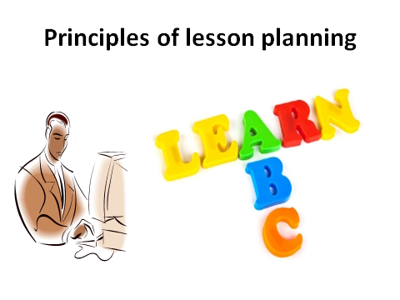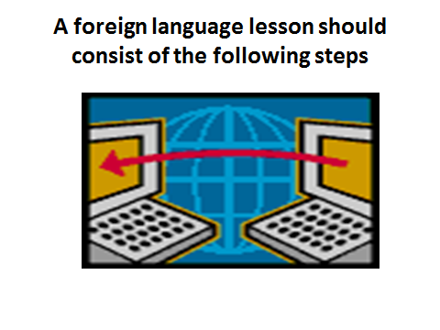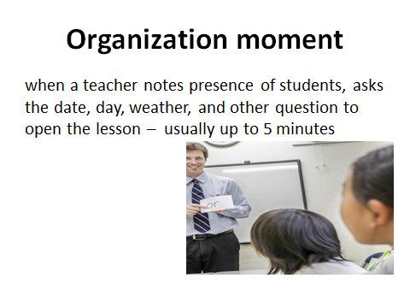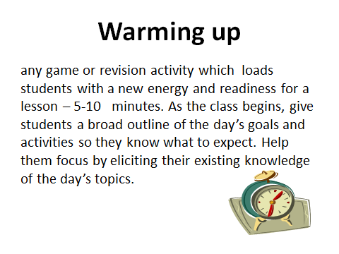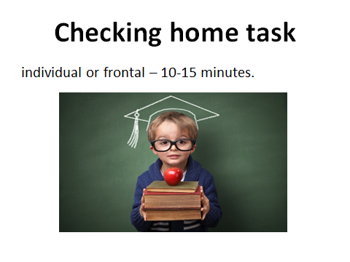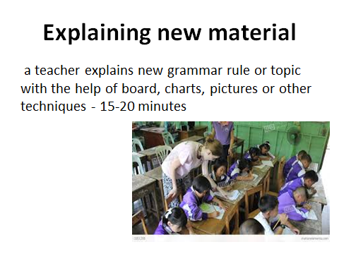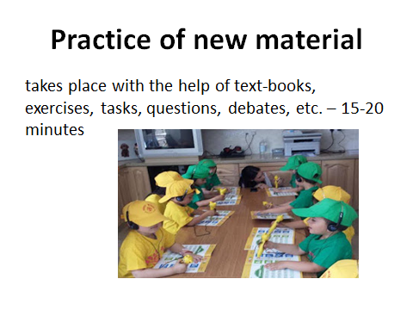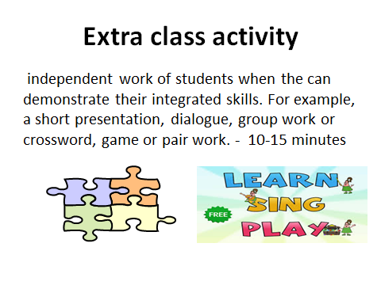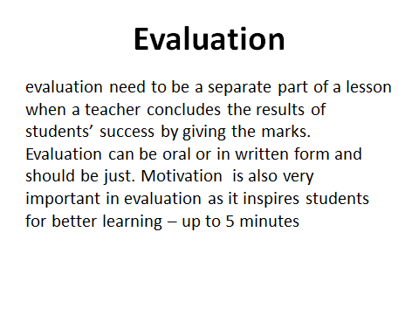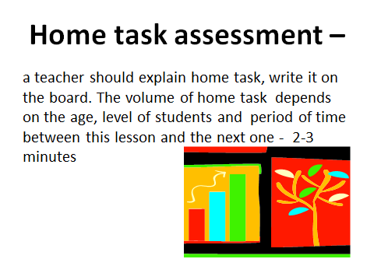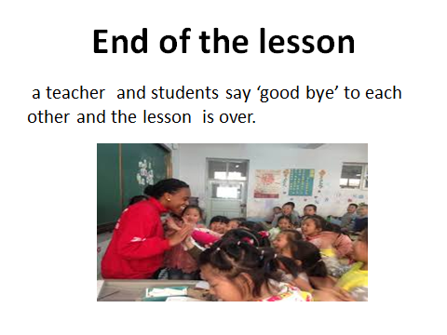
Lesson 11
Teaching language through the songs, poems and games
Questions to be discussed:
1. Identification of the problem
2. Problem formulation
3. How teachers can teach children.
Key terms: song, learn language, skills, learning by games, lesson, literacy instruction, basic abilities and skills.
Children love to sing songs. Think about the time when you were a child. What was your favorite song? What songs did you learn at home and at school? Traditional children’s songs introduce children to the world around them. They do this in a fun and developmentally appropriate way. In the US, preschool age kids learn about farm animals like cows, ducks and sheep as well as their sounds, like moo moo, quack quack, and baa baa through the popular, traditional song Old MacDonald Had a Farm.
Without realizing it, children learn language and content simultaneously. Songs build skills that help children distinguish the sounds of a language, and connect sound to script and assist with vocabulary building.
It is no surprise, then, that English language programs for young children frequently use songs to enhance language and literacy instruction.
So, do kids around the world always have to sing about Old MacDonald to learn about farm animals in English? It is a new approach for teaching English thro Learning is one of the primary activities of students in the classroom. Successful learning is only on the right way to lead the process. Good learning atmosphere and method can guide the students to learn more and meaningful. To accomplish such condition, teachers must create varitype and attractive methods for the class.
What should a teacher do if their students get bored? Using varitype games can be an alternative solution to handle this problem. Games, as a matter of fact, can help and encourage many students to sustain their interest and work.
There is a common perception that all learning should be serious and solemn in nature and that if one is having fun and there is hilarity and laughter, then it is not really learning. This is a misconception. It is possible to learn a language as well as enjoy oneself at the same time. One of the best ways of doing this is through games. Games can help the teachers to create contexts in which the language is useful and meaningful. In the whole process of teaching and learning by games, the students can take part widely and open-mindedly. To win the games each student or group should competitively answer the questions addressed by the teacher or other students or groups. In order to do so they must understand what the teacher or others are saying or have written, and they must speak or write in order to express their own point of view or give info. Again, there are lots of different games out there that can be used in the classroom. Be creative and have fun! Ensuring your students have the necessary instructions and practice before starting any activity will make it more enjoyable and beneficial for your students.
Learning is one of the primary activities of students in the classroom. Successful learning is only on the right way to lead the process. Good learning atmosphere and method can guide the students to learn more and meaningful. To accomplish such condition, teachers must create varitype and attractive methods for the class.
What should a teacher do if their students get bored? Using varitype games can be an alternative solution to handle this problem. Games, as a matter of fact, can help and encourage many students to sustain their interest and work. By this paper, the writer wants to share experiences about “how to teach English vocabulary using games”.
There is a common perception that all learning should be serious and solemn in nature and that if one is having fun and there is hilarity and laughter, then it is not really learning. This is a misconception. It is possible to learn a language as well as enjoy oneself at the same time. One of the best ways of doing this is through games.
Games can help the teachers to create contexts in which the language is useful and meaningful. In the whole process of teaching and learning by games, the students can take part widely and open-mindedly. To win the games each student or group should competitively answer the questions addressed by the teacher or other students or groups. In order to do so they must understand what the teacher or others are saying or have written, and they must speak or write in order to express their own point of view or give information
The English instruction in elementary school is intended to endorse the mastery and development of the four basic abilities and skills. Those are reading, writing, speaking and listening as reflected in abilities and skill concerning language use so that the students are able to express simple expression with emphasis our vocabulary mastery in order to avoid to vocabulary infraction and attain better out comes, the teacher should choose an appropriate teaching method, which is suitable with subject matter in teaching learning process. The need to use various instructional media will be able to help students to increase their English vocabulary.
Teaching vocabulary is clearly more than just presenting new words. It also includes a decision that words should teach the basic of how frequent they are used by speaker of the language. The words are most commonly used are those a teacher should teach first.
But commonly and usually the way of teaching makes the students lazy and bored. The teacher needs something different to make students interested, mostly children, because they are very easy to get bored. Therefore, teacher needs something interesting which can make motivate them. It is based on the characteristics and attitude of the children that they are curious and often seeks something that the teacher notices them and shows appreciation for what they are doing. So, to motivate them teacher needs something new that can stimulate their curiosity.
With the current analysis on communication in teaching language, using games appears to hold a solution for many teachers. The communication activities somehow involves in a varied use of language.
It had been found in many schools, teacher use games activities as their teaching aid. The students really appreciate any kind of activities which provide excitement and fun. It will be easy to understand and practice of English. The writer chooses games as the simple illustrated media to facilitate students’ method of learning, as we know children learn while playing games. It is easy to be understood and comprehended by students.
However, learning English vocabulary using games has an importance role for elementary teachers and students. The first, as students, they have strong and good motivation to deepen English language. The second, they are easy to accept the English language because they learn by playing games that nowadays has been grown and developed in Indonesia. The third, teaching English vocabulary using games can help teacher in teaching learning process. Finally, they (teacher and students) can teach and learn English vocabulary using games.
Today, many games are in our environment from traditional games up to modern one. They (games) have influenced on children life, not only positive effect but also the negative one. Playing games are something enjoyable for students. So many students spend their time, just to play something useless with their friends and even they forget their duty as student.
But playing games as one of educational media is very important for English students and English teacher through playing games; teacher can teach vocabulary by playing games, so children / students can understand and absorb English language easily.
Problem formulation
Based on the background and the identification problem, the problems can be formulated as follows:
How does the teacher teach English vocabulary-using games?
Are there the advantages by using games in teaching English Vocabulary?
Objectives of problem
Based on the problem formulation above, the object of problem can be formulated below:
To explain the teacher teaches English vocabulary using games.
To explain the advantages by using games in teaching English.
Benefits of study
For the teachers and the students and anyone else who are involved in teaching learning English as an international language, they could use the research finding as a source for their instruction in the teaching – learning process.
The English instruction in elementary school is intended to endorse the mastery and development of the four basic abilities and skills. Those are reading, writing, speaking and listening as reflected in abilities and skill concerning language use so that the students are able to express simple expression with emphasis our vocabulary mastery in order to avoid to vocabulary infraction and attain better out comes, the teacher should choose an appropriate teaching method, which is suitable with subject matter in teaching learning process. The need to use various instructional media will be able to help students to increase their English vocabulary.
Teaching vocabulary is clearly more than just presenting new words. It also includes a decision that words should teach the basic of how frequent they are used by speaker of the language. The words are most commonly used are those a teacher should teach first.
But commonly and usually the way of teaching makes the students lazy and bored. The teacher needs something different to make students interested, mostly children, because they are very easy to get bored. Therefore, teacher needs something interesting which can make motivate them. It is based on the characteristics and attitude of the children that they are curious and often seeks something that the teacher notices them and shows appreciation for what they are doing. So, to motivate them teacher needs something new that can stimulate their curiosity. With the current analysis on communication in teaching language, using games appears to hold a solution for many teachers. The communication activities somehow involves in a varied use of language.
It had been found in many schools, teacher use games activities as their teaching aid. The students really appreciate any kind of activities which provide excitement and fun. It will be easy to understand and practice of English. The writer chooses games as the simple illustrated media to facilitate students’ method of learning, as we know children learn while playing games. It is easy to be understood and comprehended by students.
However, learning English vocabulary using games has an importance role for elementary teachers and students. The first, as students, they have strong and good motivation to deepen English language. The second, they are easy to accept the English language because they learn by playing games that nowadays has been grown and developed in Indonesia. The third, teaching English vocabulary using games can help teacher in teaching learning process. Finally, they (teacher and students) can teach and learn English vocabulary using games.
Questions:
1. How much does the teacher explain new grammar rule or topic with the help of board, charts, pictures or other techniques?
2. What does teaching provide?
3. When learners are disruptive, move closer to them or invite them to participate in the lesson?
4. What is a good teacher?
ТHEME №11 | Teaching language through the songs, poems and games
Model of teaching
Time – 2 h. | Number of students from 15 to 25
Plan of the lesson | 1. Identification of the problem  2. Problem formulation  3. How teachers can teach children.
Aim of the lesson: Principles of teaching language by the songs, poems and games using innovative technologies in FLT. Features of teaching children.
Tasks of the lesson:
- Main features of teaching language by the songs, poems and games.
- To clarify the term “innovative technologies”.
- To explain the importance of innovative technologies in FLT.
Methods of teaching |  | Discussion, dispute
Form of teaching |  | Group
Means of teaching |  | Projector, text of lesson
Place of teaching |  | Classroom
Type of assessment |  | Oral answering
Pedagogical technology |  | Expert list, brainstorming.

TECHNOLOGICAL MAP OF THE LESSON
 | Teacher | Student
Stages | Prepares for the content of the lesson.  Prepares slides for the lesson.  Gives the list of used literature.
1. Introduction (15 min) | 1.1. Name of the lesson, key-words and plan.  1.2. Explains aims and tasks of the lesson.  1.3. Asks questions in order to recall previous knowledge. | Listens  Answers to the questions
2. Main stage(50 min) | 2.1. Gives the main part of the theme, demonstrates and explains all the key-words and theoretical part.  2.2. Explains the role of teaching in primary level school.  2.3. Names main requirements for up-to-date FL teachers  2.4.Explains importance of using innovative technologies during the FLT | Listens, reads and writes
3. Conclusion  (15 min) | 3.1. Answers to the students questions  3.2. Gives sources of additional information, makes conclusion. | Asks questions. Writes tasks.

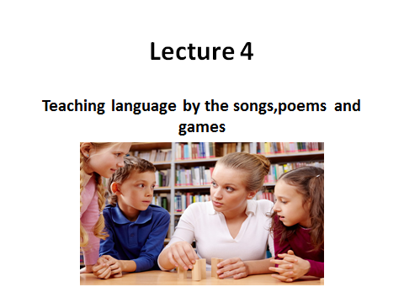

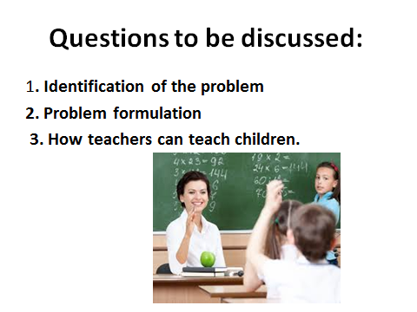

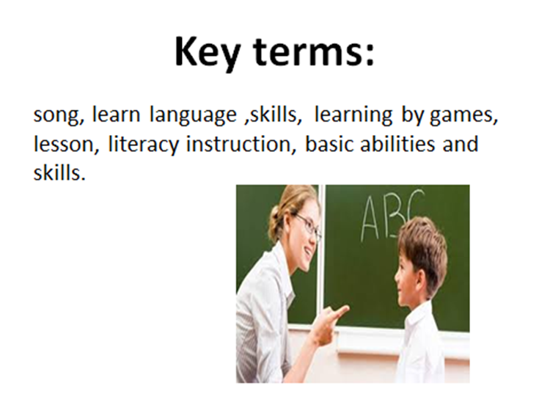

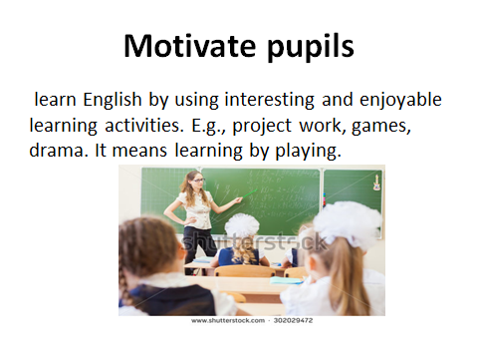

Lesson 12
The use of Games
Questions to be discussed:
1. Methods of teaching by games.
2. Choose appropriate songs.
3. Methods of teaching foreign languages.
Key terms: song, learn language, skills, learning by games, lesson, literacy instruction, basic abilities and skills.
To increase the vocabulary we need media to be used. One of them is game. The definition of game is an activity that you do to have some fun (Hornby; 1995; 486). Games can make the students more focus in learning, because they do not feel that they are forced to learn.
Games can lower anxiety, thus making the acquisition of input more likely (Richard-Amato, 1988; 147). They are highly motivating and entertaining, and they can give the students more opportunity to express their opinion and feelings (Hansen; 1994; 118). They also enable learners to acquire new experiences within a foreign language which are not always possible during a typical lesson. Games can be media that will give many advantages for teacher and the students either.
The useful of games are attract the student to learn English because it is fun and make them want to have experiment, discover and interact with their environment (Lewis,1999) other useful of games are:
Games add variation to a lesson and increase motivation by providing a plausible incentive to use the target language. For many children between four and twelve years old, especially the youngest, language learning will not be the key motivation factor. Games can provide this stimulus. (Lewis, 1999).
The game context makes the foreign language immediately useful to the children. It brings the target language to life. (Lewis, 1999).the games make the reason for speaking plausible even to reluctant children. (Lewis, 1999)
Through playing games, students can learn English they way children learn their mother tongue without being aware they are studying; thus without stress, they can learn a lot.
Even shy students can participate positively.
Moon (2000) suggests a positive learning environment:
Make your classroom a lively place through the use of attractive wall displays, displays of pupils’ work, a bool corner, etc. language classroom is noisy with the language (English) is good because it will make the classroom more alive in English (practice)
Motivate pupils to want to learn English by using interesting and enjoyable learning activities. E.g., project work, games, drama. It means learning by playing.
Create warm and happy atmosphere where teacher and pupil enjoy working together. Teacher arranges good atmosphere in classroom and make the students interested.
Help pupils to develop personal reasons for learning English. For example by encouraging out-of –school class activities, e.g. pen friends, project, reading story books.
Some instructions to teachers for teaching children to play games.
Make learning English enjoyable and fun-remember you are influencing their attitude to language learning. (Lower as affective filter). It means teacher has to try in order to students are having fun in learning (learning by playing). Remember teacher is influencing their attitude to language learning
Do not worry about mistakes. Be encouraging – make sure children feel comfortable, and not afraid to take part. It means teacher does not blame directly to students, teacher must give support to students while repaired their mistakes.
Use a lot of gestures, actions, pictures to demonstrate what you mean. It means teacher has to try to accompany her explanation with media in order to students understand easily. Don’t force the students to use the language directly, just give them examples by gestures
Talk a lot to them in English, especially about things they can see. Teacher must teach them by using English, especially about anything in their surroundings.
Play games, singsongs, say rhymes and chants together. It means teacher has skills in playing games, singsong etc to make them enjoy and interest in learning.
Tell simple theories in English, using pictures, acting with different voices.
Do not worry when they use their mother tongue. You can answer a mother tongue question in English, and sometimes recast in English what they say in their mother tongue. It means if the students use their mother tongue, the teacher translate to English and repeat again, again and again to make them always remember what teacher means.
Constantly recycle new language but do not be afraid to add new things or to use words they will not know. Teacher gives new language while remember the last topic.
Plan lesson with varied activities, some quiet, some noisy, some sitting, some standing and moving, it means teacher must demonstrate his teaching with several activities (moiling teaching), sometimes teacher sit, stand up in front of or behind the students.
Teaching English vocabulary-using games
Language learning is hard work. Effort is required at every moment and must be maintained over a long period. Games help and encourage many learners to sustain their interest and work.
Games also help the teacher to create contexts in which the language is useful and meaningful. The learners want to take part and in order to do so must understand what others are saying or have written, and they must speak or write in order to express their own point of view or give information.
The need for meaningfulness in language learning has been accepted for some years. A useful interpretation of meaningfulness is that the learners respond to the content in a definite way. If they are amused, angered, intrigued or surprised the content is clearly meaningful to them. Thus, the meaning of the language they listen to, read, speak and write will be more vividly experienced and, therefore, better remembered.
There are many kinds of games which can be used in teaching English. Of course, as a technique games need help from media. The media can be picture, flash cards, object, puppet, cassette, projector and many others object surround them. It is better if the games are familiar for children, because they learn in a variety of ways, for example; by watching, by listening, by imitating and by doing things. It means children learn their knowledge through what they see, heard in their surrounding and then imitate it and imitating by doing things (children learn by doing)
Children can generally imitate the sounds they hear quite accurately and copy the way adults speak. It means they do imitation, memorization, practice and over learning, what the people are said
Bruner says that language is the most important tool for cognitive growth and he also investigate how adults can help the children to solve their problem. Scaffolding is Bruner’s theory, it means that scaffolding is explaining to students and interacting to students to communicate, in scaffolding is holistic and must permeate all aspects of scientific teaching, if we answer.
So, teaching vocabulary-using games as methodology in learning – teaching process and the teaching materials for children which is related with their surround, it means the vocabulary which related and introducing things surround them such as family names, naming of alphabet, name of number,etc.
Questions:
  - How teachers can teach children using games?
  - Speak about core of games during the teaching process.
  - What kind of media can be used in teaching children?
ТHEME №12 | THE USE OF GAMES
Model of teaching
Time – 2 h. | Number of students from 15 to 25
Plan of the lesson | 1. Identification of the problem  2. Problem formulation  3. How teachers can teach children.
Aim of the lesson: Principles of teaching language by games using innovative technologies in FLT. Features of teaching children.
Tasks of the lesson:
- Main features of using games.
- To clarify the term “innovative technologies”.
- To explain the importance of innovative technologies in FLT.
Methods of teaching |  | Discussion, dispute
Form of teaching |  | Group
Means of teaching |  | Projector, text of lesson
Place of teaching |  | Classroom
Type of assessment |  | Oral answering
Pedagogical technology |  | Expert list, brainstorming.

TECHNOLOGICAL MAP OF THE LESSON
 | Teacher | Student
Stages | Prepares for the content of the lesson.  Prepares slides for the lesson.  Gives the list of used literature.
1. Introduction (15 min) | 1.1. Name of the lesson, key-words and plan.  1.2. Explains aims and tasks of the lesson.  1.3. Asks questions in order to recall previous knowledge. | Listens  Answers to the questions
2. Main stage(50 min) | 2.1. Gives the main part of the theme, demonstrates and explains all the key-words and theoretical part.  2.2. Explains the role of teaching in primary level school.  2.3. Names main requirements for up-to-date FL teachers  2.4.Explains importance of using innovative technologies during the FLT | Listens, reads and writes
3. Conclusion  (15 min) | 3.1. Answers to the students questions  3.2. Gives sources of additional information, makes conclusion. | Asks questions. Writes tasks.

презентациялар

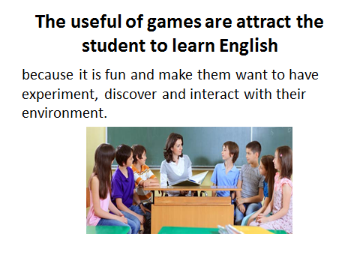

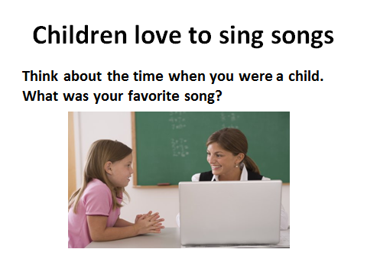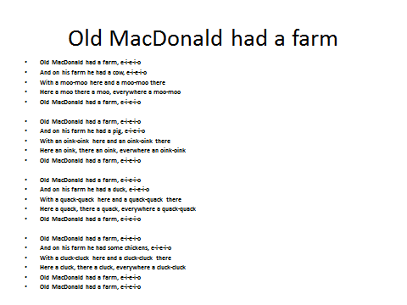
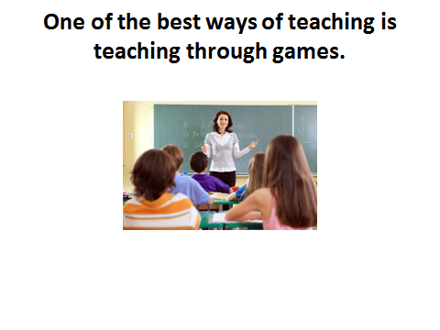
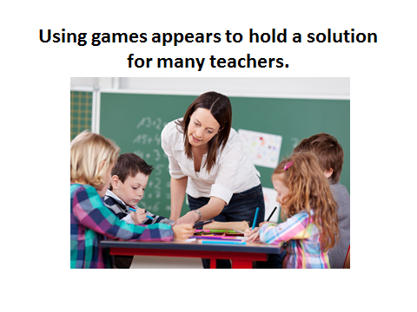

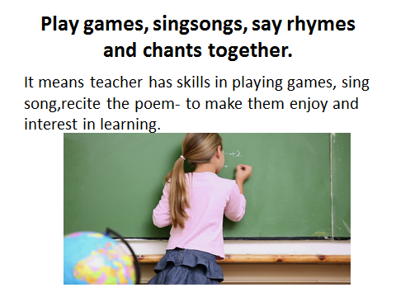
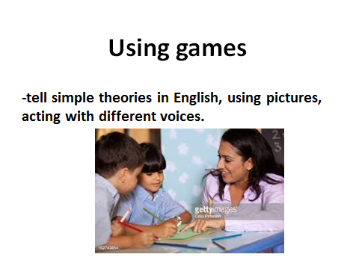
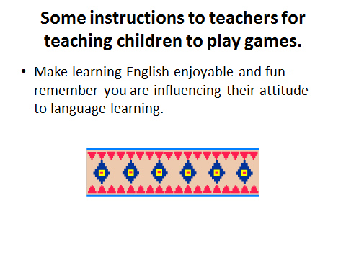
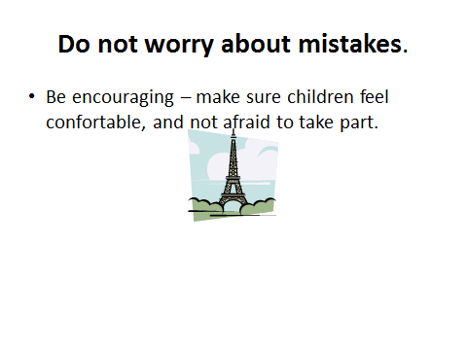
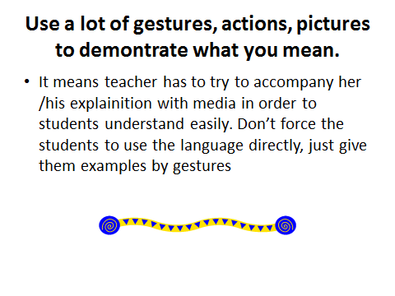
Lesson 13
Teaching language through the games. Types of games.
Questions to be discussed:
1. Importance of games in teaching.
2. How to use games?
3. The usage of vocabulary by the help of the games.
Key terms: game, the process, varitype and attractive methods, to get bored, instructional media, to motivate.
Learning is one of the primary activities of students in the classroom. Successful learning is only on the right way to lead the process. Good learning atmosphere and method can guide the students to learn more and meaningful. To accomplish such condition, teachers must create varitype and attractive methods for the class.
The English instruction in elementary school is intended to endorse the mastery and development of the four basic abilities and skills. Those are reading, writing, speaking and listening as reflected in abilities and skill concerning language use so that the students are able to express simple expression with emphasis our vocabulary mastery in order to avoid to vocabulary infraction and attain better out comes, the teacher should choose an appropriate teaching method, which is suitable with subject matter in teaching learning process. The need to use various instructional media will be able to help students to increase their English vocabulary.
Teaching vocabulary is clearly more than just presenting new words. It also includes a decision that words should teach the basic of how frequent they are used by speaker of the language. The words are most commonly used are those a teacher should teach first.
But commonly and usually the way of teaching makes the students lazy and bored. The teacher needs something different to make students interested, mostly children, because they are very easy to get bored. Therefore, teacher needs something interesting which can make motivate them. It is based on the characteristics and attitude of the children that they are curious and often seeks something that the teacher notices them and shows appreciation for what they are doing. So, to motivate them teacher needs something new that can stimulate their curiosity. With the current analysis on communication in teaching language, using games appears to hold a solution for many teachers. The communication activities somehow involves in a varied use of language.
It had been found in many schools, teacher use games activities as their teaching aid. The students really appreciate any kind of activities which provide excitement and fun. It will be easy to understand and practice of English. The writer chooses games as the simple illustrated media to facilitate students’ method of learning, as we know children learn while playing games. It is easy to be understood and comprehended by students.
However, learning English vocabulary using games has an importance role for elementary teachers and students. The first, as students, they have strong and good motivation to deepen English language. The second, they are easy to accept the English language because they learn by playing games that nowadays has been grown and developed in Indonesia. The third, teaching English vocabulary using games can help teacher in teaching learning process. Finally, they (teacher and students) can teach and learn English vocabulary using games.
Identification of the problem
Today’s, many games are in our environment from traditional games up to modern one. They (games) have influenced on children life, not only positive effect but also the negative one. Playing games are something enjoyable for students. So many students spend their time, just to play something useless with their friends and even they forget their duty as student.
But playing games as one of educational media is very important for English students and English teacher through playing games; teacher can teach vocabulary by playing games, so children / students can understand and absorb English language easily.
Problem formulation
Based on the background and the identification problem, the problems can be formulated as follows: 1/How does the teacher teach English vocabulary-using games?
.Are there the advantages by using games in teaching English Vocabulary?
Objectives of problem .Based on the problem formulation above, the object of problem can be formulated below:
To explain the teacher teaches English vocabulary using games.
To explain the advantages by using games in teaching English.
Types of games
1.Whole Class games
Some games such as interview activities, bingo, and board games can be played by the entire class.
- An interview activity to practice the “Where are you from?” and “I’m from ~.” structures might start by handing out slips of paper with eight to ten different country names. Students can then be given a worksheet with all the country names written on the left and told that their goal is to get a student signature for each country by mingling with their classmates and asking the target question. When asked the target question, a student should respond based on the slip of paper he received.
- Bingo can be played with numbers, letters, vocabulary words, or many other topics you may want to practice.
- Board games are often best played in small groups but if introducing a very challenging game, it may be a good idea to play as a class first. A group of students can be represented by a game piece and students can work together to answer questions. In the class following this, students can play the game in groups for further practice.
2. Games in Small Groups
There are also lots of games that can be played in groups of about four students.
- Board games where students move pieces and answer questions or form sentences based on images make for good practice activities. For practicing the “If ~, then ~.” structure a Chutes and Ladders layout may be fun for students.
- Card games such as Go Fish, Memory, and many more can be adapted for classroom use. When you are teaching comparatives, card games can be an invaluable tool. You can also use simple card games to test comprehension by making up decks of cards with letters for example. Have students spread all the cards face up on their desks, you then say a letter aloud, and the first student to slap the correct card gets to keep it. Repeat until all the cards are gone and the student with the most cards at the end of the game wins. To make this more challenging, you can tell students that if they slap the wrong card, they have to take one card out of their pile.
3. Pairwork Games
There are many of pair activities students can do to practice English but very few of them take the form of a game.
-The best and most versatile one by far is Battleship. This will take a lesson to explain and practice but once your students are familiar with it, can be played as a twenty to thirty minute activity. Battleship is best used to practice tenses. The worksheet consists of two identical seven by seven grids, one above the other. The first box in the upper left is kept blank, the first row is filled in with phrases such as “play soccer” and “study English”, and the first column is filled in with words such as “I, You, He, We, and They, The students.” Students should secretly draw their “boats” on the grid. Typically one boat should have five squares, one boat should have four squares, two boats should have three squares, and one boat should have two squares. Boats can only be drawn vertically or horizontally. On the board practice the structure that students will use for the activity for example “I played soccer. You studied English.” until every row and column has been practiced and then instruct students to say “Hit”, “Miss”, or “You sank my ship!” when appropriate just like in the original game. Students can usually play two or three times before moving on to another activity. Theoretical Review and Discussion.TheoreticalReview.The characteristic of children as learners. They are developing quickly as individuals; it means that they have difference in language acquisition.
Learn in a variety of ways, for example; by watching, by listening, by imitating and by doing things. It means children learn their knowledge through what they see, heard in their surrounding and then imitate it and imitating by doing things (children learn by doing)
Are not able to understand grammatical rules and explanations about language. Children are not understanding about the rule of language, they only imitate what they are seeing and hearing.
Try to make sense of situations by making use of non-verbal clues. Children will do imitate, it means learning by doing.
Talk in their mother tongue about they understand and do this helps them learn. It means they use their mother tongue to understand everything.
Can generally imitate the sounds they hear quite accurately and copy the way adults speak. It means they do imitation, memorization, practice and over learning, what the people are said. Are naturally curious. They have strong willingness to know what they see and hear in their surroundings. Love to play and use their imagination. It means they are learning while playing. Are comfortable with routines and enjoy repetition. It means they need habit to learn.
Have quite a short attention span and need variety. Because they are learning while playing, it is needed many ways to make them understand what the teacher means.
Questions:
1. Speak about the importance of teaching language through the games.
2. What types of games do you know?
3. What step of the lesson may consist of the game?

ТHEME №13 | Teaching language through the games. Types of games.
Model of teaching
Time – 2 h. | Number of students from 15 to 25
Plan of the lesson | 1. Importance of games in teaching.  2. How to use games?  3. Types of games.
Aim of the lesson: Principles of using games, to explain innovative technologies in FLT. Features of an excellent lesson plan.
Tasks of the lesson:
- Main features of importance of games in teaching FL”
- To clarify the term “games in teaching FL”.
- To explain the importance of innovative technologies in FLT.
Methods of teaching |  | Discussion, dispute
Form of teaching |  | Group
Means of teaching |  | Projector, text of lesson
Place of teaching |  | Classroom;
Type of assessment |  | Oral answering
Pedagogical technology |  | Expert list, brainstorming.

TECHNOLOGICAL MAP OF THE LESSON
 | Teacher | Student
Stages | Prepares for the content of the lesson.  Prepares slides for the lesson.  Gives the list of used literature.
1. Introduction (15 min) | 1.1. Name of the lesson, key-words and plan.  1.2. Explains aims and tasks of the lesson.  1.3. Asks questions in order to recall previous knowledge. | Listens  Answers to the questions
2. Main stage(50 min) | 2.1. Gives the main part of the theme, demonstrates and explains all the key-words and theoretical part.  2.2. Explains the role of teaching in primary level.  2.3. Names main important features of games in teaching  2.4. Explains importance of using innovative technologies during the lesson. | Listens, reads and writes
3. Conclusion  (15 min) | 3.1. Answers to the students questions  3.2. Gives sources of additional information, makes conclusion. | Asks questions. Writes tasks.

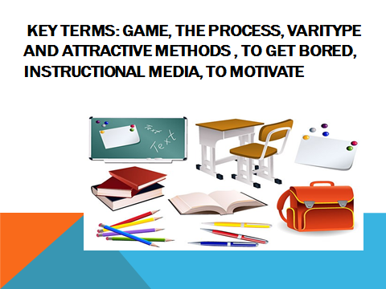

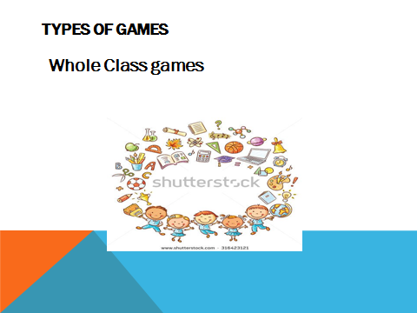

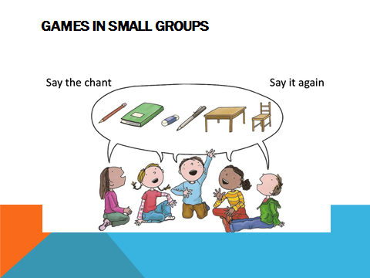

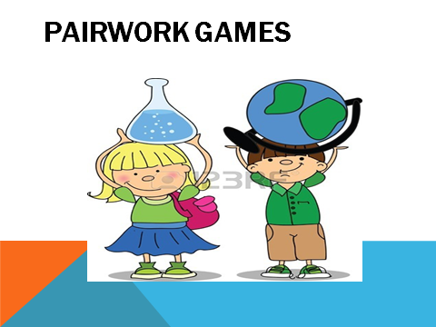

Lesson 14
The usage of vocabulary by the help of the games
Question to be discussed:
1. The usage of vocabulary by the help of the games
2. Using the words.
3. Importance of games in teaching.
Key terms: Method, the direct method, games, technology, types of games,etc.
Some steps of learning vocabulary .Having source for encountering new words.
Getting a clear image for the form of new words; Learning the meaning of new words;
Making a strong memory connection between the form and the meaning of the words.
Using the words.
In teaching to children, teacher has to use performance to teach vocabulary to them, because the children in literacy level are Performance, it means children learn language with accompanying action / scaffolding. In this level, teacher can use media, according to Nation (1990) in recited by Cameron is listed basic technique of explaining the meaning of new words by demonstration picture:
Using an object
Using a cut-out picture
Using gesture
Performance action
Photographs
Drawing and or diagram on the board
Picture from books, TV, Video or Computer
By verbal explanation:
Analytical definition
Putting in a context
Translating
The important of vocabulary
A good mastery of vocabulary helps the learners to express their ideas precisely. By having many stocks of word learners will be able to comprehend the reading materials catch other talking, give responds, speak fluently and write some kind of topics. On the contrary, if the learners do not recognize the meaning of the words use by those who address them, they will be unable to participate in conversation, unable to express some ideas, or unable to ask for information.
Considering the important of vocabulary role in learning foreign language. The mastery of this element should be ensured and develop. Otherwise, the vocabulary mastery of the children will be limited and consequence of it is that they will find difficulties in learning the skills of the language. Therefore, schools have a task to teach vocabulary to their students as suggested by John Carol as showed by Margareta MC Known (1987; 01)
Although a considerable amount of vocabulary, learning is associated with primary language learning in early years. The acquisition of most the vocabulary characteristic of an educated adult occur during the years of schooling, and infects one of the primary task of the school as far as language learning in concerned, as to teach vocabulary.
Games add variation to a lesson and increase motivation by providing a plausible incentive to use the target language. For many children between four and twelve years old, especially the youngest, language learning will not be the key motivation factor. Games can provide this stimulus. (Lewis, 1999).
The game context makes the foreign language immediately useful to the children. It brings the target language to life. (Lewis, 1999).the games make the reason for speaking plausible even to reluctant children. (Lewis, 1999)Through playing games, students can learn English they way children learn their mother tongue without being aware they are studying; thus without stress, they can learn a lot. Make your classroom a lively place through the use of attractive wall displays, displays of pupils’ work, a bool corner, etc. language classroom is noisy with the language (English) is good because it will make the classroom more alive in English (practice).
Motivate pupils to want to learn English by using interesting and enjoyable learning activities. E.g., project work, games, drama. It means learning by playing.
Create warm and happy atmosphere where teacher and pupil enjoy working together. Teacher arranges good atmosphere in classroom and make the students interested.
Help pupils to develop personal reasons for learning English. For example by encouraging out-of –school class activities, e.g. pen friends, project, reading story books.
Games encourage, entertain, teach, and promote fluency. If not for any of these reasons, they should be used just because they help students see beauty in a foreign language and not just problems that at times seem overwhelming.
Games are often used as short warm-up activities or when there is some time left at the end of a lesson. Yet, a game should not be regarded as a marginal activity filling in odd moments when the teacher and class have nothing better to do. Games ought to be at the heart of teaching foreign languages. Games are used at all stages of the lesson, provided that they are suitable and carefully chosen. Games also lend themselves well to revision exercises helping learners recall material in a pleasant, entertaining way. All authors referred to in this article agree that even if games resulted only in noise and entertained students, they are still worth paying attention to and implementing in the classroom since they motivate learners, promote communicative competence, and generate fluency.
There are many criteria games as educational media for teaching English to children:
A game must be more than just fun.
A game should involve "friendly" competition.
A game should keep all of the students involved and interested.
A game should encourage students to focus on the use of language rather than on the language itself.
A game should give students a chance to learn, practice, or review specific language material.
A game should be familiar by children.
The important things in teaching English vocabulary is how to make English learning fun for children with these excellent products
The advantages of using games in teaching English
Games have been shown to have advantages and effectiveness in learning vocabulary in various ways. First, games bring in relaxation and fun for students, thus help them learn and retain new words more easily. Second, games usually involve friendly competition and they keep learners interested. These create the motivation for learners of English to get involved and participate actively in the learning activities. Third, vocabulary games bring real world context into the classroom, and enhance students' use of English in a flexible, communicative way.
There are many advantages of using games in the classroom:
Games are a welcome break from the usual routine of the language class.
They are motivating and challenging.
Learning a language requires a great deal of effort.
Games help students to make and sustain the effort of learning.
Games provide language practice in the various skills- speaking, writing, listening and reading.
They encourage students to interact and communicate.
They create a meaningful context for language use.
Vocabulary games bring real world context into the classroom, and increase students’ use of English in a flexible, meaningful and communicative way.
Games usually involve friendly competition and they keep students interested in learning the language.
Games can help them (children) learn and hang on to new words more easily
The reasons of the writer in choosing games as educational media for teaching children are:
Games make learning fun so your class and children are willing participants and not just there because they have to be.
Playing a game has a purpose to it, an outcome, and in order to play students have to say things – they have a reason to communicate rather than just repeat things back mindlessly. Therefore, they want to know and learn more.
Students get to use the language all the time during the games
They involve a lot of repetition, and repetition is the mother of skill, it can be boring, but thanks to these games, it is fun.
How do you expect your class or children to remember vocabulary if they never use it? Repetition is the mother of skill.
The games lend themselves perfectly to quick bursts of revision. Using some of the games, you can revise a massive amount of vocabulary and grammar in a few minutes.
If you use games to revise two or three topics every lesson, as well as teach the new language, imagine how well your kids will do at exam time, and how proud you will feel.
Children have a short attention span (even more so these days with the style and pace of the media, and computer games), so injecting lively varied games into your classes to practice the language you are teaching will keep your children alert and enjoying themselves
The philosophy of encouragement incorporated into these games allows all students, including the less good ones, to gain in confidence. Usually this doesn't just mean they get better at your subject, but in all subjects. This makes everybody, including you, more motivated and optimistic, and you can really make a difference by helping your pupils have more self-esteem so they succeed in all areas of life.
You do not need many materials to play these games (in some cases you need only your regular black board or classroom props). Once you have used the games once you will need virtually no preparation time at all!
You will be able to give stimulating fun classes while keeping your evenings free for yourself and your own hobbies, family and friends.
Teaching vocabulary using games is one effective and interesting way that can be applied in any classrooms. The results of this research suggest that games are used not only for mere fun, but more importantly, for the useful practice and review of language lessons, thus leading toward the goal of improving learners' communicative competence.
The role of games in teaching and learning vocabulary cannot be denied. However, in order to achieve the most from vocabulary games, it is essential that suitable games are chosen. Whenever a game is to be conducted, the number of students, proficiency level, cultural context, timing, learning topic, and the classroom settings are factors that should be taken into account.
Games are often used as short warm-up activities or when there is some time left at the end of a lesson. In this case, a game should not be regarded as a marginal activity filling in odd moments when the teacher and class have nothing better to do. Games ought to be at the heart of teaching (foreign) languages.
Games can be used at all stages of the lesson. But teachers must be sure that games provided, are suitable and carefully selected by the teachers.
Before playing a game teachers should give attention to the number of students, proficiency level, cultural context, timing, learning topic, and the classroom settings.
Games also lend themselves well to revision exercises helping learners recall material in a pleasant, entertaining way.
Questions;
1. Speak about the importance of teaching language through the games.
2. What types of games do you know?
3. What step of the lesson may consist of the game?

ТHEME №14 | THE USAGE OF VOCABULARY BY THE HELP OF THE GAMES.
Model of teaching
Time – 2 h. | Number of students from 15 to 25
Plan of the lesson | 1. Importance of games in teaching.  2. How to use games?  3. The usage of vocabulary by the help of the games.
Aim of the lesson: Principles of using games, to explain innovative technologies in FLT. Features of an excellent lesson plan.
Tasks of the lesson:
- Main features of importance of games in teaching FL”
- To clarify the term “games in teaching FL”.
- To explain the importance of innovative technologies in FLT.
Methods of teaching |  | Discussion, dispute
Form of teaching |  | Group
Means of teaching |  | Projector, text of lesson
Place of teaching |  | Classroom;
Type of assessment |  | Oral answering
Pedagogical technology |  | Expert list, brainstorming.

TECHNOLOGICAL MAP OF THE LESSON
 | Teacher | Student
Stages | Prepares for the content of the lesson.  Prepares slides for the lesson.  Gives the list of used literature.
1. Introduction (15 min) | 1.1. Name of the lesson, key-words and plan.  1.2. Explains aims and tasks of the lesson.  1.3. Asks questions in order to recall previous knowledge. | Listens  Answers to the questions
2. Main stage(50 min) | 2.1. Gives the main part of the theme, demonstrates and explains all the key-words and theoretical part.  2.2. Explains the role of teaching in primary level.  2.3. Names main important features of games in teaching  2.4. Explains importance of using innovative technologies during the lesson. | Listens, reads and writes
3. Conclusion  (15 min) | 3.1. Answers to the students questions  3.2. Gives sources of additional information, makes conclusion. | Asks questions. Writes tasks.

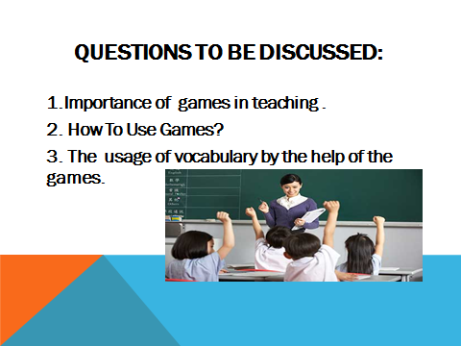

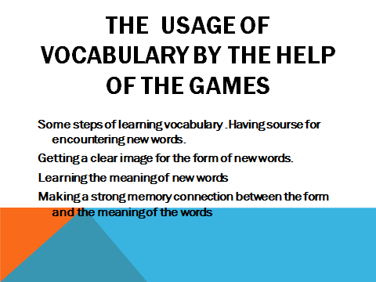
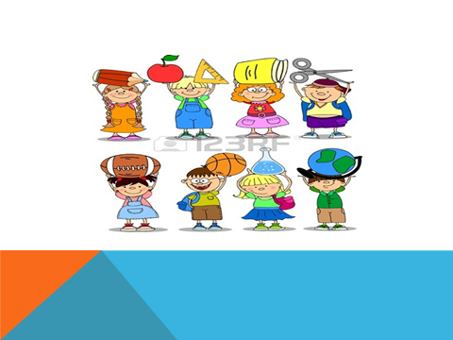

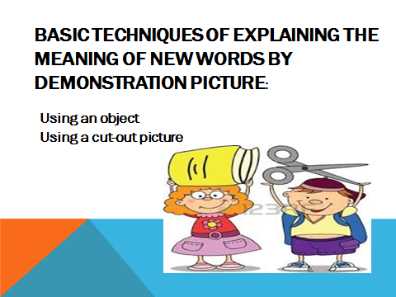

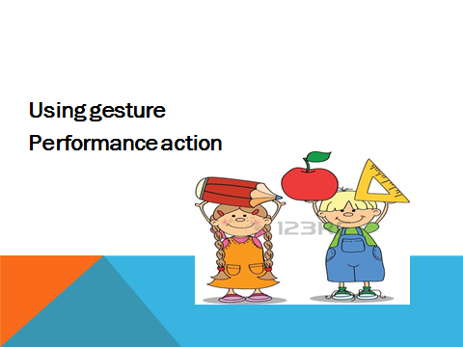

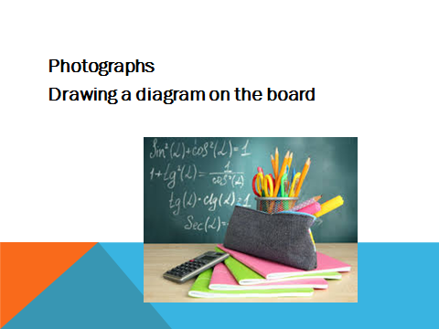

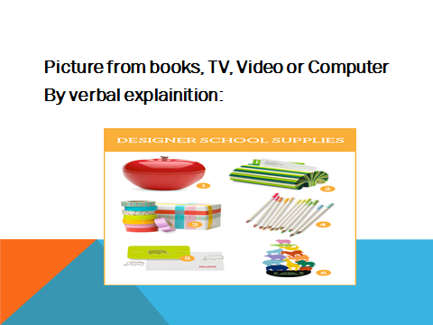

Lesson 15
Using realia, toys and games in teaching process.
Question to be discussed:
1. What is Realia?
2. Using toys and games.
Key words: Learning, song and story time, listen and watch, games, realia, teaching methods.
Learning a foreign language should be effective and enjoyable. One of the things that make foreign language teaching ineffective is due to the fact that students often have to learn words, sentence structure, and topics that they do not really need. At realia it does not happen because we custom-tailor syllabus and teaching programs to match our students needs. Yes, we design study programs that suit your individual needs through a variety of teaching methods such as reading, writing, discussions, tasks, etc.
A song and story time offers a great opportunity for children to learn and practice English! It’s much more appropriate for toddlers than a regular English class, and it’s fun for both the children and their mothers. Singing simple children’s songs that repeat words and sounds is an excellent way for international toddlers to start learning English. At first, the children will just listen and watch; but as you repeat the same song over and over, they will quickly become familiar with the language. Eventually, they will start to sing along, naturally.
To help keep young children focused, also incorporate the element of surprise into your song and story time. One easy way to do that is to use a puppet that pops out of a box or other container. Using the same puppet in each song and story time helps the children think of the puppet as their friend. They look forward to seeing their friend each week and want to talk with the puppet friend.
Ruby the Raccoon puppet ELLA story time
For story time, use stories that are short and repetitive. When possible, incorporate gestures and actions into a story. Even if the children cannot say the words yet, they will do the gestures and actions, and will begin to associate them with the words. Be sure to alternate stories with the songs to keep the children engaged.
It’s best to begin your song and story time with a play period of 15-20 minutes. During this time, the children can play with color and alphabet puzzles, blocks and other age-appropriate toys that feature English words. This playtime allows the children to become comfortable playing near other toddlers. Have the mothers speak to you, and each other, in English as their children play. By doing this, you create an environment that helps the toddlers begin to develop receptive English vocabulary and listening skills.
Key Activities for Song and Story time
1. Start your song and story time with common children’s finger play songs, such as Where is Thumbkin? The Itsy Bitsy Spider and Twinkle, Twinkle Little Star.
2. Follow these songs with a story that includes a lot of repetition. If possible, use a storybook that has peek-a-boo windows that you can slowly open. This builds anticipation and excitement for the toddlers, and they stay quite focused. I usually use the Brown Bear, Brown Bear story (Brown bear, brown and bear. What do you see? I see a (yellow duck) looking at me.) It repeats the phrase ‘What do you see?’ on each two-page spread. The children love this and after several weeks of hearing the story, they begin to say the lines as you read. (This supports teaching colors in Let’s Begin Unit 2, Let’s Learn and Let’s Learn More)
3. Now bring in the element of surprise! Children, especially toddlers, love surprises. If it’s a regular section of your lesson, they eagerly anticipate what is coming. I use a raccoon puppet that is housed in a garbage can. Before I reveal the puppet, I peek into the can and close it. Then I say something like this:
“Someone is waiting to see you! Do you remember who she is?”
(Now open the can.)
“It’s Ruby! She’s happy to see all of you!”
“Ruby, say hi to the boys and girls.”
(Ruby waves and says ‘hi’ to the boys and girls.)
“Boys and girls, can you say ‘Hi’ to Ruby?”
(The children wave and some say ‘hi’).
4. Ruby, the raccoon puppet, helps the children sing the Alphabet Song (A,B,C,D,E,F,G,etc) (Let’s Begin Unit 1 Let’s Learn to Read) and then reveals the letter of the week.
ELLASongStorytime RUBY puppet 02232015ELLA Ruby and the alphabet
5. Show realia and picture cards of objects and animals that begin with that letter.
If the letter is ‘T’, show and identify pictures of the following items:
LB LG Teddy Bear pic cardELLA LG LB Train pic cardELLA LG LB Tiger pic cardLB LG triangle pic card
a teddy bear
a train (make the sound of a train whistle)
a tiger (roar like a tiger)
a triangle (make a triangle with your hands)
Do a gesture or make a sound with each word. Have the children do it with you and say the word.
(Practice ‘What is it? from Let’s Begin Unit 1 Let’s Learn More)
Use a song and/or an activity that features the letter of the week. For the letter T:
*Show the children how to turn around as you say ‘turn around’.
*Repeat ‘turn around and have the children do it with you.
Do this several times.
*Now, do the same with ‘touch the ground’
(Let’s Begin Unit 7 Let’s Learn)
Then sing Teddy Bear, Teddy Bear
Read another short story, like Trains.
Finish up the song and story time with other songs like:
Head, Shoulders, Knees and Toes (Let’s Begin Unit 7 Let’s Learn More) and
I’m a Little Teapot (Let’s Begin Unit 6 Let’s Learn to Read).
Now is the Time to Say Goodbye is a great song for closing your Song and StoryTime.
Questions:
  - How much better will be your lesson if you use visual aids?
  - Speak about the aim of realia.
  - What is realia ?
  - Explain the core of using visual aid.
ТHEME №15 | Using realia,toys and games in teaching process.
Model of teaching
Time – 2 h. | Number of students from 15 to 25
Plan of the lesson | 1.Storytelling.  2.What is Realia?
Aim of the lesson: Principles of using realia, toys and games in teaching process.
To explain innovative technologies in FLT. Features of using correct material.
Tasks of the lesson:
- Main features of using realia,toys and games in teaching FL”
- To clarify the term “realia” in teaching FL.
- To explain the importance of innovative technologies in FLT.
Methods of teaching |  | Discussion, dispute
Form of teaching |  | Group
Means of teaching |  | Projector, text of lesson
Place of teaching |  | Classroom;
Type of assessment |  | Oral answering
Pedagogical technology |  | Expert list, brainstorming.

TECHNOLOGICAL MAP OF THE LESSON
 | Teacher | Student
Stages | Prepares for the content of the lesson.  Prepares slides for the lesson.  Gives the list of used literature.
1. Introduction (15 min) | 1.1. Name of the lecture, key-words and plan.  1.2. Explains aims and tasks of the lecture.  1.3. Asks questions in order to recall previous knowledge. | Listens  Answers to the questions
2. Main stage(50 min) | 2.1. Gives the main part of the theme, demonstrates and explains all the key-words and theoretical part.  2.2. Explains the role of teaching in primary level.  2.3. Names main important features of realia, games in teaching.  2.4. Explains importance of using innovative technologies during the lesson. | Listens, reads and writes
3. Conclusion  (15 min) | 3.1.Answers to the students questions  3.2. Gives sources of additional information, makes conclusion. | Asks questions. Writes tasks.

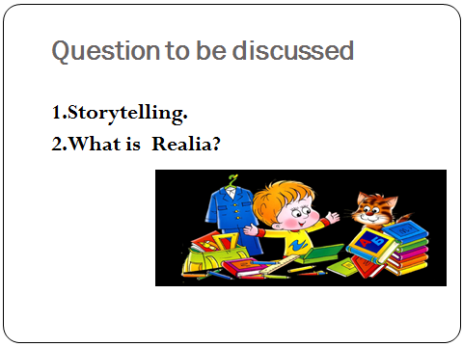

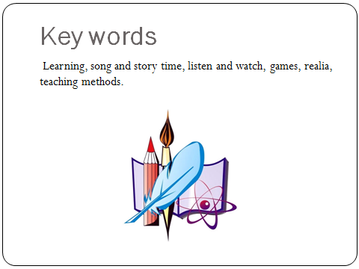

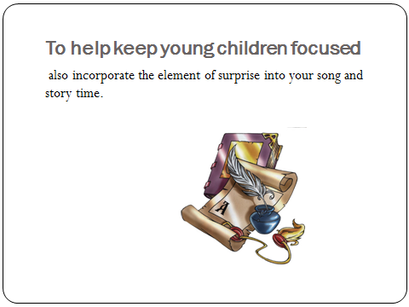

Lesson 16
Virtual Realia
Question to be discussed:
1. What is Realia?
2. Virtual Realia.
Key words: Learning, song and story time, listen and watch, games, realia, teaching methods.
Realia: (in language teaching) actual objects and items which are brought into a classroom as examples or as aids to be talked or written about and used in teaching. (Longman Dictionary of Language Teaching & Applied Linguistics.Richards, Platt, & Platt. 1992. Essex.)
Virtual realia: (in language teaching) digitized objects and items from the target culture which are brought into the classroom as examples or aids and used to stimulate spoken or written language production.
Songs and stories not only helps the toddlers develop English skills; but it also shows the young mothers what they can do at home to help their very young children learn English. Try a song and story time sometime.
The use of realia is commonplace in the ESL/EFL classroom and is widely considered to have great value in fostering an active teaching-learning environment. By presenting information through diverse media, realia helps to make English language input as comprehensible as possible and to build "an associative bridge between the classroom and the world" (Heaton, 1979). ‘’realia "are not only a series of artifacts that describe the customs and traditions of a culture, but they are also a set of teaching aids that facilitate the simulation of experience in the target culture" (my italics). Realia provides language learners with multi-sensorary impressions of the language which, "learned partly at least through seeing, hearing, touching, and manipulating" items. And interaction with authentic materials aids in contextually grounding instruction by bringing students into contact with language as it is used in the target culture in order to meet actual communication needs. The use of realia, then, can enhance linguistic and cultural comprehensibility, which are both prerequisites for real language learning.
Learners can explore aspects of realia like greeting cards can provide great vocabulary in the form of puns, idioms, and slang. They can also serve as a springboard for a discussion of underlying cultural values, beliefs, and behavior as well as provide an often non-language-dependent means of introducing students to the lesson topic .Further, there is evidence that through the use of realia teachers may increase the number of student responses and, therefore, overall participation and interest in learning activities.
With the increasing integration of computers into language instruction and the phenomenal growth of the Internet, the idea of digitizing realia and organizing it into a web site is a logical further development in language teaching in the digital age. Whereas traditional realia is linear in nature, when transferred to a more interactive and flexible medium, Virtual Realia merges an established technique with the new educational technologies in bringing culturally-based authentic materials into EFL classrooms worldwide.
The teachers are faced, however, with a curriculum which requires them to teach some culture. In addition, many of the English teachers in our program are former Russian teachers who have undergone or are presently undergoing extensive requalification in English due to the increased demand for English instruction at the expense of Russian which occurred following the political changes. As computer-based instruction is a key component of the teacher-training curriculum at university.Virtual Realia is a collection of linguistic and non-linguistic authentic materials which have been compiled, scanned, and posted on our WWW server. The site offers a new perspective to using authentic materials by allowing EFL teachers instant access to American cultural realia. It benefits especially those international teachers who are less mobile or unable to collect their own materials.
Like more traditional realia, virtual realia is motivating and meaningful in that it brings an authentic piece of the target culture into the language classroom. The added advantage with this new medium is that realia-based lessons need not be bound to cities and places that the teacher has physically been to but, rather, can be based on materials from a variety of places collected from a variety of people with various interests. Further, students interact directly with these materials rather than with someone else's interpretation and analysis of them and thus may find virtual realia even more appropriate for their interests than traditional authentic materials collected by the teacher. Another benefit of virtual realia is that the materials are truly interactive and more flexible than traditional ones in that they can be easily adapted and up dated. For example, a page from a brochure can easily be digitally altered for use in an information gap activity without damaging the "original." Further, teachers can choose which pages of the document to use in class rather than being forced to use the entire item. Also, the computer-savvy instructor can juxtapose the digital items when developing virtual realia-based communicative activities, or create documents which contain only certain types of virtual realia. These images and activities can be stored on a disk and easily accessed or printed out. Moreover, these materials can serve as the basis for various computer-based collaborative projects, as supplemental materials, or as on-line assignments and tests.
The contents of the Virtual Realia site are arranged by topic rather than by difficulty level. The reasoning is that teachers are often discouraged from using an attractive piece of realia because it appears to be too difficult. By not assigning a "level" to the items, teachers are more likely to select pieces which will compel their students to "reach" a bit. Also, rather than judging the apparent difficulty of the realia item itself, one should ensure that the accompanying tasks reflect the appropriate ability level for the students concerned. Traditionally, authentic materials have been reserved for intermediate to advanced levels. However, as Adams (1995) notes, "students at lower levels stand to gain at least as much by exposure to well-selected authentic texts appropriate to their needs and abilities." With this in mind, special attention has been given to items rich in context and graphics and modest to moderate in text.
The Virtual Realia items are intended to serve as "raw materials" for teachers designing lessons focusing on American cultural studies, content-based lessons, and skill area units. The sample activities included with many of the items suggest ideas that teachers can use when designing their own exercises. The high-beginner/low-intermediate-level Ellis Island brochure contains two pages of pictures and text and gives an immigrant's account of his ordeal on Ellis Island at the beginning of this century. Sample activities and exercises I designed to accompany this page include guided, short answer and vocabulary exercises as well as more open-ended, expressive activities like a role-play and "letter home" writing assignment. I also included student-generated drawings which give a pictorial account of the immigrant's experience in a sequential ordering activity.
Virtual Realia items were also selected to provide insights into American culture which delve below the surface and explore lesser known aspects. While the units provided suggest a starting point for teachers interested in designing their own Virtual Realia-based lessons, the activities themselves can serve as a downloadable template for future on-line exercises the teacher may wish to develop.
Both the adoption of authentic materials in the classroom and Internet access appear to be on the rise (Thus it will be easier for international teachers to take advantage of the benefits and "cultural experience" that Virtual Realia can provide. The Internet explosion has allowed teachers (and students) to travel through cyberspace anywhere in the world. And through the use of carefully selected virtual realia gathered during these journeys, teachers can expose students to many if not most of the printed materials they could expect to encounter during an actual stay in the target country/culture. Indeed, the hyper textual nature of Virtual Realia "removes the limitations of the printed page and breaks down (the) geographical boundaries which once served as obstacles to procuring authentic materials. It allows the teacher to stop at a small café off the beaten path, pop into the train station to check departures for the weekend, or clip some coupons and check over a shopping receipt from the local supermarket just like a native of that town might do and then bring this collection back to class to use in lessons without ever having left their home or school.
Can virtual realia still be considered realia? The larger question regarding authenticity of which realia is a part paints a confused and contradictory picture at best. What does seem clear, however, is that authenticity is a relative matter and that different aspects of it can be present in varying degrees To help answer the question above, let us first consider a few definitions of realia. If we accept a synthesis of these working definitions, concede that realia does not necessarily have to be something tangible (e.g. authentic audio clips), and further agree that something which is brought into the classroom digitally still counts as being brought into the classroom, then our answer is clearly, yes. But virtual realia isn't really the object at all; it's just a digitized image of the item. Foreign language practitioners do accept modifications of realia items such as the lamination of authentic materials onto a card .Wood (1980) even presents the postage stamp as a cultural artifact that may be easily photographed and enlarged to facilitate its use and discussion in class. I propose that as long as the item concerned is a true facsimile of a piece of realia and the integrity and practical authenticity is preserved, then the item can be considered realia. Of course, not everyone will be able to take advantage of Virtual Realia. However, if you are reading this article online, you surely can. And by performing the relatively painless bits to atoms conversion of the Virtual Realia materials (printing them out), anyone can use this resource in classroom instruction. What one realistically needs to exploit this resource is a computer, a modem, Internet access, a printer, and a free web browser such as Netscape.
Virtual Realia can be used as an on-line tool in making the vague concrete for language learners. It can facilitate the integration of computer-based foreign language instruction with other disciplines, such as cultural studies, history, and literature. In doing so, Virtual Realia reveals the similarities and differences between native and target cultures as well as raises (multi-) cultural awareness. Virtual Realia can improve the quality and availability of culturally-based, authentic EFL materials. It was designed with the belief that studying a foreign language is a means to a greater end--communicating meaningfully with another culture and its people.
Adams, T. (1995). What Makes Materials Authentic? ERIC DOCUMENT 391389.
Berwald, J. (1987). Teaching Foreign Languages with Realia and Other Authentic Materials. Q & As. Washington, D.C.: ERIC Clearinghouse on Languages 1-6.

Celce-Murcia, M. &Hilles, S. (1988). Technniques and Resources in Teaching Grammar. Oxford: Oxford University Press.
Cerf, V. (1997).Father of the Internet. Interview on The Site, June 3, 1997. MSNBC. http://www.thesite.com/0697w1/iview/iview421_060397.html [1997, June 4].
Dickens, M., Robertson, I., & Hofmann, E. (1995).Realia: Bringing the Real World into the Classroom [Online]. Available: http://www.wlc.com/oxus/realia.htm [1997, June 1].
Heaton, J. (1979). An Audiovisual Method for ESL. In M. Celce-Murcia & L. McIntosh (Eds.), Teaching English as a Second or Foreign Language. Rowley, MA: Newbury House.
MHess, M. &Sklarew, S. (1994). Realia and American Culture. WATESOL Journal, Fall, 10-12.
Negroponte, N. (1995). Being Digital. New York. Vintage Books.
Rivers, W. (1983).Speaking in Many Tongues. New York: Cambridge University Press, Third Edition.
Short, D. (1991). Integrating Language and Content Instruction: Strategies and Techniques. NCBE Program Information Guide Series, 7 (Fall) [Online]. http://www.ncbe.gwu.edu/ncbepubs/pigs/pig7.html [Accessed June 7, 1997].
Tanguay, E. (1997). English Teachers, Prepare Yourself for the Digital Age [Online]. http://userpage.fu-berlin.de/~tanguay/english-teachers.htm [1997, May 16].
Taylor, D. (1994). Inauthentic Authenticity or Authentic Inauthenticity?TESL-EJ [Online], 1 (2). Available: http://www.zait.uni-bremen.de/wwwgast/tesl_ej/ej02/a.1.html [1997, June 1].
Walz, J. (1986). Increasing Student Talk Time in the Foreign Language Classroom.The Canadian Modern Language Review. 42 (5), 952-967.

Wood, R. (1980). Teaching Francophonie with Postage Stamps.The Canadian Modern Language Review. 36 (1), 105-124.
Zukowski-Faust, J. (1997). What is Meant by Realia? AZ-TESOL Newsletter, 18 (1), 9.
Questions:
1. How much better will be your lesson if you use visual aids?
2. Which techniques will you use during your lesson?
3. Which classroom activities do you prefer?

ТHEME №16 | VIRTUAL REALIA.
Model of teaching
Time – 2 h. | Number of students from 15 to 25
Plan of the lesson | 1. What is Realia?  2.Virtual realia.
Aim of the lesson: Principles of using realia, toys and games in teaching process.
To explain innovative technologies in FLT. Features of using correct material.
Tasks of the lesson:
- Main features of using realia,toys and games in teaching FL”
- To clarify the term “realia” in teaching FL.
- To explain the importance of innovative technologies in FLT.
Methods of teaching |  | Discussion, dispute
Form of teaching |  | Group
Means of teaching |  | Projector, text of lesson
Place of teaching |  | Classroom;
Type of assessment |  | Oral answering
Pedagogical technology |  | Expert list, brainstorming.

TECHNOLOGICAL MAP OF THE LESSON
 | Teacher | Student
Stages | Prepares for the content of the lesson.  Prepares slides for the lesson.  Gives the list of used literature.
1. Introduction (15 min) | 1.1. Name of the lecture, key-words and plan.  1.2. Explains aims and tasks of the lecture.  1.3. Asks questions in order to recall previous knowledge. | Listens  Answers to the questions
2. Main stage(50 min) | 2.1. Gives the main part of the theme, demonstrates and explains all the key-words and theoretical part.  2.2. Explains the role of teaching in primary level.  2.3. Names main important features of realia, games in teaching.  2.4. Explains importance of using innovative technologies during the lesson. | Listens, reads and writes
3. Conclusion  (15 min) | 3.1.Answers to the students questions  3.2. Gives sources of additional information, makes conclusion. | Asks questions. Writes tasks.

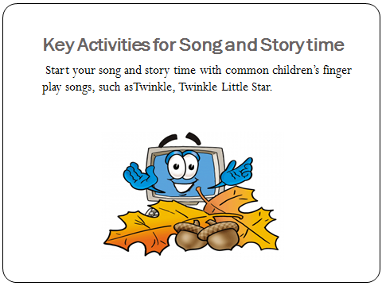

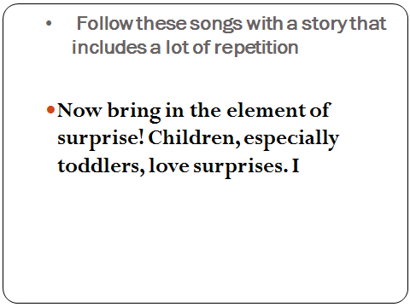

Lesson 17
Strategies for assessment in the classroom for young learners
Questions to be discussed:
1. Most popular types of tests for your ESL classroom
2. How to proceed.
3. Assessing according the CEFR
key words: competency in science ,young learners, subject, classroom management, teacher's approach ,language production, professional conduct
Though it is probably most students’ least favorite part of education, testing is necessary. In almost any language program, at one point or another, students will have to take tests. And since most students will one day have to perform test or other language assessment, giving your students a chance to practice their test taking in your classroom will only help them in the future. Even so, not all tests are created equal. Different testing methods test different types of knowledge and require different test taking skills. Here are some of the most popular types of tests that ESL teachers use in their classrooms.
Most popular types of tests for your ESL classroom
1Multiple Choice
Multiple choice tests have been a popular choice for educators for many years. Each question gives students several options for answers, and they choose the correct answer from among the incorrect answers. Multiple choice tests are easy to grade and can cover a large range of information without taking too much time or being too overwhelming. Using these tests in your classroom may help prepare students for standardized tests. Multiple choice tests, however, may not give teachers the most accurate measure of a student’s language knowledge and may overly rely on test taking strategy. Some teachers may be tempted to use the same tests year after year, and savvy students may find less than honest ways to score high on these tests.
2. Alternative response
True/false tests, a type of alternative response tests, are another long time favorite for many different teachers. Each question presents a statement, and the student must decide whether that statement is correct or not. True/false tests are another easy grader, but again depend heavily on test taking strategy. When students must correct false statements and make them true, you may get a better measure of their overall language knowledge. These types of tests can be tricky, though. Small details can throw off even the best students, and test takers may spend much of their time second guessing their answers.
3. Matching
Matching tests require students to pair items in one column with those in another. Some language teachers may ask their students to match English words with those same words in their first language. Others may provide lists of places and people who go together. Matching tests can cover a large range of material and offer an easy grading experience for the teacher. When students match items for a test, they have some base information for each answer. They know that each item must coordinate with another. Perhaps this decreases test stress because even those with no knowledge of an answer have a chance to get the question correct. However, one mistake on a matching test can throw off so many answers a student has no hope of passing. When letters A, B and C just don’t jive with numbers 1, 2 and 3, a student can become paralyzed and perform even worse.
4. Completion
Completion tests require students to give some information to complete a sentence on the page. Completion tests might be filling in the blank tests, cloze tests, or free answer tests. Completions give students a chance to show the teacher what they know rather than testing for what they do not know. Language students can use their entire knowledge of English to come up with an answer that makes sense for each question, and these tests check how well a student can communicate rather than how much he has memorized. Completion tests may be harder on the teacher since they require more time to grade. Also, the teacher needs to have flexibility on the answers since students may not choose the exact word the teacher had in mind. Providing a word bank can help students with these types of tests, but smart teachers will give students more options than they will need to complete the test. For example, a test with 20 questions might have 30 words in the word bank. (Having an equal number of questions and answers would make this a matching test.)
5. Essay
Essay tests are less common in the ESL classroom since they require a larger base of general knowledge than simpler test forms. Essay tests, however, are highly communicative. Students can be creative with the language they know, and strong students will find correct ways of expressing their ideas even if they do not remember exactly what was taught in class. Essay tests can be stressful for ESL students, though. The idea of filling in a blank page can be paralyzing to students whose confidence is wavering. And beginning students may not have enough base knowledge of English to succeed with this type of test. Grading essay tests can be challenging as well. So much of essay grading is subjective, so teachers who use a rubric to grade essay tests will find their scores most objective.
6. Oral Testing
Oral testing is particularly important in language classrooms because spoken language is the ultimate goal in any language program. Oral tests focus on students’ ability to communicate with what they know. Since spoken language is creative and flexible, students may find that oral testing gives them opportunities to self correct, ask for clarification and use language creatively. A one on one interview, though, can be intimidating, especially for shy students. Those that are quiet in class can find the pressure of a private conversation with their teacher enough to throw their performance on the exam. Teachers, on the other hand, may appreciate the opportunity to hear students who choose not to speak on a daily basis in class. Grading oral tests can be more subjective or more objective depending on how the test is structured.
Ultimately, the best teachers will include all of these testing strategies in their classrooms.
By doing so, they decrease the influence of the test itself and really get to the heart of their students’ knowledge.
What testing method do you use most often?
You may have horrible memories of taking tests as a student but now that you are teaching, it is important to test your students on the material you cover in class.
Tests are essential because they allow both you and your students to evaluate their performance. You will discover what areas they are struggling with and they will find out where they need to focus their attention. Here are some things to remember when testing students.
How to proceed
1. Frequency
Rather than save material from the whole year to include in one massive exam, consider quizzing students at the end of each chapter and then every quarter or semester to break material up into more reasonable amounts. It may seem like students are always preparing for a quiz or test but as long as they have clear goals and material is covered thoroughly, they should adapt to the routine easily. Another benefit is that with more tests, each one is a lower percentage of the overall grade so there is less anxiety about performance on individual tests.
2. Content
Sometimes tests should focus on very specific material while others should be more comprehensive. It is important to check that students are retaining information in the long term and not just memorizing information. Use questions or question types that students have already seen in class. Springing a new type of question or activity on them during an exam can be incredibility confusing while including the exact questions from the study guide can be too easy. Take the middle ground here. Use familiar formats and ask different questions or variants of questions. This will give students the opportunity to demonstrate what they have learned without getting bogged down in reading directions.
3. Variety.
If possible try to include a variety of exercises in your tests. Not every school is able to do this but interview tests can be very effective because students have to demonstrate their ability to listen and speak as well as read and write. Since the first two are critical for students who will have the opportunity to speak English outside the classroom, they are also very important in the evaluation process. You can also use projects to grade students if you are willing to attempt something new. Perhaps for one semester skits can be the primary factor in determining overall grades. While these can be a challenge to evaluate compared to multiple choice questions, they also give students who do not perform well on tests the chance to more fully demonstrate their abilities.
4. Preparation
It is important to help students prepare for exams so that they can feel confident going in to them. By creating a study guide, reviewing material in class, giving students information about the test, and answering any questions students have, you will help them immensely. Stress can reduce student performance so simply encourage them to study the material and do their best. By reducing their anxiety, you have ensured that they will be more successful.
5. Incentive
You can also set goals for your students when it comes to exams so that they have something specific to work towards. Depending on your students, you should consider individual and class goals. Make these reasonable but challenging and do not reveal individual test scores to the class as this might cause some students some embarrassment. You may decide the goal should be a class average of 85%. Assuming that students performed about this well on past exams, this should be a reasonable and attainable goal. The incentive might be that you will not assign homework for one week which will help motivate students to achieve their target score.
6. Review
After returning the graded tests to students, go over the answers so that students can figure out what they did incorrectly. Simply telling them the answers will not help them understand their mistakes. You can mark the papers without correcting them and then go over each and every question in class so that students can correct their answers and ask questions. While students really should take advantage of this opportunity to correct their mistakes so that they have correct material to review another time, you may need to use an incentive to encourage students to make corrections.
In most courses, you will have to give your students tests on the material you cover in class.
While they are actually great tools to gauge how well students are doing, tests also cause learners a lot of anxiety so try to make them as painless as possible. You are not out to make students miserable so avoid trick questions. Approach the material directly and in familiar ways so that students can succeed.
A wide variety of games can be used when teaching English.
The key is to ensure that everyone fully participates and has enough practice with the lesson material to play. If students are not confident, they will struggle and not get the most out of the activity
Questions:
1. What most popular types of tests for your ESL classroom do you know?
2. Are completion and matching effective?
3. How to proceed?
ТHEME №17 | Strategies for Assessment in the Classroom for young learners
Model of teaching
Time – 2 h. | Number of students from 15 to 25
Plan of the lesson | 1. Most popular types of tests for your ESL classroom  2. How to Proceed.  3. Assessing according the CEFR.
Aim of the lesson: Principles of assessing in teaching process.
To explain innovative technologies in FLT. Features of using correct marks.
Tasks of the lesson:
- Main features of assessment in the classroom in teaching FL”
- To clarify the term “assessment” in teaching process.
- To explain the importance of innovative technologies in FLT.
Methods of teaching |  | Discussion, dispute
Form of teaching |  | Group
Means of teaching |  | Projector, text of lesson
Place of teaching |  | Classroom;
Type of assessment |  | Oral answering
Pedagogical technology |  | Expert list, brainstorming.

TECHNOLOGICAL MAP OF THE LESSON
 | Teacher | Student
Stages | Prepares for the content of the lesson.  Prepares slides for the lesson.  Gives the list of used literature.
1. Introduction (15 min) | 1.1. Name of the lecture, key-words and plan.  1.2. Explains aims and tasks of the lecture.  1.3. Asks questions in order to recall previous knowledge. | Listens  Answers to the questions
2. Main stage(50 min) | 2.1. Gives the main part of the theme, demonstrates and explains all the key-words and theoretical part.  2.2. Explains the role of teaching in primary level.  2.3. Names main Important features of assessment in teaching children.  2.4.Explains importance of using innovative technologies during the lesson. | Listens, reads and writes
3. Conclusion  (15 min) | 3.1.Answers the students questions.  3.2.Gives sources of additional information, makes conclusion. | Asks questions. Writes tasks.

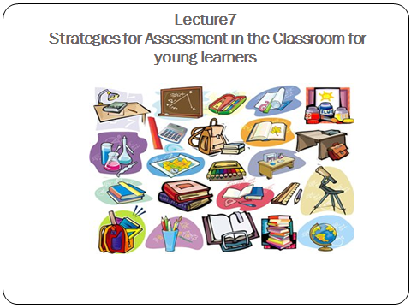

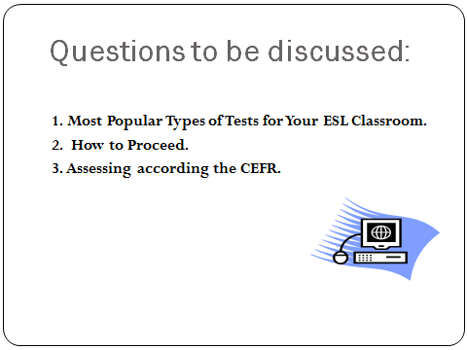

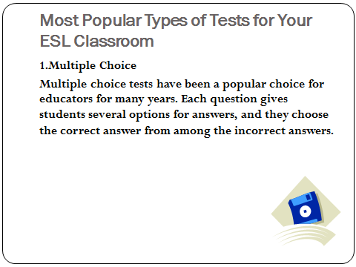

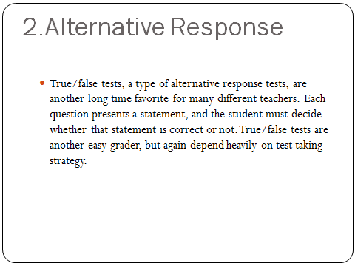

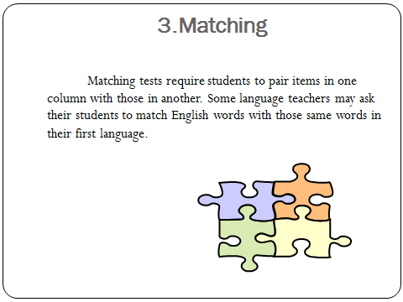

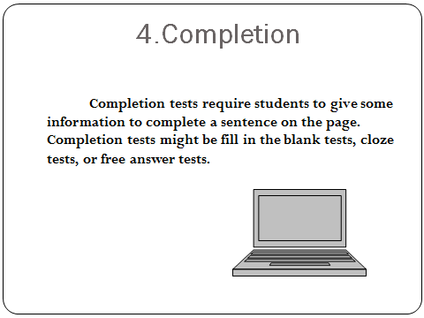

Lesson 18
The modern model of teaching and learning English in Uzbekistan
Questions to be discussed:
1. Most popular types of tests for your ESL classroom
2. How to proceed.
3. Assessing according the CEFR
key words: competency in science ,young learners, subject, classroom management, teacher's approach ,language production, professional conduct
The document of “Common European Framework of Reference for Languages: Learning. Teaching. Assessment” (CEFR) was created by the Council of Europe.
The CEFR document is the result of a need for a common international framework for language learning facilitated co-operation among educational institutions in different countries. It was demanded to create a single and integrated educational space in Modern languages teaching/learning and international standards of language assessment in European countries. The main function of this document was to provide a common basis for the elaboration of language syllabuses, curriculum, guidelines, examination, and textbooks across Europe. It also provided a method of assessing and teaching which was applied to all Modern languages in Europe.
In Uzbekistan ELT is seen as a career in a field of educational specialization: it requires a specialized knowledge base obtained through both academic study and practical experience. Nowadays the demonstration of a certain level of proficiency in English as component of certification is required.
The domestic multistage model of continuous and successive FLT includes the following levels of FL given in the Table 1.
Table1. The stages and levels of FL
Educational stage | Classes | Levels according to CEFR
Primary and secondary education | 1-4 forms at school | A1
Primary and secondary education | 5-9 forms at school | A2
Primary and secondary education | Language-oriented schools | A2+
Special secondary education | Academic lyceum  1-3 courses | B1
Special secondary education | Vocational colleges | B1
Special secondary education | Language-oriented academic lyceums | B1+
Higher education | Bachelor degree non-linguistic institutes and universities | B2
Higher education | Master degree non-linguistic institutes and universities | B2
Higher education | The second language in Bachelor and Master degree institutions and universities | B2
Higher education | Bachelor degree linguistic institutes and universities | C1
Higher education | Master degree linguistic institutes and universities | C1

School education falls apart into two stages: 1) the primary education (1-4 forms) and 2) the secondary education (5-9 forms). Education at academic lyceums is considered as upper secondary education. At vocational colleges ELT concerns 1) General English and 2) English for Specific Purposes (ESP) or English for Occupational Purposes (EOP). ESP is traditionally associated with study at college and non-linguistic institute and university. In the Uzbek educational system study at lyceum and college is considered as a profile education: 1) study at academic lyceum provides intensive development of intellectual abilities, deep, differentiated and vocational-oriented education, after academic lyceums they can continue further education at institutes and universities, or undertake some job; 2) study at vocational college provides deep development of professional abilities, obtaining one of the professions, graduates of professional colleges get certificate of a junior specialist. Teaching and learning English at this stage of education demands study of general English and English for specific purposes, i.e. to develop both the language competency, study skills which will help them to succeed in further education and occupation/job.
The higher education provides training of qualified specialists at the Bachelor and Masters’ degree departments (Pre-service FL training). The Table above does not present post-graduate education (institution of senior scientific personnel and researches) and upgrading courses of In-service teachers training and retraining to change a qualification.
The effectiveness of teachers’ pedagogical activity, at first, depends on acquiring the ideas of modernization. A modernization means: 1) changing the goal and results of education; application of modern methods and technologies in practice of teaching/learning; reworking out the state standards and curriculums for EL teaching and learning. Thus, all components of methodical system of ELT should be modernized, particularly: 1) approaches and principles to EL teaching and learning; 2) goals of teaching and learning; 3) content of EL teaching and learning; 4) aids, methods and techniques; 4) ways and forms of control of the results of EL teaching and learning.
In our conditions the CEFR is used for development of the language policy to set minimum language requirements for a wide range of purposes, in curriculum planning, preparing textbooks and development of methods of teaching and evaluation. It is intended for dynamic progress in acquiring FL.
Questions:
1. What is the goal of the CEFR?
2. What do we mean by descriptors in the CEFR?
3. Why do we adapt the CEFR to the national context of Uzbekistan?
4. What terms are used for descriptors?

ТHEME №18 | Strategies for Assessment in the Classroom for young learners
Model of teaching
Time – 2 h. | Number of students from 15 to 25
Plan of the lesson | 1. Most popular types of tests for your ESL classroom  2. How to Proceed.  3. Assessing according the CEFR.
Aim of the lesson: Principles of assessing in teaching process.
To explain innovative technologies in FLT. Features of using correct marks.
Tasks of the lesson:
- Main features of assessment in the classroom in teaching FL”
- To clarify the term “assessment” in teaching process.
- To explain the importance of innovative technologies in FLT.
Methods of teaching |  | Discussion, dispute
Form of teaching |  | Group
Means of teaching |  | Projector, text of lesson
Place of teaching |  | Classroom;
Type of assessment |  | Oral answering
Pedagogical technology |  | Expert list, brainstorming.

TECHNOLOGICAL MAP OF THE LESSON
 | Teacher | Student
Stages | Prepares for the content of the lesson.  Prepares slides for the lesson.  Gives the list of used literature.
1. Introduction (15 min) | 1.1. Name of the lecture, key-words and plan.  1.2. Explains aims and tasks of the lecture.  1.3. Asks questions in order to recall previous knowledge. | Listens  Answers to the questions
2. Main stage(50 min) | 2.1. Gives the main part of the theme, demonstrates and explains all the key-words and theoretical part.  2.2. Explains the role of teaching in primary level.  2.3. Names main Important features of assessment in teaching children.  2.4.Explains importance of using innovative technologies during the lesson. | Listens, reads and writes
3. Conclusion  (15 min) | 3.1.Answers the students questions.  3.2.Gives sources of additional information, makes conclusion. | Asks questions. Writes tasks.

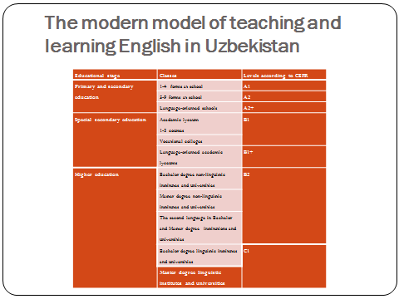

2.Мустақил таълим мавзулари
N | Maвзу номи | Soat
 | Importance of teaching English language in primary schools. | 2-презентация
 | Teacher education, curriculum and materials for  primary English language education | 2-презентация
 | Methods of teaching English language in primary school. | 2-презентация
 | Analysis of the effectiveness of the usage of methods of teaching English language in Primary schools. | 2-презентация
 | Teaching primary level children. | 2-презентация
 | Main requirements in teaching primary school level children. | 2-презентация
7 | Pedagogical competence of the teacher in teaching children | 2-презентация
8 | Classroom management and teacher's approach | 2-презентация
9 | Lesson planning | 2-презентация
10 | Features of an excellent lesson plan | 2-презентация
11 | Teaching language through the songs, poems and games | 2-презентация
12 | The use of Games | 2-презентация
13 | Teaching language through the games. Types of games. | 2-презентация
14 | The usage of vocabulary by the help of the games | 2-презентация
15 | Using realia, toys and games in teaching process. | 2-презентация
16 | Virtual Realia | 2-презентация
17 | Strategies for assessment in the classroom for young learners | 2-презентация
18 | The modern model of teaching and learning English in Uzbekistan | 2-презентация
 | Total: | 36
3. GLOSSARY
Ability - assimilated entity ways of doing things, provided a set of acquired knowledge and skills.
Approach to learning - learning strategy and the language of choice of teaching methods, implementing such a strategy; point of view on the essence of the subject, which must be taught.
Audiovisual training- educational visual aids designed for the presentation of visual and auditory information
Authentic materials - texts and other materials (newspapers , maps , schedules, transportation, theater tickets, advertisements , etc.) , created in the target language country and expected to use their mother tongue, but later found application in the educational process .
Brainstorming - a special way of organizing the joint creative work of a group of people, designed to increase their mental alertness and intelligent solutions to complex problems by enhancing, stimulating group brainstorming, solving problems.
Business game - a form of organization of collective learning activities in practical classes in a foreign language, having the aim of training professional dialogues to create different communication situations and encourage learners to the statement within a given situation.
Deductive method of teaching- a learning method which involves first rules, regulations which is then illustrated by examples of their use in speech.
Definition - a way of semantization vocabulary, disclosing meanings of the word through a brief definition of the concept with the help of lexical units which are already known to students.
Didactic game - a game with educational objectives, the main among which are the formation of verbal skills and increasing motivation of language learners.Conditionalespeech exercises - exercises aimed at strengthening the language of the material in order to bring its use to automatism.
Curriculum - a document defining the composition of the subjects studied in schools, their distribution by years of training, the amount of time allotted to each school subject, and therefore the structure of the school year.
Close - test - a test to determine the difficulty of the text for reading and understanding has been developed by the American scientist W. Taylor. It is used in the classroom for FL as admission control is performed mainly in writing. It is one of the effective means of developing language guess, text prediction, can also replace a comprehensive test on various types of speech activity when determining the level of language proficiency.
Common European Framework (levels of mastering foreign language) - in 1997 the Council of Europe was approved the document of " Modern Languages: Learning, Teaching, and Assessment. Common European competence «where the goals, objectives, content of language teaching are characterized by the final level of FL learner . The document describes the criteria and approaches to the monitoring of achievement.
Common teaching competence - the ability to use rational methods of intellectual work and self- improvement in mastering of the chosen specialty
Communication failure - total or partial failure of misunderstanding the communication. The main communication failures include:
• differences in the pictures of the world, formed by different nationalities;
• mismatching estimates fragments and phenomena of reality;
• violation of the verbal behavior, including the rules of courtesy and etiquette stereotypes;
• violation of the communication channel;
• misunderstanding of speech intention;
• the nature of language units (word ambiguity, etc.);
• inaccurate indication of the referent;
• use of nonce words, dialect, jargon, etc.
Communicative activity (personal activity) approach - a modern approach to education, one of the modifications of the communicative approach, the foundations were laid in psychology studies by S.L. Rubinstein, A.N. Leontyev, I.A.Zimney, now it got realization in practice. The main thing in this approach is: in the center is a learner as a subject of teaching activities, the teaching system implies a maximum consideration of individual psychology, age and national characteristics of the individual student. Communicative activity approach orients the classes of FL learning communication.
Communicative competence - the ability to solve by means of a foreign language relevant to students and the public communication of the household tasks , educational, industrial and cultural life; student's ability to use the facts of language and speech for the realization of the objectives of communication. The ability to implement linguistic competence in different conditions of speech communication.
Communicative insignificant e mistakes- mistakes of different kinds (phonetic, stylistic), including clerical, reservations, which do not lead to the disruption of communication. Such mistakes do not require immediate correction; they are also admitted by native speakers.
Communicative Grammar - a description of foreign or native language that reveals the particular units of a language and the rules of their functioning taking into account the practical teaching purposes; based on the communicative tasks of communication, the values of the means of expression
Communicative orientation - training for practical language skills.
Communicative significant mistakes- linguistic (phonetic - lexical - grammatical) or socio-cultural mistakes leading to disruption of communication, misunderstanding or misinterpretation of the speaker while communication. Such mistakes must be corrected. The nature of the mistake correction should be clear to the learner; however the learner should not just memorize the correct option. The process of working on mistakes involves the following steps:
• the student must feel that somewhere there is a mistake;
• the student must know where is a mistake;
• the student must understand the nature of the mistake.
Communicative task- a form of existence of the motive of verbal expression, non-verbal problem arises during joint speech activities if necessary to transfer or receives information; realized in 4 main areas of communication: social-welfare, socio- cultural, professional and academic.
Compensatory skills - the ability to use paraphrases to transmit reading or listening, for example , the ability to use a chain of coherent simple sentences rather than one of a complex , synonyms , similar in meaning of the word with a deficit of language means .
Compression of the text–abbrivied «compression " of the text to the limits of the minimum redundancy sufficient for understanding , can be used as an exercise , as well as for the compilation of abstracts or annotations may be semantic or structural .
Contextual guess - a type of language guessing, based on the definition of the meaning of words through context.
Control -1) the process of determining the level of knowledge, skills and abilities of the student as a result of their oral and written assignments, tests and formulation on this basis for the evaluation of a particular section of the program, course or teaching process; 2 ) part of the lesson , during which the teacher evaluates the pupil or group of pupils learns the content of the subject in all or some of its aspects.
Contrast connection - one of the control functions, which is aimed to obtain information about the level of teaching.
Criteria for selection of language material - the selection of rules of language material: the selection of a language filling educational texts, compatibility and multiple meaning words, derivational value, frequency, with the exception of synonyms.
Cultural component of the word - lexical background related to the concept of national culture; background communication word.
Educational complex - a set of textbooks.
Educational standard - basic system parameters adopted as state standards of education. The main unit of the educational standard is its structure, content, academic load and demands on the level of preparation of students.
Evaluation criteria - this is how we assess students.
Exercise - a structural unit of the methodical organization of the material, which operates directly in the educational process, providing substantive action with this material and forming the basis of their mental activities, mental activity.
Handout - specially selected and methodically organized language and speech material to be presentations and assimilation of the learning process.
Heuristic conversation - a dialogue among teacher and learners, during which the students themselves find the solution of the discussed problem.
Humanities competence - competence with regard to selection and presentation in the classroom for students in meaningful information assumes ownership of the following skills: 1) to select texts for classes in accordance with the objectives of education; 2) to comment on the contents of the text using in pre-texting, while texting and post texting.
Individual lesson (one-to-one lesson) - one of the most effective ways of learning, when the teacher teaches one student. This kind of lesson requires constant attention to the student and a conscientious attitude to teachining, the teacher should have monitoring . Individual lessons raise the level of the learners.
Inductive learning method - (from latin. induction - selection) - a practical method of teaching, providing the students a familiarization with the material in which a result of the observation of the facts of language, students are brought to the generalizations and conclusions, it is the basis for problem-based learning.
Interactive learning - technology of active learning based on the interaction of subjects of educational activity and contributes to enhanced mental performance of each student.
Interactive forms of work - such forms of organization of speech interaction in the process of performing tasks that require the active participation of partner or partners for the successful implementation of the task.
Language - the language in which teaching is carried out in the educational institution.
Learning content - a set of what the student should learn in teaching process.
Language exercises - exercises involving operations with units of language and form the basic skills
Language for Specific Purposes (language for special purposes) - accepted in modern linguistics designation of functional variants of the literary language, the service professional communication.
Language material - phonemes, letters intonemy, words, phrases, ready-made phrases, grammatical forms, etc., to be studied in the process of mastering a foreign language.
Learning speech situation - a model of a set of circumstances that encourages potential interlocutors to communicate through the use of linguistic resources in the interest of learning speech.
Learning tools - a set of manuals and technical device, by which the teacher teach the language and activities of students on the mastery of the language.
Lesson - the lowest organizational unit of the educational process.
Levels of language proficiency - the degree of formation of the communicative competence, allowing solving a foreign language extra linguistic communication tasks in accordance with the terms of communication and using of the necessary language skills, language skills and abilities.
Lexical minimum - lexical units that must be learned by learners for a certain period of learning process.
Lexical unit - a unit of a language, lexical meaning is independent and able to serve as a unit of speech.
Method - a group of techniques to address the complex and general educational problems
Methods of teaching foreign languages - 1 ) a science that investigates the goals, objectives , content, tools, techniques , training methods , as well as studying the processes of teaching and training in the foreign language material 2 ) a set of methods, techniques , training methods aimed to master a foreign language .
Methods of teaching - the specific activities and operations of the teacher, whose purpose is to gain knowledge, develop skills, promote learning activities of students to solve specific problems of the learning process.
Methodical principles of teaching - learning principles, reflecting the specific foreign language teaching.
Module (training) - a course or its autonomous part (lessons, topics and topics of the course, semester or part of it) with the necessary software and educational software, sufficient for the construction of various educational paths within it, it is easy to connect to other modular courses if necessary able to be modified in content, in form, the amount is due to the flexible internal structure.
Monologues - one of the form of speaking , as a kind of verbal activity , one person’s speech addressed to one person or group of students , characterized deploy connectivity , validity , logical structure and semantic completeness (unlike the dialogical speech ) .
Minimum base - starting lexical and grammar minimum, providing the possibility of "survival" in the country of the language being studied in a limited number of everyday situations.
Organizational form of teaching - teaching option of communication between teachers and students in the learning process.
Parameters of estimation – is estimating criteria (accuracy of the task, the lexical and structural diversity of speech, phonetic skills, logical, etc.)
Perceptual (receptive) kinds of speech activity - WFD related to speech perception -oral (speaking) and written (letter).
Polylog - a kind of dialogic speech , a conversation between multiple active in it, in the term originated in the study of the properties of the language of communication in addition to the term dialogue .
Personal approach - an individual approach to the student as a special personality, became widespread in the modern methodology in the framework of personal - oriented (communicative activity) approach of learning.
Principles of teaching - the basic provisions governing the nature of the learning process, which are formed on the basis of the chosen direction, and the direction corresponding to this approach.
Phonetic charge - step lesson (usually starting), which is designed to build and improve the skills of students.
Problem learning - learning, providing for the creation of problematic situations in the classroom and discussion of possible approaches to solving them in the course of CTE students learn to apply previously acquired knowledge and acquired skills and master the experience (methods) of creative activity.
Productive speech - oral or written speech, students do not merely reproduce the learned speech patterns, and design their own statements in accordance with the content of thought, communicative intentions.
Receptive types of speech activity - related to the perception of speech - oral (listening) and written (reading), are characterized by a probabilistic forecasting.
Role play - a form of organization of collective learning activities on a practical lesson in a foreign language, having the aim of the formation and development of language skills and abilities in an environment as close as possible to the conditions of a real communion.
Safety factor of the test - the average value of the correlation of the test or reference to all tests or assignments from the general sum.
Screening test - a test which is intended to determine the ability, as well as deficiencies while teaching students.
Skill - automated methods of action.
Speaking - oral, consisting of a comprehensive ability to understand sounding speech (listening) and the ability to produce it in audio form (speaking).
Speech activity (SA) - an active, focused, mediated by the language system and due to the situation of communication process of transmitting and receiving messages.
Speech competence - possession of ways of forming and formulating thoughts through language and the ability to use such methods in the process of perception and speech production; part of the communicative competence.
Speech etiquette - the national- specific rules of verbal behavior, realized in a system of stable formulas and expressions adopted in situations prescribed by society, «polite " contact with the person.
Speech exercises - type of exercise which intended: to serve the development of speech abilities through phonetic, lexical and grammatical skills; are used to train the spontaneous use memorized linguistic phenomena in speech, usually without awareness while speaking.
Speech material - educational texts, exercises, speech patterns, etc.
State educational standard - approved by the state regulatory document that defines the mandatory minimum requirements for the content of education and training; describes the aims and objectives of education, includes a list of skills and abilities to achieve target education, establishes the maximum amount of academic load of students.
Step of teaching process- a relatively complete cycle of the educational process, characterized by specificity of methods, tools and learning environment, and takes place in more or less strict time limits, necessary and sufficient to achieve the communication objectives and the implementation of the contents of this teaching phase.
Step of the lesson - a relatively independent part of the lesson, which has an intermediate relative to the overall goal of employment goal.
Subject competence - the totality of knowledge, skills, abilities formed in learning a particular discipline, acquired in the process of studying FL as an academic subject and characterizes a certain level of FL, includes the following competencies: linguistic (language), speech, communicative, regional geographic , professional.
Teaching method -1) a set of methods of teaching and learning; 2) the direction of learning.
Teaching profile - emerged in modern technique type of teaching learners in a foreign language and other subjects according to their professional interests and needs in the language.
Test - setting the standard form, the fulfillment which allows you to set the level and availability of specific knowledge and skills with the help of special scales results.
Textbooks for foreign language - printed, visual and sounding learning tools used in the educational process: exercise books, collections of texts, anthologies, tapes, videos, computer programs, handouts, tables, diagrams, etc.
"The European Language Portfolio » - a group of documents in which students can create and present in a formalized and systematic form of evidence of their qualifications, achievements and experience in the study of foreign languages, including samples of their own independent work.
Threshold level - a sufficient level of communicative proficiency that is required to communicate in a foreign language in various situations of daily and professional communication.
Thematic plan - methodical documents specifying the content and organization of the discipline. Thematic plan is developed on the base of the curriculum.
Training program - teaching and methodical documents defining the content and scope of knowledge, skills, abilities, mastering subject and the content of those sections and the distribution of them by the process of studying.
Training system - a set of basic components of the learning process, determining the selection of material for the lessons, form submission, methods and means of teaching, as well as ways of organizing it.
Tutorial - basic learning tool; provides guidance in the training and trainees; it contains samples of spoken and written language, the language material.
Verbal ability - a person's ability to carry out this or that speech act in a solution of communicative problems and worked out on the basis of skills and knowledge acquired .
Verbal communication - a form of interaction between two or more people through the language, including the exchange of information or affective-cognitive evaluation.
Working in small groups - active type of work that allows students to communicate, to listen to multiple points of view on a particular issue, in conjunction correct answers to each other. This method works with the audience the most practical for mastering the material and makes it easier for the teacher to control students, but is not suitable for every lesson, and often for better absorption of the studied material.
Working in pairs - the kind of work, especially stimulating students' attention, for lessons on the consolidation of already covered material.

4.Иловалар
4.1. Фан дастури

ЎЗБЕКИСТОН РЕСПУБЛИКАСИ

ЎЗБЕКИСТОН РЕСПУБЛИКАСИ

ОЛИЙ ВА ЎРТА МАХСУС ТАЪЛИМ ВАЗИРЛИГИ

САМАРҚАНД ДАВЛАТ ЧЕТ ТИЛЛАР ИНСТИТУТИ

БОШЛАНҒИЧ СИНФЛАРДА
ЧЕТ ТИЛИНИ ЎҚИТИШ МЕТОДИКАСИ
(танлов фан)

Ф А Н Д А С Т У Р И

Билим соҳаси: 100 000 – Гуманитар соҳа

Таълим соҳаси: 120 000 – Гуманитар фанлар

Таълим йўналиши: 5120100 – Филология ва тилларни ўқитиш
(роман-герман филологияси)

САМАРҚАНД-2018

ОЛИЙ ВА ЎРТА МАХСУС ТАЪЛИМ ВАЗИРЛИГИ

САМАРҚАНД ДАВЛАТ ЧЕТ ТИЛЛАР ИНСТИТУТИ

БОШЛАНҒИЧ СИНФЛАРДА
ЧЕТ ТИЛИНИ ЎҚИТИШ МЕТОДИКАСИ
(танлов фан)

Ф А Н Д А С Т У Р И

Билим соҳаси: 100 000 – Гуманитар соҳа

Таълим соҳаси: 120 000 – Гуманитар фанлар

Таълим йўналиши: 5120100 – Филология ва тилларни ўқитиш
(роман-герман филологияси)

Фан дастури Самарқанд давлат чет тиллар институти Ўқув-услубий Кенгашининг 2018 йил “___” _______________ даги “____” – сонли баённомаси билан маъқулланган.

Фан дастури Самарқанд давлат чет тиллар институтининг Француз тили ва адабиёти кафедрасида ишлаб чиқилди.

Тузувчи:

Долиева Л.Б. – СамДЧТИ “Француз тили ва адабиёти”

кафедраси ўқитувчиси

Тақризчилар:

Нишонов П. – ЎзДЖТУ Француз тили назарияси

ва амалиёти кафедраси доценти

Атауллаева Д. – СамДЧТИ “Француз тили ва адабиёти”

кафедраси катта ўқитувчиси

Фан дастури Самарқанд давлат чет тиллар институти Илмий Кенгашида кўриб чиқилган ва тавсия қилинган.
(2018 йил “___” ______________ даги “____” – сонли баённома).

К И Р И Ш

Ўқув фанининг долзарблиги ва олий касбий таълимдаги ўрни.
Мазкур танлов фан Ўзбекистон Республикаси Президентининг 2012 йил 10-декабрдаги "Чет тилларни ўрганиш тизимини янада такомиллаштириш чора-тадбирлари тўғрисида”ги ПҚ 1875-сонли қарори ҳамда Ўзбекистон Республикаси Вазирлар Маҳкамасининг 2015 йил 25 мартдаги "Умумтаьлим муассасаларининг чет тиллар ўқитувчилари малакасини ва касб маҳоратини оширишга доир қўшимча чора-тадбирлар тўғрисида" ги 67-сонли қарорида белгиланган вазифалар ижросини таъминлаш мақсадида яратилди.
Фан дастури "Бошланғич синфларда чет тилини ўқитиш методикаси" курси ҳисобланиб, у тўлиқ амалий машғулотларни ўз ичига олган ҳолда "Филология ва тилларни ўқитиш'" (роман-герман филолгияси) таълим йўналиши бўйича таҳсил оладиган битирувчи курс талабалари учун мўлжалланган.

Фаннинг мақсад ва вазифалари
Курснинг мақсади - умумтаълим муассасалари учун малакали чет тили мутахассисларини тайёрлаш, хусусан, талабаларнинг умумтаълим мактаблари бошланғич синфларида чет тилини самарали ўқитишлари учун муҳим бўлган билим ва кўникмаларни эгаллашларига ёрдам беришдир.
Фан олдига қўйилган мақсадга эришиш учун қуйидаги вазифалар амалга оширилади:
- талабаларга кичик ёшдаги ўқувчиларга хорижий тилларни ўқитиш усуллари ва методлари ҳақидаги билимларни бериш;
- ўқитиш жараёнида юзага келиши мумкин бўлган ёш билан боғлик муаммоларни бартараф этиш йўлларини ўргатиш;
- талабаларнинг лингвистик ва маданий компетенцияларини ўстириш;
- ўқувчиларда фонетик, грамматик ҳамда лексик билим ва кўникмаларни шакллантириш усулларини ўргатиш.

Курс бўйича талабанинг малакасига қўйиладиган талаблар
“Бошланғич синфларда чет тилини ўқитиш методикаси” курсини ўзлаштирган талаба:
- чет тили ўқитишнинг мақсад ва вазифалари;
- кичик ёшдаги (6-10 ёш) болаларга чет тилини ўргатишда уларнинг психологик хусусиятларини эътиборга олиш;
- бошланғич синфларда қўлланиладиган ўқитиш методларини таҳлил килиш ва мос келадиганини танлаш тўғрисида тасаввурга эга бўлиши керак.
- чет тилида коммуникатив компетенцияни шакллантириш тўғрисида;
- чет тили ўқитишнинг мазмуни, принциплари ва воситалари тўғрисида;
- чет тили таълимининг турли аспектлари тўғрисида билимга эга бўлиши керак.
- бошланғич синфларда дарсларни режалаштириш ва дарсни олиб бориш;
- ўқув материалларини ёш тафовутларини инобатга олган ҳолда танлаш ҳамда уларни дарс жараёнида қўллай олиш;
- материалларни ўқувчилар ёши ва қобилиятларига кўра мослаштириш;
- ўқув-методик материалларнинг янгиларини яратиш ва таҳрир қилиш каби кўникма ва малакаларга эга бўлиши керак.

Курснинг ўқув режадаги бошқа фанлар билан боғлиқлиги

Бошланғич синфларда чет тилини ўқитиш методикаси фани тўртинчи босқичда бошқа назарий ва амалий фанлар билан узвий боғлиқ ҳолда ўқитилади. Мазкур курс талабаларнинг чет тилини ўқитиш, тил ўрганувчилар луғат бойлигини янги сўз ва атамалар билан бойитишга, жонли тил билан алоқа қилишларига, ҳозирги замон хорижий тилларнинг ўзига хос хусусиятларини ўргатишга қаратилган бўлиб, у асосий ўрганилаётган тил, шунингдек ижтимоий фанлар – педагогика, психология, фалсафа, социология, шунингдек, ихтисослик фанлари бўлган лексикология, стилистика, таржима назарияси ва амалиёти каби фанлар билан узвий боғлиқ.

Курсни ўқитишда замонавий ахборот ва педагогик технологиялар
Талабаларнинг “Бошланғич синфларда чет тилини ўқитиш методикаси” курсини ўзлаштиришлари учун ўқитишнинг илғор ва замонавий методларидан, педагогик ва ахборот-коммуникация технологияларидан кенг фойдаланилади. Машғулотларда дарслик ва ўқув қўлланмалардан ташқари аутентик материаллар: аудио, видео, касбга доир журналлар, интернет манбаларидан фойдаланиш мақсадга мувофиқ. Ушбу фанни ўқитиш жараёнида таълимнинг интерфаол методлари кенг қўлланилади. Жумладан, амалий машғулотларда мос равишдаги интерфаол методларнинг қуйидаги турларидан кенг фойдаланилади:
- гуруҳли музокаралар;
- жамоа лойиҳалари;
- жуфтликлар бўлиб топшириқларни бажариш;
- якка ҳолда маълум мавзу бўйича презентациялар қилиш;
- давра суҳбатлари ўтказиш;
- кейс– стади;
- ақлий ҳужум ва ҳ.

Шунингдек, “Бошланғич синфларда чет тилини ўқитиш методикаси” курсини ўқитишда замонавий ахборот технологиялари қўлланилади, хусусан мультимедиа воситалари ёрдамида машғулотлар ташкил этилади, Power Point дастури ёрдамида презентациялар, компьютерда тестлар ўтказиш каби тадбирлар имкон доирасида тез-тез ўтказилади.

Ўзбекистон Республикаси Президентининг 2012 йил 10 декабрдаги "Чет тилларни ўрганиш тизимини янада такомиллаштириш чора-тадбирлари тўғрисида"ги ПҚ 1875-сонли қарорида "...чет тилини ўрганиш умумтаълим мактабларининг биринчи синфларидан ўйин тарзидаги дарслар ва оғзаки нутқ дарслари шаклида, иккинчи синфдан бошлаб эса, алифбо, ўқиш ва грамматикани ўзлаштиришдан босқичма-босқич бошланади" деб таькидланган. Ушбу курс бўйича дарсларга жалб этилган профессор-ўқитувчилар машғулотлар жараёнида юқоридаги талабларни инобатга олишлари лозим.
Шунингдек, фаннинг айрим мавзулари бўйича амалий машғулотларни бошланғич таълим объектларида ўтказилишини таъминлаш ҳам мақсадга мувофиқ.

АСОСИЙ ҚИСМ

Курснинг услубий жиҳатдан узвий кетма-кетлиги
Асосий қисмда фанни мавзулари мантиқий кетма-кетликда келтирилади. Ҳар бир мавзунинг моҳияти асосий тушунчалар ва тезислар орқали очиб берилади. Бунда мавзу бўйича талабаларга ДТС ва маалака талаблари асосида етказилиши зарур бўлган билим ва кўникмалар тўла қамраб олинган.
Асосий қисм сифатига қўйиладиган талаб мавзуларнинг долзарблиги, уларнинг иш берувчилар талаблари, мамлакатимизда бўлаётган ижтимоий-сиёсий ва демократик ўзгаришлар, давлатимизнинг чет мамлакатлар билан олиб бораётган ҳамкорлик алоқалари, иқтисодий-ҳуқуқий ва бошқа соҳалардаги ислоҳатларнинг устувор масалаларини қамраб олинган ҳамда фан ва технологияларнинг сўнгти ютуқлари эътиборга олиниши мақсадга мувофиқ.
Мавзуларнинг модуллар бўйича тақсимланиши:

т/р | Мавзулар номи
Модул-1. Ўзбекистонда бошланғич синф ўқувчисининг профили: ёши, ўзига
хос психологик хусусиятлари.
Модул-2. Педагог нутқи. Кичик ёшдагиларга чет тилида кўрсатмалар
бериш.
 | Модул-3. Чет тилини қўшиқлар орқали ўргатиш. Кичик ёшдагиларнинг тинглаш кўникмасини ошириш.
Модул-4. Чет тилини ўқитишнинг илк босқичида талаффуз кўникмасини
шакллантириш.
 | Модул-5. Бошланғич синф ўқувчиларининг билимини баҳолаш.

МАШҒУЛОТЛАР МАВЗУЛАРИНИНГ ҚИСҚАЧА ТАВСИФИ

Модул-1. Ўзбекистонда бошланғич синф ўқувчисининг профили: ёши, ўзига
хос психологик хусусиятлари.

- Чет тили ўрганувчиларнинг ёш хусусиятларини ўрганиш.
- Турли ёшдаги кишиларнинг психологик хусусиятлари.
- Бошланғич синф ўқувчиларига бериладиган мавзу ва машқларнинг лисоний хусусиятлари.
- Чет тил ўқитишнинг метод ва тамойиллари ва уларни белгилашда мамлакатимиз ва хорижлик методик олимларнинг қарашлари.
- Коммуникатив компетенциялар ва уларнинг таркибий қисмлари.
- Лингвистик компетенция.
- Социолингвистик компетенция,
- Социомаданий компетенция.
- Стратегик ва дискурсив компетенция.
- Чет тил ўқитишнинг амалий аспектлари.
- Касбий компетенция тушунчаси.
- Кичик ёшдаги гуруҳлар билан ишлаш учун талаб этиладиган малакалар.
- Тил ўқитишнинг тарбиявий аспектлари.
- Тил ўқитишнинг таълимий аспектлари.
- Чет тил ўқитишнинг ривожлантирувчи аспектлари.
- Чет тили ўқитувчисини тайёрлашнинг замонавий моделлари.

Модул-2. Педагог нутқи.
Кичик ёшдагиларга чет тилида кўрсатмалар бериш.

- Педагог нутқининг ўзига хос хусусиятлари.
- Педагог нутқи тўғрисидаги таълимотлар.
- Педагогнинг нутқий малакаси.
- Нутқ маданияти, нутқнинг коммуникатив сифатлари, тил ва нутқ, адабий тил нормалари.
- Нутқ ва терминология масалалари.
- Нотиқликнинг турлари.

Модул-3. Чет тилини қўшиқлар орқали ўргатиш. Кичик ёшдагиларнинг тинглаш кўникмасини ошириш.

- Чет тилларни ўқитишда қўшиқларнинг ўрни.
- Қўшиқларни мавзуий гуруҳлари.
- Эшитилган қўшиқлар бўйича грамматик, лексик ва мамлакатшуносликка
оид машқлар тузишга ўргатиш.
- Тинглаб тушуниш нутқ компетенцияси сифатида.
- Тинглаш ва тинглаб тушуниш. Уларнинг ўзаро фарқли жиҳатлари.
- Тинглаб тушунишдаги объектив ва субъектив қийинчиликлар.
- Тинглаб тушуниш машқлари механизмлари.
- Тинглаб тушунишда хотиранинг ўрни.
- Хотирани кучайтиришга қаратилган машқлар.
- Аудиоматнлар билан ишлаш усуллари.
- Аудиоматнларга машқлар ишлаб чиқиш.

Модул-4. Чет тилини ўқитишнинг илк босқичида
талаффуз кўникмасини шакллантириш.

- Чет тилини ўрганишда талаффузнинг ўрни.
- Талаффузга ўргатишнинг мазмуни.
- Фонетик машқлар.
- Сўзларни такрорий ўқиш.
- Гап ва матнларни ўқиш.
- Унли ва ундош товушлар тизими.
- Ритмик-интонацион кўникмаларни шакллантириш.
- Талаффуз кўникмаларини шакллантириш.
- Товушлар билан ишлаш босқичлари.
- Чет тили таълимида гапиришга ўргатишнинг ўрни.
- Монологик нутқ.
- Омма олдида сўзлаш.
- Диалогик нутқ.
- Гапириш кўникмасини шакллантиришда учрайдиган қийинчиликлар.
- Хато қилишдан қўрқиш, уялиш.
- Гапириш кўникмасини шакллантиришда ёд олишнинг ўрни.
- Гапиришга бўлган мотивацияни ошириш.

Модул-5. Бошланғич синф ўқувчиларининг билимини баҳолаш.
- Ўқувчилар билимини баҳолашнинг мақсад ва вазифалари.
- Чет тили таълимида баҳолаш мезонлари.
- Баҳолашнинг турлари.
- Анъанавий баҳолаш тизими.
- CEFR тизими бўйича баҳолаш тизими.
- Баҳолаш принциплари.
- Баҳолашнинг доимийлик, объективлик, дифференциаллик ва аниқлик тамойиллари.
- Баҳолашда субъективизм.

МУСТАҚИЛ ТАЪЛИМНИ
ТАШКИЛ ЭТИШНИНГ ШАКЛИ ВА МАЗМУНИ

“Бошланғич синфларда чет тилини ўқитиш методикаси”курси бўйича талабанинг мустақил таълими шу фанни ўрганиш жараёнининг таркибий қисми бўлиб, бу жараён услубий ва ахборот ресурслари билан тўла таъминланган бўлиши лозим.
- Талабалар аудитория машғулотларида профессор-ўқитувчининг маълумотларини тинглайдилар, муаммоли масалаларни ечадилар.
- Аудиториядан ташқарида талаба дарсларга тайёрланади, адабиётларни конспект қилади, уй вазифа сифатида берилган топшириқни бажаради.
- Айрим мавзуларни кенгроқ ўрганиш мақсадида қўшимча адабиётларни ўқиб рефератлар тайёрлайди ҳамда мавзу бўйича тестлар ечади.
Уйга вазифаларни бажариш, қўшимча дарслик ва адабиётлардан янги билимларни мустақил ўрганиш, керакли маълумотларни излаш ва уларни топиш йўлларини аниқлаш, интернет тармоқларидан фойдаланиб маълумотлар тўплаш ва илмий изланишлар олиб бориш, илмий тўгарак доирасида ёки мустақил равишда илмий манбалардан фойдаланиб илмий мақола ва маърузалар тайёрлаш кабилар талабаларнинг дарсда олган билимларини чуқурлаштиради, уларнинг мустақил фикрлаш ва ижодий қобилиятини ривожлантиради.
Мустақил таълим натижалари рейтинг тизими асосида баҳоланади.

Тавсия этиладиган мустақил таълим шакллари:
- маълум бир мавзу бўйича видео дарс тайёрлаш;
- илмий мақола ёзиш;
- реферат тайёрлаш;
- маълум бир мавзу юзасидан брошюра ёки буклет тайёрлаш;
- постер шаклида тақдимот тайёрлаш;
- лойиҳалар ишлаб чиқиш;
- SWOT – таҳлил олиб бориш;
- Мавзу юзасидан кейслар яратиш ва бошқалар.

Тавсия этиладиган мустақил таълим топшириқлари

№ | Мустақил таълим мавзулари
1. | Ўзбекистонда бошланғич синф ўқувчисининг профили: ёши, ўзига  хос психологик хусусиятлари.
2. | Кичик ёшдагиларни ўқитиш тамойиллари ва методлари таҳлили.
3. | Касбий компетенция: кичик ёшдагилар билан ишлаш учун зарурий малакалар.
4. | Педагог нутқи. Кичик ёшдагиларга чет тилида кўрсатмалар бериш.
5. | Чет тилини қўшиқлар орқали ўргатиш.
6. | Кичик ёшдагиларнинг тинглаш кўникмасини ошириш. Тинглаб  тушунишга мўлжалланган аудио диск ва кассеталар билан ишлаш.
7. | Чет тилини ўқитишнинг илк босқичида талаффуз кўникмасини шакллантириш.
8. | Бошланғич синф ўқувчиларини чет тилида гапиришга ўргатиш: монолог ва диалог.
9. | Бошланғич синф ўқувчиларининг билимини баҳолаш.

Дастурнинг информацион услубий таъминоти баҳолаш мезонлари

Ўқув жараёнини технологик асосда ташкил қилишда қуйидаги омилларга эътиборни қаратилади:

-умумий мақсадни аниқлаш, айрим бир мавзуни ўқитиш мақсадини аниқлаш;

-ўқув жараёнининг технологиясини ишлаб чиқиш, ўқитиш натижасидан келиб чиққан ҳолда талабалар билимини баҳолаш; зарур бўлган тақдирда ўқитиш технологиясига керакли ўзгартиришлар киритиш.
- - амалий машғулотларда ақлий хужум, гуруҳли фикрлаш, кичик гуруҳлар мусобақалари, гуруҳли фикрлаш ва бошқа педагогик технологияларни қўллаш назарда тутилади.

ТАВСИЯ ЭТИЛАДИГАН АДАБИЁТЛАР:
Асосий адабиётлар
- А.Ирискулов ,С.Хан,К.Инагамова Kid’sEnglish 1,T:2013
- C. Xaн, Л. Джураева,К.Инагамова Kid’sEnglish2, T:2014
- C. Xaн, Л. Джураева, Kid’s English 3T: 2015
- Родина Н.М,Протасова Е.Ю.Методика обучения дошкольников иностранному языку: учебное пособие. - M: 2010.
- Парамонова Л.А.,Протасова Е.Ю.Дошкольное и начальное образование за рубежом. -M: 2001.

Қўшимча адабиётлар рўйхати
1. Протасова Е.Ю..Дошкольный возраст:современные методы обучения второму языку //Дошкольное воспитание. - M: 2013.
2. Карташева В.Н.Ранее иноязычное образование Теория и практика. - Yelets, 2001.
3. Vale, D and Feunteun, A Teaching Children English: A Training Course for Teachers of English to Children, Cambridge: Cambridge University Press, 1995
4. McKay, P and Guse, J.Five-Minute Activities for Young Learners, Cambridge: Cambridge University Press, 2007
5. Lewis, G. and Mol, H Grammar for Young Learners (Resource Books for Teachers)Oxford: Oxford University Press, 2009
6. Griffiths G., Keohene K. Personalizing language learning. - Cambridge, 2000.
7. Hammerly H. Fluency and accuracy: toward balance in language teaching and learning.
8. Tabors P. O. One child, two languages. - Baltimore, 2002.
9. Teaching English: Primary Essentials,BritaniyaKengashimahsuloti

Internet сайтлари
- www.google.com/ru
- www.unistrasi.it
- www.Ziyonet.uz
ЎЗБЕКИСТОН РЕСПУБЛИКАСИ ОЛИЙ ВАЎРТА МАХСУС ТАЪЛИМ ВАЗИРЛИГИ

САМАРҚАНД ДАВЛАТ ЧЕТТИЛЛАР ИНСТИТУТИ

ИНГЛИЗ ТИЛИ НАЗАРИЯСИ ВА АМАЛИЁТИ КАФЕДРАСИ

«ТАСДИҚЛАЙМАН»
Ўқув ишлари бўйича проректор
______________Ф.Ш.Рузикулов
2018й. « __» август

БОШЛАНҒИЧ СИНФЛАРДА ЧЕТ ТИЛ ЎҚИТИШ МЕТОДИКАСИ

ФАНИНИНГ ИШЧИ ЎҚУВ ДАСТУРИ
(танлов фан)
(4-курс)

Таълим соҳаси: 120000 - Гуманитар фанлар
Таълим йўналиши: 5120100 - Филология ва тилларни ўқитиш
(инглиз тили)

Умумий ўқув соати - 72 соат
Шу жумладан:
Амалий машғулотлари -36 соат (7семестр )
Мустақил таълим соати - 36соат (7 семестр)

Самарқанд -2018
Фаннинг ишчи ўқув дастури Самарқанд давлат чет тиллар институти 201_йил “___” _____даги____ -cонли буйруғи билан (буйруқнинг______ -иловаси) тасдиқланган “Бошланғич синфларда чет тил ўқитиш методикаси ” фани дастури асосида тайёрланган.

Ишчи ўқув дастури Самарқанд давлат чет тиллар институти Кенгашининг 2018 йил “ ___” августдаги 1- сон баёни билан тасдиқланган.

Тузувчи:

С.Э.Эркинов – СамДЧТИ, “Инглиз тили назарияси ва амалиёти” кафедраси мудири в.в.б.

Тақризчилар:

Н.Я.Турдиева – СамДЧТИ, “Таржима назарияси ва амалиёти” кафедраси мудири, ф.ф.н.

Ш.Ж.Шомуродова –СамДЧТИ, “Инглиз тили ўқитиш методикаси ва амалиёти” кафедраси мудири, ф.ф.н.

СамДЧТИ Роман-герман тиллари
факультети декани:
2018 йил “____”__________ _________ доц. Б.Я.Примов
(имзо)

Инглиз тили назарияси ва амалиёти
кафедраси мудири:
2018 йил “____”______________ _________ С.Э.Эркинов
(имзо)
1. Ўқув фани ўқитилиши бўйича услубий кўрсатмалар

Бошланғич синфларда чет тил ўқитиш методикаси фани ўқитиш жараёнида таьлимнинг анъанавий ва интерфаол ўқитиш усуллардан фойдаланилади. Амалий машғулотлар оғзаки ва ёзма шаклда ташкил этилиши кўзда тутилади. Амалий машғулотларни ўқитиш жараёнида илғор педагогик теxнологиялардан, xусусан кўргазмали слайдларни компьютер орқали намойиш eтиш, электрон материалларни проектор орқали тасвирга чиқариш воситаларидан фойдаланилади. Фаннинг амалий машғулотларида таьлимнинг инновацион, интерфаол методлари, жумладан экспресс-сўровлар, ақлий ҳужум, ажурли арра, мунозара, кичик гуруҳларда ишлаш, меню, дебат каби методларини қўллаш назарда тутилади.

Фан бўйича талабаларнинг билими, кўникма ва малакаларига
қўйиладиган талаблар
Бошланғич синфлард чет тил ўқитиш методикаси ўқув фанини ўрганиш, ўзлаштириш жараёнида таълимнинг бакалавр босқичи талабаларидан ўрта умумтаълим мактаб, болаларга чет тил ўқитиш методикасидан амалий билимларни эгаллаш талаб қилинади.
1. Назарий билимларни эгаллаш бўйича талаблар:
- Бошлангич синфларда чет тил ўқитиш методикасининг мақсади, вазифалари, предмети, илмий-тадқиқот методлари, методик тушунчалар, воситалар, методлар, тамойиллар, усуллар, машқлар тизимини билиш;
-тил ўрганувчиларга тил материалини (талаффуз, лексика, грамматика) методикасини тушунтириш;
- чет тилида нутқ фаолияти турларини тинглаб тушуниш, гапириш,ўқиш ва ёзув малакаларини ўргатишни билиш;
-чет тили ўқитиш жараёнини ташкил қилиш, режалаштириш, дарс режаси тузиш ва рейтинг тизимини билиш;
2. Амалий билимларни эгаллаш бўйича талаблар:
-чет тили ўқитишнинг мақсад ва вазифаларини амалга ошириш, усулларини билиш;
-тил материали бўйича нутқ кўникмаларини шакллантиришга оид билимга эга бўлиш;
-нутқ фаолияти турлари бўйича малакаларни шакллантиришга оид билимга эга бўлиш;
-ўқув жараёнини ташкил этиш, дарс режасини тузиш, тил ўрганувчиларнинг билим, кўникма ва малакаларини назорат қилишга оид билимга эга бўлиш.
3. Тил материали (фонетика, лексика, грамматика) бўйича кўникмаларга оид талаблар:
-тил материали қийинчиликларини аниқлаш ва уларни бартараф этиш усулларидан фойдалана олиш;
-кўргазмали қурол ва техник воситалардан фойдалана олиш;
-тил материали бўйича малакаларни шакллантирувчи, ривожлантирувчи машқлар туза олиш;
-таълимнинг дидактик ва методик принципларини қўллай олиш;
-тил ўрганувчиларнинг ўрганилаётган тил бўйича билим, кўникма ва малакаларини баҳолаш.
4. Нутқ фаолияти (тинглаб тушуниш, гапириш, ўқиш, ёзув) турлари ва ўқитиш жараёнини ташкил қилиш малакаларига оид талаблар:
-ўқувчиларни тинглаб тушунишга ўргатиш;
- монолог, диалог нутқ шаклларини ўргатиш;
- ўқиш техникасини ўргатиш;
-матнни ўқиб унинг умумий ва асосий мазмунини тўлиқ тушунишни ўргатиш;
-ўқиш турларини ўргатиш;
-ёзувни ўргатиш, воситаларни қўллаш;
-хорижий мамлакат ўқувчилари билан хат ёзишни ташкил қилиш;
-дарсни режалаштириш;
-ўтилган дарсни ва ўзгалар дарсини таҳлил қилиш;
-дарсни замонавий талаблар асосида ўтиш.

2. Амалий машғулотлар

№ | Амалий машғулотлар мавзулари | Дарс соатлари хажми
1 | Importance of teaching English language in primary schools. | 2
2 | Teacher education, curriculum and materials for  primary English language education | 2
3 | Methods of teaching English language in primary school. | 2
4 | Analysis of the effectiveness of the usage of methods of teaching English language in Primary schools. | 2
5 | Teaching primary level children. | 2
6 | Main requirements in teaching primary school level children. | 2
7 | Pedagogical competence of the teacher in teaching children | 2
8 | Classroom management and teacher's approach | 2
9 | Lesson planning | 2
10 | Features of an excellent lesson plan | 2
11 | Teaching language through the songs, poems and games | 2
12 | The use of Games | 2
13 | Teaching language through the games. Types of games. | 2
14 | The usage of vocabulary by the help of the games | 2
15 | Using realia, toys and games in teaching process. | 2
16 | Virtual Realia | 2
17 | Strategies for assessment in the classroom for young learners | 2
18 | The modern model of teaching and learning English in Uzbekistan | 2
 | Total: | 36

Амалий машғулотлар мультимедия курулмалари билан жиҳозланган аудиторияда хар бир академик гуруҳга алохида ўтилади. Машғулотлар фаол ва интерфаол усуллар ёрдамида ўтилади. Ҳар хил усуллар (янги педагогик технологиялари) ёрдамида, кўргазмали қуроллар ва мультимедиа қурулмалар ёрдамида узатилади.
3. Мустақил таълим

№ | Мустақил таълим мавзулари | Дарс соатлари хажми
1 | Importance of teaching English languagein primary schools. | 2
2 | Teacher education, curriculum and materials for  primary English language education | 2
3 | Methods of teaching English language in primary school. | 2
4 | Analysis of the effectiveness of the usage of methods of teaching English language in Primary schools. | 2
5 | Teaching primary level children. | 2
6 | Main requirements in teaching primary school level children. | 2
7 | Pedagogical competence of the teacher in teaching children | 2
8 | Classroom management and teacher's approach | 2
9 | Lesson planning | 2
10 | Features of an excellent lesson plan | 2
11 | Teaching language through the songs, poems and games | 2
12 | The use of Games | 2
13 | Teaching language through the games. Types of games. | 2
14 | The usage of vocabulary by the help of the games | 2
15 | Using realia, toys and games in teaching process. | 2
16 | Virtual Realia | 2
17 | Strategies for assessment in the classroom for young learners | 2
18 | The modern model of teaching and learning English in Uzbekistan | 2
 | Total: | 36

Мустақил ўзлаштириладиган мавзулар амалий машғулотларидан кейин бажарилади. Мустақил ўзлаштириладиган мавзулар бўйича талабалар томонидан рефератлар тайёрланади ва уни тақдимоти ташкил қилинади.

4. Фан бўйича талабалар билимини баҳолаш меъзонлари

Баҳолаш усуллари | Экспресс тестлар, ёзма ишлар,оғзаки сўров. Презентациялар.
Баҳолаш мезонлари | 86-100 балл «аъло»  -фанга оид назарий ва услубий тушунчаларни тўла ўзлаштира олиш;  -фанга оид билим ва кўникмаларни таҳлил қилишда ижодий фикрлай олиш;  -ўрганилаётган жараёнлар ҳақида мустақил мушоҳада юритиш;  -хулоса ва қарор қабул қилиш, олган билимларини амалда қўллай олиш;  -моҳиятини тушунтириш, билиш, айтиб бериш, тасаввурга эга бўлиш.  71-85 балл “яхши”  -фанга оид билим ва кўникмаларни таҳлил қилишда ижодий фикрлай олиш;  -ўрганилаётган жараёнлар ҳақида мустақил мушоҳада юритиш;  -хулоса ва қарор қабул қилиш, олган билимларини амалда қўллай олиш;  -моҳиятини тушунтириш, билиш, айтиб бериш, тасаввурга эга бўлиш.  55-70 балл “қониқарли”  -ўрганилаётган жараёнлар ҳақида мустақил мушоҳада юритиш;  -хулоса ва қарор қабул қилиш, олган билимларини амалда қўллай олиш;  -моҳиятини тушунтириш, билиш, айтиб бериш, тасаввурга эга бўлиш.  54-0 балл “қониқарсиз”  -ўрганилаётган жараёнлар ҳақида мустақил мушоҳада юрита олмаслик;  -хулоса ва қарор қабул қила олмаслик, олган билимларини амалда қўллай олмаслик;  -моҳиятини тушунтира олмаслик, билмаслик.

МУСТАҚИЛ ТАЪЛИМНИ ТАШКИЛ ЭТИШНИНГ ШАКЛИ ВА МАЗМУНИ
- Талабалар мустақил таълимини баҳолашнинг икки кўриниши мавжуд: аудиторияда ва аудиториядан ташқарида.
- Биринчи шаклда талаба белгиланган уйга вазифани қўшимча маълумотлар билан бойитган ҳолда мустақил тарзда ҳар кунлик амалий машғулотларда бажариб келганлиги орқали мустақил таълим балини ҳам тўплаб боради.
- Иккинчи шаклда мустақил таълим аудиториядан ташқари, яъни амалий машғулотлар вақтида эмас, балки алоҳида белгиланган соатларда қабул қилинади.
- Талабадан фан бўйича мустақил ўрганган билимларини аудиторияда турли ҳил интерактив услублар орқали намойиш қила олиш ва бошқаларга ўргата олиши талаб этилади.

Жорий назорат (ЖН) – талабанинг фан мавзулари бўйича билим ва амалий кўникма даражасини аниқлаш ва баҳолаш усули. Жорий назорат фаннинг хусусиятидан келиб чиққан ҳолда амалий машғулотларда оғзаки, сўров, тест ўтказиш, суҳбат, назорат иши, коллеквиум, уй вазифаларини текшириш ва шу каби бошқа шаклларда ўтказилиши мумкин.

ТАЛАБАЛРНИНГ ЖОРИЙ НАЗОРАТДАН ТЎПЛАГАН БАЛЛАРИНИНГ
Н А М У Н А В И Й М Е З О Н Л А Р И
№ | Н а з о р а т к ў р с а т к и ч л а р и | Олган Жорий баллари
№ | Н а з о р а т к ў р с а т к и ч л а р и | Макс.балл | ЖН-1 | ЖН-2
 | Дарсга қатнашганлик ва ўзлаштириш даражаси. Амалий машғулотлардаги фаоллиги. Амалий машғулот дафтарининг юритилиши ва ҳолати. | 10 | 5 | 5
 | Мустақил таълим топшириқларининг ўз вақтида ва сифатли бажариш, ўзлаштириш даражаси. | 20 | 10 | 10
 | Оғзаки савол-жавоблар, коллоквиум ва бошқа назорат турлари натижалари бўйича. | 10 | 5 | 5
 | Жами олган ЖН баллари : | 40 | 20 | 20
(Изоҳ: Талабанинг ўқув фани бўйича мустақил ишига умумий баллнинг 20 балини ажратиш тавсия этилади. Бу 20 балл ЖНга киритилади.)

ОРАЛИҚ НАЗОРАТ БАЛЛАРИНИНГ НАМУНАВИЙ МЕЗОНЛАРИ
№ | Назорат кўрсаткичлари | Максимал балл
 | Маъруза машғулотларига қатнашганлик ва ундаги фаоллиги даражаси | 5 балл
 | 1-топшириқ бўйича билим савияси | 9 балл
 | 2-топшириқ бўйича билим савияси | 8 балл
 | 3-топшириқ бўйича билим савияси | 8 балл
 | Жами ОН баллари : | 30 балл

ОРАЛИҚ НАЗОРАТНИ БАҲОЛАШ ТЕХНОЛОГИЯСИ
№ | Назоратни баҳолаш шакллари | Максимал балл | 100-86 % | 85-71 % | 70-55 % | 54-0 %
1. | Маърузадаги фаоллиги даражаси | 5 балл | 5 балл | 4 балл | 4 балл | 3-0 балл
2. | 1-топшириқ бўйича билим савияси | 9 балл | 9-7 балл | 8-6 балл | 6-4 балл | 4-0 балл
3. | 2-топшириқ бўйича билим савияси | 8 балл | 8-6,9 балл | 7-6 балл | 5,5-4,5 балл | 4,4-0 балл
4. | 3-топшириқ бўйича билим савияси | 8 балл | 8-6,9 балл | 6,5-5,3 балл | 5,5-4 балл | 4,8-0 балл
 | Жами ОН баллари : | 30  Балл | 30-25,8  балл | 25,5-21,3 балл | 21-16,5 балл | 16,2-0  балл

ЯКУНИЙ НАЗОРАТ БАЛЛАРИНИНГ НАМУНАВИЙ МЕЗОНЛАРИ
№ | Назорат кўрсаткичлари | Максимал балл
 | 1-топшириқ бўйича билим савияси | 10 балл
 | 2-топшириқ бўйича билим савияси | 10 балл
 | 3-топшириқ бўйича билим савияси | 10 балл
 | Жами ЯН баллари : | 30 балл
ЯКУНИЙ НАЗОРАТНИ БАҲОЛАШ ТЕХНОЛОГИЯСИ
№ | Назоратни баҳолаш шакллари | Максимал балл | 100-86 % | 85-71 % | 70-55 % | 54-0 %
1. | 1-топшириқ бўйича билим савияси | 10 балл | 10-9 балл | 9-8 балл | 8-6 балл | 6-0 балл
2. | 2-топшириқ бўйича билим савияси | 10 балл | 10-8,4 балл | 8,5-7 балл | 7-5,5 балл | 5,2-0 балл
3. | 3-топшириқ бўйича билим савияси | 10 балл | 10-8,4 балл | 8-6,3 балл | 6-5 балл | 5-0 балл
 | Жами ОН баллари : | 30  Балл | 30-25,8  балл | 25,5-21,3 балл | 21-16,5 балл | 16,2-0  балл

НАЗОРАТ ТУРЛАРИ БЎЙИЧА БАҲОЛАШНИНГ УМУМИЙ ТЕХНОЛОГИК ЖАДВАЛИ
Назорат турлари | Ажратилган максимал балл | 100-86 % | 85-71 % | 70-55 % | 54-0 %
Жорий назорат -1 | 20 балл | 20-17,2 балл | 17-14,2 балл | 14-11 балл | 10,8-0 балл
Жорий назорат -2 | 20 балл | 20-17,2 балл | 17-14,2 балл | 14-11 балл | 10,8-0 балл
Оралиқ назорат | 30 балл | 30-25,8 балл | 25,5-21,3 балл | 21-16,5 балл | 16,2-0 балл
Якуний назорат | 30 балл | 30-25,8 балл | 25,5-21,3 балл | 21-16,5 балл | 16,2-0 балл

5. Асосий ва қўшимча ўқув адабиётлар ҳамда ахборот манбалари.
Асосий адабиётлар
- А.Ирискулов ,С.Хан,К.Инагамова Kid’sEnglish 1,T:2013
- C. Xaн, Л. Джураева,К.Инагамова Kid’sEnglish2, T:2014
- C. Xaн, Л. Джураева, Kid’s English 3T: 2015
- Родина Н.М,Протасова Е.Ю.Методика обучения дошкольников иностранному языку: учебное пособие. - M: 2010.
- Парамонова Л.А.,Протасова Е.Ю.Дошкольное и начальное образование за рубежом. -M: 2001.

Қўшимча адабиётлар рўйхати
1. Протасова Е.Ю..Дошкольный возраст:современные методы обучения второму языку //Дошкольное воспитание. - M: 2013.
2. Карташева В.Н.Ранее иноязычное образование Теория и практика. - Yelets, 2001.
3. Vale, D and Feunteun, A Teaching Children English: A Training Course for Teachers of English to Children, Cambridge: Cambridge University Press, 1995
4. McKay, P and Guse, J.Five-Minute Activities for Young Learners, Cambridge: Cambridge University Press, 2007
5. Lewis, G. and Mol, H Grammar for Young Learners (Resource Books for Teachers)Oxford: Oxford University Press, 2009
6. Griffiths G., Keohene K. Personalizing language learning. - Cambridge, 2000.
7. Hammerly H. Fluency and accuracy: toward balance in language teaching and learning.
8. Tabors P. O. One child, two languages. - Baltimore, 2002.
9. Teaching English: Primary Essentials,BritaniyaKengashimahsuloti

Internet сайтлари
- www.google.com/ru
- www.unistrasi.it
- www.Ziyonet.uz

4.3.Тарқатма ва мустақил таълим учун материаллар

Technology of “Brainstorm”
- Do not evaluate and don`t be nervous.
- You can do what you want.
- All ideas are valuable.
- Do not interrupt the speaking children!
- Do not ignore one`s idea.
- The main idea is to speak mildly and measurably.
- Speak a lot as much as possible for to give specific information.
- Don`t be angry with repeated ideas.

Note2.
Expert paper.
Expert paper 1.
1. What kind of advices for effective teaching do you know?
2. Speak about classroom activities for teaching a foreign language.

Expert paper2.
1. What is a method?
2. Will the method make the best use of time?

Expert paper3.
- What term is an overall plan for systematic presentation of language?
2. Will the method invite children to participate in the lesson?

Expert paper4
- Techniques.
- What methods can I use to teach an effective lesson?
3. What classroom activities for teaching a foreign language do you know?

Expert paper5
1. What does teaching provide?
2. When learners are disruptive, move closer to them or invite them to participate in the lesson?
3. What is a good teacher?
Note 3
I. Presentation.
First step: Matching the words and their translation.
1. Diet uyqu, uxlamoq
2. Sleep ekskursiya
3. Sweets odat
4. excursions qush
5. habit energiya
6. energy yemoq
7. bird ko’zoynaktaqmoq
8. stress stress
9. tire shirinlik
10. dentist diyeta
11. wear glasses sog’liq
12. vegetable his etmoq
13. eat tishdoktori
14. feel charchamoq
15. health sabzavot
Second step: Chain Drill.
In the second step the teacher plays Chain Drill with pupils. Pupils one by one will repeat all new words they have passed in order to check their pronunciation and memory.
Diet, Sleep – sweets, excursion, habit, energy, bird.

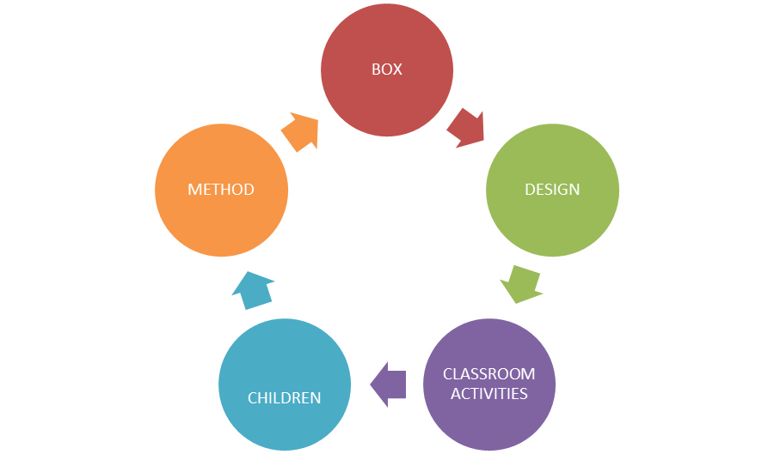

Note2.
Expert paper.
Expert paper 1.
1.What kind of advices for effective teaching do you know?
2.Do you prefer activities for teaching a foreign language.
3. What is a classroom management?

Expert paper2.
1.What types of systematic presentation of language do you know?
2. Will the method invite children to participate in the lesson?
3. Will the method make the best use of time?

Expert paper3.
1.Which techniques of teaching language will you use?
2.What methods can I use to teach an effective lesson?
3. What classroom activities for teaching a foreign language do you know?

Expert paper4.
1.What does teaching provide ?
2. When learners are disruptive, move closer to them or invite them to participate in the lesson?
3. What is a gospel teacher?
Note3
Production.
First step: Using the method of unscrambled words. The teacher sticks the unscrambled words on the blackboard and pupils should guess which word is hidden here.

se i tnd

srstes

thlahe

w e s t e s

f u i t r

t i d e

Second step: T – scheme method.
In this step the teacher uses T – Scheme method to enable pupils speak, what they think, review new words and it improves their speaking skills.
Teacher draws the letter T on the top of this letter he/she writes “A Healthy life” and in two columns pupils should speak about healthy and unhealthy food.

A Healthy life.

Healthy food or drink Unhealthy food / drink

fresh fruit chocolate

fish hamburgers

milk alchohol

eggs sugar

vegetables sweets

Note2.
Expert paper.
Expert paper 1.
1. Give appropriate definition of the term “Competence”.
2. Speak about teaching a foreign language.
3. What is a method?

Expert paper2.
4. What is the presentation of language?
5. What professional skills are needed?
6. Will the creativity give the best result?

Expert paper3.
7. What techniques will we use?
8. What methods can I use to teach an effective lesson?
9. Should the lesson plan be informative, brief, and purposeful?

Expert paper4.
1. What does teaching provide?
2. When learners are disruptive, move closer to them or invite them to participate in the lesson?
3. What is a gospel teacher?
Note 3
First step: Matching the words of body and the picture.

The body

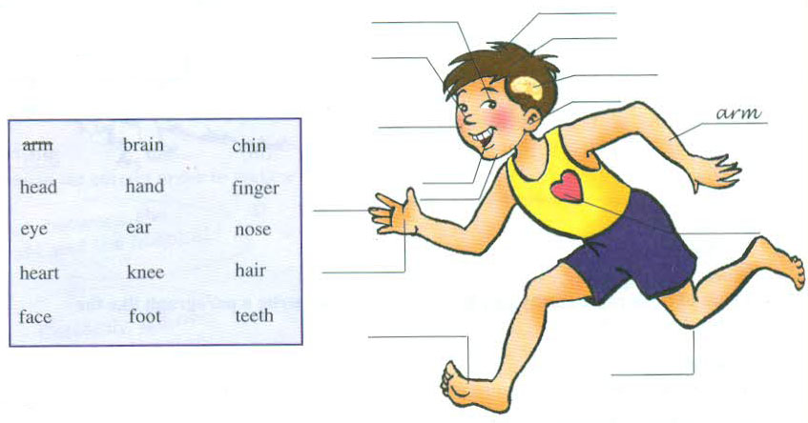

Second step: Play Snowball.
In this steps the teacher plays snowball with pupils. Pupils one by one throw the ball each other sagging one word. It improves their oral speech and it makes pupils revise new words:
head,
back,
finger,
heart,
leg,
ear,
foot.

NOTE 2.
Questions on the technology “Envelope” (the questions are put separately into the envelope.)
What steps should a foreign language lesson consist of?

How much does the teacher explain new grammar rule or topic with the help of board, charts, pictures or other techniques?

Organization moment – what does a teacher usually ask to open the lesson up to 5 minutes?

Objectives.

What teaching materials or equipments do you know?

With the help of ……….should be the new material practised.

We distinguish between terminal and enabling objectives. Give short information about two terms.

NOTE 2.
Questions on the technology “Envelope” (the questions are put separately into the envelope.)
What steps should a foreign language lesson consist of?

How much does the teacher explain new grammar rule or topic with the help of board, charts, pictures or other techniques?

Objectives.

What teaching materials or equipments do you know?

With the help of ……….should be the new material practiced.

We distinguish between terminal and enabling objectives. Give short information about two terms.

NOTE 3
TABLE “KNOWLEDGE”
I know | I want to know | I have known

First step: Filling the gaps.
Alisher: Mum, I’ve got a pain in my _________. I can’t hear you.
Mum: Oh poor you.
Sevara: I’ve got a pain in my tooth. I can’t _________ anything.
Barno: oh poor you.
Doniyor: I’ve got a pain in my _________. I can’t walk.
Bahrom: Oh poor you.
Kate: I’ve got a pain in my wrist. I can’t ____________.
Marina: Yes, you can. You have got a pain in your left wrist.

Second step: Play Bingo.
In this game pupils will have such kind of card with 5 words in line. Teacher shows the pictures naming the words. Pupils should watch the words. Whose card’s words will be said by the teacher that pupil will be the champion?

  head | foot | heart | finger | hair
  eye | face | Knee | hand | teeth

NOTE 2
Questions on the technology “Envelope” (the questions are put separately into the envelope.)
What steps should a foreign language lesson consist of?

How much does the teacher explain new grammar rule or topic with the help of board, charts, pictures or other techniques?

Organization moment – what does a teacher usually ask to open the lesson up to 5 minutes?

Objectives.

What teaching materials or equipments do you know?

With the help of ……….should be the new material practiced.

We distinguish between terminal and enabling objectives. Give short information about two terms.

NOTE 3.
TABLE “KNOWLEDGE”.
I know | I want to know | I have known
Questions:
1. Speak about the importance of teaching language through the games.
2. What types of games do you know?
3. What step of the lesson may consist of the game?

Procedure:
- Teacher distributes handouts to the children
- Children listen to the tape and put words and in correct columns

Go to a museum enjoy nature go fishing have fresh dairy products

busy streets go by metro lots of shops walk in fields

City | Village

Cities or villages?
According to statistics, people who live villages are healthier than those who live in towns and cities. They eat more fresh vegetables and fruits and they don’t breathe in smog and poisonous fumes. Of course they can’t go to the cinema or museums very often, but they can go to the forests to pick berries and mushrooms. On the other hand, people who live in cities have much better access to things such as computers, libraries and sports facilities, and they usually have more modern conveniences in their houses. Surprisingly, people who live in villages mostly want to move to the city, and those who live in cities want live in village.
Objectives: to practise listening for detailed information Students listen to the tape a second time and say True or False. Are these sentences true (√) or false (x)?
Time: 10
Materials: Handouts
Interaction: group work
Procedure:
- Teacher distributes handouts to the students
- Divide students into four groups.
- If sentences true (√) or false (x)?
Example: People who live in villages don’t eat fresh fruits. X
- People who live in cities are healthier.
- People who live in villages don’t go to the cinema very often.
- People who live in cities go to the forest and fields,
- People who live in cities are more likely to visit places such as museums and libraries.
- People who live in cities usually have more modern houses.
- People who live in village do not want to live in big cities.
Note 1
Technology of “Brainstorm”
- Do not evaluate and don`t be nervous.
- You can do what you want.
- All ideas are valuable.
- Do not interrupt the speaking children!
- Do not ignore one`s idea.
- The main idea is to speak mildly and measurably.
- Speak a lot as much as possible for to give specific information..
- Don`t be angry with repeated ideas
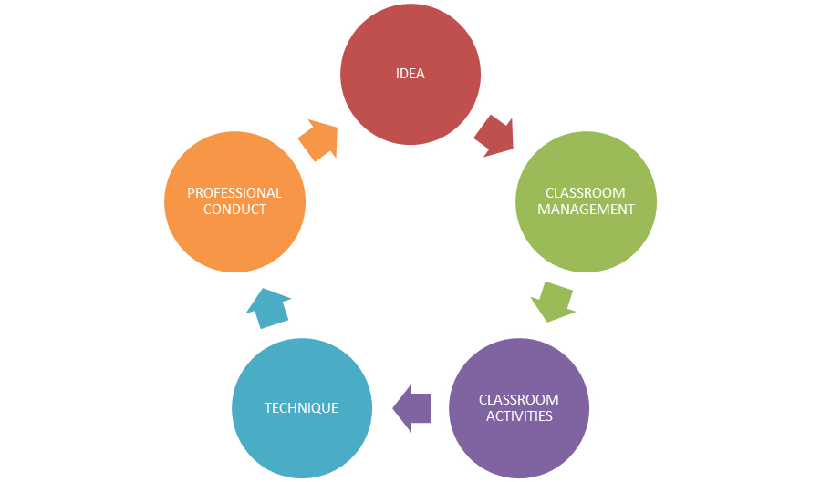

Questions:
1. How much better will be your lesson if you use visual aids?
2. Which techniques will you use during your lesson?
3. Which classroom activities do you prefer?

NOTE 2
Questions on the technology “Envelope” (the questions are put separately into the envelope.)
What steps should a foreign language lesson consist of?

How much does the teacher explain new grammar rule or topic with the help of board, charts, pictures or other techniques?

Organization moment – what does a teacher usually ask to open the lesson up to 5 minutes?

Objectives.

What teaching materials or equipments do you know?

With the help of ……….should be the new material practised.

We distinguish between terminal and enabling objectives. Give short information about two terms.

I. Put these words in alphabetical order.
1._______________________________ headache
2. ______________________________ heartache
3. ______________________________ toothache
4. ______________________________ backache
5. ______________________________ foot ache
6. ______________________________ earache
7. ______________________________ shoulder ache
8. ______________________________ hand ache

9. ______________________________ finder ache
10._____________________________ arm ache
11. _____________________________ stomach ache

II. Complete the sentences using the words in the box.

broken ache cut sore twisted pain

  - 2.
I’ve got a_____in my back.
I’ve got a _________throat.

3. 4.
I’ve got a _________ankle.
I’ve got stomach_________.

5.
I’ve got a ____on my finger.
6.
I’ve got a _________leg.

Questions:
1. How much better will be your lesson if you use visual aids?
2. Which techniques will you use during your lesson?
3. Which classroom activities do you prefer?
NOTE 2.

Questions on the technology “Envelope” (the questions are put separately into the envelope.)
What steps should a foreign language lesson consist of?

How much does the teacher explain new grammar rule or topic with the help of board, charts, pictures or other techniques ?

Organization moment – what does a teacher usually ask to open the lesson up to 5 minutes?

Objectives.

What teaching materials or equipments do you know?

With the help of ……….should be the new material practiced.

We distinguish between terminal and enabling objectives. Give short information about two terms.

I. Put these words in alphabetical order.
1._______________________________ headache
2. ______________________________ heartache
3. ______________________________ toothache
4. ______________________________ backache
5. ______________________________ foot ache
6. ______________________________ earache
7. ______________________________ shoulder ache
8. ______________________________ hand ache
9. ______________________________ finder ache
10._____________________________ arm ache
11. _____________________________ stomach ache

II. Complete the sentences using the words in the box.

broken ache cut sore twisted pain

1. 2.
I’ve got a_____in my back.
I’ve got a _________throat.

3. 4.
I’ve got a _________ankle.
I’ve got stomach_________.

5.
I’ve got a ____on my finger.
6.
I’ve got a _________leg.

NOTE 2.
Questions on the technology “Envelope” (the questions are put separately into the envelope.)
What steps should a foreign language lesson consist of?

How much does the teacher explain new grammar rule or topic with the help of board, charts, pictures or other techniques?

Organization moment – what does a teacher usually ask to open the lesson up to 5 minutes?

Objectives.

What teaching materials or equipments do you know?

With the help of ……….should be the new material practiced.

We distinguish between terminal and enabling objectives. Give short information about two terms.

NOTE 3.
TABLE “KNOWLEDGE”.
I know | I want to know | I have known
Questions:
1. What is the goal of the CEFR?
2. What do we mean by descriptors in the CEFR?
3. Why do we adapt the CEFR to the national context of Uzbekistan?
4. What terms are used for descriptors?
Play Snowball (5 minutes).
Ex 4 p 14.
A: I have got a pain in my head
B: He has got a pain in his head; I have got a pain in my wrist.
C: He has got a pain in his head, she has got a pain in her wrist, I have got a pain in my leg.
D: He has got a pain in his head, she has got a pain in her wrist, He has got a pain in his leg, I have got a pain in my shoulder.

IX. Working with handouts. (10 minutes).
Look at the picture and write the problem.
A: I have got a pain in my tooth
B: I have got a pain in my leg
C: I have got a sore throat
D: I have got a pain in my heart
X. Working in group (5 minutes).
Matching: Match each problem with the correct advice.

1. I feel very ill a) You shouldn’t eat cake
2. I am very tired b) You shouldn’t eat ice-cream
3. I have got a sore throat c) You should see a doctor
4. I have got a headache d) You shouldn’t stand on it
5. I have twisted my ankle e) You should rest
6. I have put on weight f) You should take some painkillers
XI. Working in pairs (10 minutes).
Ex 5 p 14. Make your own dialogue using grammar structure.
A: What’s the matter?
B: I have got a cold.
A: What’s the matter?
B: I have got a headache.
A: What’s the matter?
B: I have got a stomachache.

4.4. Тестлар
- When did listening comprehension come to the methodology of foreign languages teaching?
- In 1960
- In 1916
- In 1966
- In 1976
- It is very important to make and choose the text. It should be interesting and be adequate to learner’s ___________
- Age
- Interest
- Fun
- Aims
- What is the aim of practical learning?
- to take information in English
- to learn new information
- to write down information
- to give information in English
- What is listening comprehension?
- a means of teaching is used as a way of introduction of the language material in oral form
- a means of teaching is used as a way of introduction of the language material in written form
- a means of teaching is used as a way of introduction of the language material in oral and written form
- ability to listen a foreign language
- What are two ways of teaching Listening comprehension?
- is teaching at first language materials then language skills, forming language skills
- is teaching language skills then language materials, developing language skills
- is teaching language materials and distorting language skills
- is teaching the language first and then listening
- LC is a means of assessment of pupils' comprehension when they_____________
- hear or read a text
- write an essay
- hear the text
- retell the text
- What are the systems of exercises for LC?
- Special and non special exercises.
- Specialized exercises
- Individual and group exercises
- Pair work or individual exercises
- Aim of the speech exercises
- to develop skills of comprehension of speech under conditions similar to natural ones
- to practice acquired experience and skills
- to develop skills of hearing and understanding it
- to develop skills of narrating something about something
- Ways of checking of understanding in LC?
- Orally and in writing
- Only orally
- Only In writing and acting certain role play
- In performing a role or showing an action
- What is scanning?
- looking over a text quickly to get a specific piece of information
- Looking over the text quickly to get a general idea of the content. Your eyes move quite fast, taking in titles of chapters, their beginnings and ends, and the first sentences of paragraphs.
- This is reading fairly quickly without concentrating too hard or worrying about every single word. We often use it when reading an enjoyable novel.
- Students read silently by themselves and at their own pace. The selections must be at students' reading level in order for them to comprehend what they're reading.
- What is independent reading?
- Students read silently by themselves and at their own pace. The selections must be at students' reading level in order for them to comprehend what they're reading.
- This is reading fairly quickly without concentrating too hard or worrying about every single word.
- looking over a text quickly to get a specific piece of information
- Looking over the text quickly to get a general idea of the content
- What is skimming?
- Looking over the text quickly to get a general idea of the content. Your eyes move quite fast, taking in titles of chapters, their beginnings and ends, and the first sentences of paragraphs.
- looking over a text quickly to get a specific piece of information
- Students read silently by themselves and at their own pace. The selections must be at students' reading level in order for them to comprehend what they're reading.
- This is reading fairly quickly without concentrating too hard or worrying about every single word.
- What is reading aloud to students?
- Teachers use the interactive read-aloud procedure to share selections that are appropriate for students' interest level but too difficult for them to read by themselves.
- Looking over the text quickly to get a general idea of the content. Your eyes move quite fast, taking in titles of chapters, their beginnings and ends, and the first sentences of paragraphs.
- Students read silently by themselves and at their own pace.
- This is looking over a text quickly to get a specific piece of information
- What is light reading?
- This is reading fairly quickly without concentrating too hard or worrying about every single word. We often use it when reading an enjoyable novel.
- Students read silently by themselves and at their own pace.
- This is looking over a text quickly to get a specific piece of information
- Teachers use the interactive read-aloud procedure to share selections that are appropriate for students' interest level but too difficult for them to read by themselves.
- What is study reading?
- Study reading involves thinking about what is being read so that it is understood and can be recalled. It needs to be worked at, with time for reflection, thought, analysis, criticism, comparison, notes made, points highlighted and emphasized, arguments followed and evaluated, the whole summarized.
- Students read silently by themselves and at their own pace. The selections must be at students' reading level in order for them to comprehend what they're reading.
- This is reading fairly quickly without concentrating too hard or worrying about every single word.
- Looking over the text quickly to get a general idea of the content. Your eyes move quite fast, taking in titles of chapters, their beginnings and ends, and the first sentences of paragraphs.
- What are stages for development of reading skills?
- Previewing, predicting, skimming and scanning, guessing from context, paraphrasing
- Skimming and scanning
- Predicting, guessing from context and not paraphrasing
- Previewing, paraphrasing, predicting
- What is previewing?
- reviewing titles, section headings, and photo captions to get a sense of the structure and content of a reading selection
- using a quick survey of the text to get the main idea, identify text structure, confirm or question predictions
- stopping at the end of a section to check comprehension by restating the information and ideas in the text.
- using prior knowledge of the subject and the ideas in the text as clues to the meanings of unknown words, instead of stopping to look them up
- What is skimming and scanning?
- using a quick survey of the text to get the main idea, identify text structure, confirm or question predictions
- using prior knowledge of the subject and the ideas in the text as clues to the meanings of unknown words, instead of stopping to look them up
- reviewing titles, section headings, and photo captions to get a sense of the structure and content of a reading selection
- stopping at the end of a section to check comprehension by restating the information and ideas in the text.
- What is guessing from context?
- using prior knowledge of the subject and the ideas in the text as clues to the meanings of unknown words, instead of stopping to look them up
- stopping at the end of a section to check comprehension by restating the information and ideas in the text.
- using a quick survey of the text to get the main idea, identify text structure, confirm or question predictions
- using knowledge of the subject matter to make predictions about content and vocabulary and check comprehension
- What is paraphrasing?
- stopping at the end of a section to check comprehension by restating the information and ideas in the text
- using prior knowledge of the subject and the ideas in the text as clues to the meanings of unknown words, instead of stopping to look them up
- using a quick survey of the text to get the main idea, identify text structure, confirm or question predictions
- using knowledge of the subject matter to make predictions about content and vocabulary and check comprehension
- What is predicting?
- using knowledge of the subject matter to make predictions about content and vocabulary and check comprehension; using knowledge of the text type and purpose to make predictions about discourse structure
- stopping at the end of a section to check comprehension by restating the information and ideas in the text
- using a quick survey of the text to get the main idea, identify text structure, confirm or question predictions
- stopping at the end of a section to check comprehension by restating the information and ideas in the text
- To teach field-specific elements of oral communication, instructors should consider two questions. They are….?
- What kinds or genres of speaking do students in my field need to master? and what characterizes effective speech in each of these different genres?
- What interesting materials do students expect from a master and how to give them?
- What will be effective methods and how to imply them?
- What kinds of technology do we need to make it more effective?
- What is the role of occasion in oral speech?
- It helps speakers determine how long to speak, what to focus on, whether to speak formally or informally, what visual aids are called for, and a host of other factors.
- It helps speakers to know exactly what to speak and how to speak depended only on learned vocabulary
- It does not help speakers determine how long to speak, what to focus on.
- It helps speakers to know what to speak beforehand
- What do you understand by the word “ authentic ? “
- Taken from real life
- Is not taken from real life
- Taken from novels and writers’ lives
- Closely connected with imaginary world
- It is necessary to present the sample pre-reading activities by…
- All the answers are correct
- Looking at pictures, maps, diagrams, or graphs and their captions.
- Talking about the author's background, writing style, and usual topics
- Using the title, subtitles, and divisions within the text to predict content and organization or sequence of information

- Choose the correct schema of good oral communication
- audience, purpose, occasion
- understanding, interest, expectations
- beliefs, perceptions, topic
d) communication, interact, confidence
- What should a good speaker use in his speech?
- speakers should build repetition into their speech with clear, orienting introductions
- develop students speaking skills
- carry different senses of what is appropriate in terms of language, organization, subject matter, and style of delivery
- should to use simple questions.

- What kind of question should be discussed while teach oral communication?
- kinds or genres of speaking do students in my field need to master?
- is it to explain? to inform?
- to establish social connections?
- Why oral speech is more difficult than written?
- Who was the first to argue Chomsky’s notion?
- Hymes
- Henry
- Linkoln
- Hardy
- What kind of question should be discussed while teach elements of speaking?
- kinds or genres of speaking do students in my field need to master?
- is it to explain? to inform?
- to establish social connections?
- Why oral speech is more difficult than written?
- What criterias should consider a good speakers while addressing?
- relevant traits of the audience
- language styles
- new ideas
- grammar competence
- What is the useful informal technique?
- to have learners discuss a question or issue in pairs before opening the discussion to the class as a whole
- provide opportunities for all learners to develop their speaking skills
- informal or low-stakes speaking activities
- experiences in dealing orally with course ideas and to raise learners’ comfort level with speaking in class
- Who should use orienting introductions?
- Speakers
- Non-verbal speakers
- Audience
- Learners
- What can give useful information technique to learners?
- a non-threatening experience in discussing course ideas
- provide experiences in dealing orally with course ideas
- develop their speaking skills
- learners have been encouraged to express themselves
- Who should be clear about own purposes?
- Speakers
- Non-verbal speakers
- Audience
- Learners
- What is the imitative writing? Choose the correct one
- at the beginning level of learning to write, students will simply “write down” English letters, and possibly sentences in order to learn the conventions of the orthographic code
- usually arrears in controlled written grammar exercises. Some written tasks as essays, compositions, summary are also included into intensive writing
- this type means writing with only the self in mind as an audience. The most vivid example of this type of writing is note taking where students take notes during a lecture for the purpose of later recall
- short answer exercises, essay examinations, research reports are display writing examples, when students have to display their knowledge of language and academic skills
- What is the intensive writing? Choose the correct one
- usually arrears in controlled written grammar exercises. Some written tasks as essays, compositions, summary are also included into intensive writing
- short answer exercises, essay examinations, research reports are display writing examples, when students have to display their knowledge of language and academic skills
- at the beginning level of learning to write, students will simply “write down” English letters, and possibly sentences in order to learn the conventions of the orthographic code
- this type means writing with only the self in mind as an audience. The most vivid example of this type of writing is note taking where students take notes during a lecture for the purpose of later recall
- What is the self- writing? Choose the correct one
- this type means writing with only the self in mind as an audience. The most vivid example of this type of writing is note taking where students take notes during a lecture for the purpose of later recall
- this type is done not for marks or checking by teachers. Its aim is genuine communication. Writing diaries, letters, post cards, notes, personal messages or other informal writing can take place
- at the beginning level of learning to write, students will simply “write down” English letters, and possibly sentences in order to learn the conventions of the orthographic code
- usually arrears in controlled written grammar exercises. Some written tasks as essays, compositions, summary are also included into intensive writing
- What is the display writing? Choose the correct one
- short answer exercises, essay examinations, research reports are display writing examples, when students have to display their knowledge of language and academic skills
- this type means writing with only the self in mind as an audience. The most vivid example of this type of writing is note taking where students take notes during a lecture for the purpose of later recall
- this type is done not for marks or checking by teachers. Its aim is genuine communication. Writing diaries, letters, post cards, notes, personal messages or other informal writing can take place
- at the beginning level of learning to write, students will simply “write down” English letters, and possibly sentences in order to learn the conventions of the orthographic code
- What is the real writing? Choose the correct one
- this type is done not for marks or checking by teachers. Its aim is genuine communication. Writing diaries, letters, post cards, notes, personal messages or other informal writing can take place
- short answer exercises, essay examinations, research reports are display writing examples, when students have to display their knowledge of language and academic skills
- this type means writing with only the self in mind as an audience. The most vivid example of this type of writing is note taking where students take notes during a lecture for the purpose of later recall
d) at the beginning level of learning to write, students will simply “write down” English letters, and possibly sentences in order to learn the conventions of the orthographic code
- Choose the topics of writing at the beginning level (2-4 classes)
- short messages and personal letters, a plan, questions to short texts, description of pictures
- to give the information about him/herself, family, school, city/town, interests and hobby
- to write a short commentary/letter in newspaper or journal with the norms and conventions of native speakers
d) to do note-taking (plan, copy out the key words, speech patterns) to use it for production of the text
- Choose the topics of writing at the second stage (5-9 classes)
- to give the information about him/herself, family, school, city/town, interests and hobby
- to describe events or facts
- short messages and personal letters, a plan, questions to short texts, description of pictures
- to write a plan and notes for an oral message
- Choose the topics of writing at the lyceums and colleges
- to describe events or facts
- short messages and personal letters, a plan, questions to short texts, description of pictures
- to give the information about him/herself, family, school, city/town, interests and hobby
- to write personal data in questionnaire and registration document
- What is the brainstorming?
- This is a great activity to do in small groups or with the entire class. Naturally, one idea will spark another, so it is helpful to have students working together
- With the central theme drug abuse in the center of your page, to the left students would make list of causes for drug abuse with arrows pointing at the central idea
- An individual activity for getting thoughts from your head on to paper. The goal of this activity is to never let your pen or pencil stop writing
- Students must write their topic in the center of the page and put a circle around it. Then you can move in one of two directions
- What is the free writing?
- An individual activity for getting thoughts from your head on to paper. The goal of this activity is to never let your pen or pencil stop writing
- This is a great activity to do in small groups or with the entire class. Naturally, one idea will spark another, so it is helpful to have students working together
- Students must write their topic in the center of the page and put a circle around it. Then you can move in one of two directions
- With the central theme drug abuse in the center of your page, to the left students would make list of causes for drug abuse with arrows pointing at the central idea
- What is the cluster mapping?
- Students must write their topic in the center of the page and put a circle around it. Then you can move in one of two directions
- This is a great activity to do in small groups or with the entire class. Naturally, one idea will spark another, so it is helpful to have students working together
- An individual activity for getting thoughts from your head on to paper. The goal of this activity is to never let your pen or pencil stop writing
d) With the central theme drug abuse in the center of your page, to the left students would make list of causes for drug abuse with arrows pointing at the central idea
- What is the flow charting?
- With the central theme drug abuse in the center of your page, to the left students would make list of causes for drug abuse with arrows pointing at the central idea
- Students must write their topic in the center of the page and put a circle around it. Then you can move in one of two directions
- This is a great activity to do in small groups or with the entire class. Naturally, one idea will spark another, so it is helpful to have students working together
d) This is especially useful when comparing and contrasting two or three topics or when exploring two or three areas of one topic. With this prewriting method, have students make two (or three) columns on their paper. Each column should have a topic which focuses the idea generation
- What is the double/triple entry?
- This is especially useful when comparing and contrasting two or three topics or when exploring two or three areas of one topic. With this prewriting method, have students make two (or three) columns on their paper. Each column should have a topic which focuses the idea generation
- With the central theme drug abuse in the center of your page, to the left students would make list of causes for drug abuse with arrows pointing at the central idea
- Students must write their topic in the center of the page and put a circle around it. Then you can move in one of two directions
- This is a great activity to do in small groups or with the entire class. Naturally, one idea will spark another, so it is helpful to have students working together
23.Choose the correct activities for the type of exercise: Production on the basis of visual supports
- describing the picture, photo; a fragment of a movie
- eliciting of text content in the written form on the basis of a plan or headline of the text
- writing a headline to the text with arguments
- composition and essay writing
- Choose the correct activities for the type of exercise: Reproduction of the content on the basis of the text
- writing a headline to the text with arguments
- describing the picture, photo; a fragment of a movie
- eliciting of text content in the written form on the basis of a plan or headline of the text
- composition and essay writing
- Choose the correct schema of good oral communication
- audience, purpose, occasion
- understanding, interest, expectations
- beliefs, perceptions, topic
- communication, interact, confidence
- What should a good speaker use in his speech?
- speakers should build repetition into their speech with clear, orienting introductions
- develop students speaking skills
- carry different senses of what is appropriate in terms of language, organization, subject matter, and style of delivery
- should to use simple questions.
- What kind of question should be discussed while teach oral communication?
- kinds or genres of speaking do students in my field need to master?
- is it to explain? to inform?
- to establish social connections?
- Why oral speech is more difficult than written?

- Who was the first to argue Chomsky’s notion?
- Hymes
- Henry
- Linkoln
- Hardy
- What kind of question should be discussed while teach elements of speaking?
- kinds or genres of speaking do students in my field need to master?
- is it to explain? to inform?
- to establish social connections?
- Why oral speech is more difficult than written?
- What criterias should consider good speakers while addressing?
- relevant traits of the audience
- language styles
- new ideas
- grammar competence
- What is the useful informal technique?
- to have learners discuss a question or issue in pairs before opening the discussion to the class as a whole
- provide opportunities for all learners to develop their speaking skills
- informal or low-stakes speaking activities
- experiences in dealing orally with course ideas and to raise learners’ comfort level with speaking in class
- Who should use orienting introductions?
- Speakers
- Non-verbal speakers
- Audience
- Learners
- What can give useful information technique to learners?
- a non-threatening experience in discussing course ideas
- provide experiences in dealing orally with course ideas
- develop their speaking skills
- learners have been encouraged to express themselves
34.Who should be clear about own purposes?
- Speakers
- Non-verbal speakers
- Audience
- Learners
- What is the imitative writing? Choose the correct one
- at the beginning level of learning to write, students will simply “write down” English letters, and possibly sentences in order to learn the conventions of the orthographic code
- usually arrears in controlled written grammar exercises. Some written tasks as essays, compositions, summary are also included into intensive writing
- this type means writing with only the self in mind as an audience. The most vivid example of this type of writing is note taking where students take notes during a lecture for the purpose of later recall
- short answer exercises, essay examinations, research reports are display writing examples, when students have to display their knowledge of language and academic skills
- What is the intensive writing? Choose the correct one
- usually arrears in controlled written grammar exercises. Some written tasks as essays, compositions, summary are also included into intensive writing
- short answer exercises, essay examinations, research reports are display writing examples, when students have to display their knowledge of language and academic skills
- at the beginning level of learning to write, students will simply “write down” English letters, and possibly sentences in order to learn the conventions of the orthographic code
- this type means writing with only the self in mind as an audience. The most vivid example of this type of writing is note taking where students take notes during a lecture for the purpose of later recall
- What is the self- writing? Choose the correct one
- this type means writing with only the self in mind as an audience. The most vivid example of this type of writing is note taking where students take notes during a lecture for the purpose of later recall
- this type is done not for marks or checking by teachers. Its aim is genuine communication. Writing diaries, letters, post cards, notes, personal messages or other informal writing can take place
- at the beginning level of learning to write, students will simply “write down” English letters, and possibly sentences in order to learn the conventions of the orthographic code
- usually arrears in controlled written grammar exercises. Some written tasks as essays, compositions, summary are also included into intensive writing
- What is the display writing? Choose the correct one
- short answer exercises, essay examinations, research reports are display writing examples, when students have to display their knowledge of language and academic skills
- this type means writing with only the self in mind as an audience. The most vivid example of this type of writing is note taking where students take notes during a lecture for the purpose of later recall
- this type is done not for marks or checking by teachers. Its aim is genuine communication. Writing diaries, letters, post cards, notes, personal messages or other informal writing can take place
- at the beginning level of learning to write, students will simply “write down” English letters, and possibly sentences in order to learn the conventions of the orthographic code
- What is the real writing? Choose the correct one
- this type is done not for marks or checking by teachers. Its aim is genuine communication. Writing diaries, letters, post cards, notes, personal messages or other informal writing can take place
- short answer exercises, essay examinations, research reports are display writing examples, when students have to display their knowledge of language and academic skills
- this type means writing with only the self in mind as an audience. The most vivid example of this type of writing is note taking where students take notes during a lecture for the purpose of later recall
- at the beginning level of learning to write, students will simply “write down” English letters, and possibly sentences in order to learn the conventions of the orthographic code
- Choose the topics of writing at the beginning level (2-4 classes)
- short messages and personal letters, a plan, questions to short texts, description of pictures
- to give the information about him/herself, family, school, city/town, interests and hobby
- to write a short commentary/letter in newspaper or journal with the norms and conventions of native speakers
- to do note-taking (plan, copy out the key words, speech patterns) to use it for production of the text
- Choose the topics of writing at the second stage (5-9 classes)
- to give the information about him/herself, family, school, city/town, interests and hobby
- to describe events or facts
- short messages and personal letters, a plan, questions to short texts, description of pictures
- to write a plan and notes for an oral message
- Choose the topics of writing at the lyceums and colleges
- to describe events or facts
- short messages and personal letters, a plan, questions to short texts, description of pictures
- to give the information about him/herself, family, school, city/town, interests and hobby
- to write personal data in questionnaire and registration document
- What is the brainstorming?
- This is a great activity to do in small groups or with the entire class. Naturally, one idea will spark another, so it is helpful to have students working together
- With the central theme drug abuse in the center of your page, to the left students would make list of causes for drug abuse with arrows pointing at the central idea
- An individual activity for getting thoughts from your head on to paper. The goal of this activity is to never let your pen or pencil stop writing
- Students must write their topic in the center of the page and put a circle around it. Then you can move in one of two directions
- What is the free writing?
- An individual activity for getting thoughts from your head on to paper. The goal of this activity is to never let your pen or pencil stop writing
- This is a great activity to do in small groups or with the entire class. Naturally, one idea will spark another, so it is helpful to have students working together
- Students must write their topic in the center of the page and put a circle around it. Then you can move in one of two directions
- With the central theme drug abuse in the center of your page, to the left students would make list of causes for drug abuse with arrows pointing at the central idea
- What is the cluster mapping?
- Students must write their topic in the center of the page and put a circle around it. Then you can move in one of two directions
- This is a great activity to do in small groups or with the entire class. Naturally, one idea will spark another, so it is helpful to have students working together
- An individual activity for getting thoughts from your head on to paper. The goal of this activity is to never let your pen or pencil stop writing
g) With the central theme drug abuse in the center of your page, to the left students would make list of causes for drug abuse with arrows pointing at the central idea
- What is the flow charting?
- With the central theme drug abuse in the center of your page, to the left students would make list of causes for drug abuse with arrows pointing at the central idea
- Students must write their topic in the center of the page and put a circle around it. Then you can move in one of two directions
- This is a great activity to do in small groups or with the entire class. Naturally, one idea will spark another, so it is helpful to have students working together
- This is especially useful when comparing and contrasting two or three topics or when exploring two or three areas of one topic. With this prewriting method, have students make two (or three) columns on their paper. Each column should have a topic which focuses the idea generation
- What is the double/triple entry?
- This is especially useful when comparing and contrasting two or three topics or when exploring two or three areas of one topic. With this prewriting method, have students make two (or three) columns on their paper. Each column should have a topic which focuses the idea generation
- With the central theme drug abuse in the center of your page, to the left students would make list of causes for drug abuse with arrows pointing at the central idea
- Students must write their topic in the center of the page and put a circle around it. Then you can move in one of two directions
- This is a great activity to do in small groups or with the entire class. Naturally, one idea will spark another, so it is helpful to have students working together
- Choose the correct activities for the type of exercise: Production on the basis of visual supports
- describing the picture, photo; a fragment of a movie
- eliciting of text content in the written form on the basis of a plan or headline of the text
- writing a headline to the text with arguments
- composition and essay writing
- Choose the correct activities for the type of exercise: Reproduction of the content on the basis of the text
- writing a headline to the text with arguments
- describing the picture, photo; a fragment of a movie
- eliciting of text content in the written form on the basis of a plan or headline of the text
- composition and essay writing
- Choose the correct schema of good oral communication
- audience, purpose, occasion
- understanding, interest, expectations
- beliefs, perceptions, topic
- communication, interact, confidenceWhat should a good speaker use in his speech?
- speakers should build repetition into their speech with clear, orienting introductions
- develop students speaking skills
- carry different senses of what is appropriate in terms of language, organization, subject matter, and style of delivery
- should to use simple questions.
- What kind of question should be discussed while teach oral communication?
- kinds or genres of speaking do students in my field need to master?
- is it to explain? to inform?
- to establish social connections?
- Why oral speech is more difficult than written?
- Who was the first to argue Chomsky’s notion?
- Hymes
- Henry
- Linkoln
- Hardy
- What kind of question should be discussed while teach elements of speaking?
- kinds or genres of speaking do students in my field need to master?
- is it to explain? to inform?
- to establish social connections?
- Why oral speech is more difficult than written?
- What criterias should consider a good speakers while addressing?
- relevant traits of the audience
- language styles
- new ideas
- grammar competence
- What is the useful informal technique?
- to have learners discuss a question or issue in pairs before opening the discussion to the class as a whole
- provide opportunities for all learners to develop their speaking skills
- informal or low-stakes speaking activities
- experiences in dealing orally with course ideas and to raise learners’ comfort level with speaking in class
- Who should use orienting introductions?
- Speakers
- Non-verbal speakers
- Audience
- Learners.
- What can give useful information technique to learners?
- a non-threatening experience in discussing course ideas
- provide experiences in dealing orally with course ideas
- develop their speaking skills
- learners have been encouraged to express themselves

- Who should be clear about own purposes?
- Speakers
- Non-verbal speakers
- Audience
- Learners
- Whatis the imitative writing? Choose the correct one
- at the beginning level of learning to write, students will simply “write down” English letters, and possibly sentences in order to learn the conventions of the orthographic code
- usually arrears in controlled written grammar exercises. Some written tasks as essays, compositions, summary are also included into intensive writing
- this type means writing with only the self in mind as an audience. The most vivid example of this type of writing is note taking where students take notes during a lecture for the purpose of later recall
- short answer exercises, essay examinations, research reports are display writing examples, when students have to display their knowledge of language and academic skills.
- What is the intensive writing? Choose the correct one
- usually arrears in controlled written grammar exercises. Some written tasks as essays, compositions, summary are also included into intensive writing
- short answer exercises, essay examinations, research reports are display writing examples, when students have to display their knowledge of language and academic skills
- at the beginning level of learning to write, students will simply “write down” English letters, and possibly sentences in order to learn the conventions of the orthographic code
- this type means writing with only the self in mind as an audience. The most vivid example of this type of writing is note taking where students take notes during a lecture for the purpose of later recall.
- What is the self- writing? Choose the correct one
- this type means writing with only the self in mind as an audience. The most vivid example of this type of writing is note taking where students take notes during a lecture for the purpose of later recall
- this type is done not for marks or checking by teachers. Its aim is genuine communication. Writing diaries, letters, post cards, notes, personal messages or other informal writing can take place
- at the beginning level of learning to write, students will simply “write down” English letters, and possibly sentences in order to learn the conventions of the orthographic code
- usually arrears in controlled written grammar exercises. Some written tasks as essays, compositions, summary are also included into intensive writing
- What is the display writing? Choose the correct one
- short answer exercises, essay examinations, research reports are display writing examples, when students have to display their knowledge of language and academic skills
- this type means writing with only the self in mind as an audience. The most vivid example of this type of writing is note taking where students take notes during a lecture for the purpose of later recall
- this type is done not for marks or checking by teachers. Its aim is genuine communication. Writing diaries, letters, post cards, notes, personal messages or other informal writing can take place
- at the beginning level of learning to write, students will simply “write down” English letters, and possibly sentences in order to learn the conventions of the orthographic code.
- What is the real writing? Choose the correct one
- this type is done not for marks or checking by teachers. Its aim is genuine communication. Writing diaries, letters, post cards, notes, personal messages or other informal writing can take place
- short answer exercises, essay examinations, research reports are display writing examples, when students have to display their knowledge of language and academic skills
- this type means writing with only the self in mind as an audience. The most vivid example of this type of writing is note taking where students take notes during a lecture for the purpose of later recall
- at the beginning level of learning to write, students will simply “write down” English letters, and possibly sentences in order to learn the conventions of the orthographic code.
- Choose the topics of writing at the beginning level (2-4 classes)
- short messages and personal letters, a plan, questions to short texts, description of pictures
- to give the information about him/herself, family, school, city/town, interests and hobby
- to write a short commentary/letter in newspaper or journal with the norms and conventions of native speakers
- to do note-taking (plan, copy out the key words, speech patterns) to use it for production of the text.
- Choose the topics of writing at the second stage (5-9 classes)
- to give the information about him/herself, family, school, city/town, interests and hobby
- to describe events or facts
- short messages and personal letters, a plan, questions to short texts, description of pictures
- to write a plan and notes for an oral message.
- Choose the topics of writing at the lyceums and colleges
- to describe events or facts
- short messages and personal letters, a plan, questions to short texts, description of pictures
- to give the information about him/herself, family, school, city/town, interests and hobby
- to write personal data in questionnaire and registration document.
- What is the brainstorming?
- This is a great activity to do in small groups or with the entire class. Naturally, one idea will spark another, so it is helpful to have students working together
- With the central theme drug abuse in the center of your page, to the left students would make list of causes for drug abuse with arrows pointing at the central idea
- An individual activity for getting thoughts from your head on to paper. The goal of this activity is to never let your pen or pencil stop writing
- Students must write their topic in the center of the page and put a circle around it. Then you can move in one of two directions.
- What is the free writing?
- An individual activity for getting thoughts from your head on to paper. The goal of this activity is to never let your pen or pencil stop writing
- This is a great activity to do in small groups or with the entire class. Naturally, one idea will spark another, so it is helpful to have students working together
- Students must write their topic in the center of the page and put a circle around it. Then you can move in one of two directions
- With the central theme drug abuse in the center of your page, to the left students would make list of causes for drug abuse with arrows pointing at the central idea.
- What is the cluster mapping?
- Students must write their topic in the center of the page and put a circle around it. Then you can move in one of two directions
- This is a great activity to do in small groups or with the entire class. Naturally, one idea will spark another, so it is helpful to have students working together
- An individual activity for getting thoughts from your head on to paper. The goal of this activity is to never let your pen or pencil stop writing
- With the central theme drug abuse in the center of your page, to the left students would make list of causes for drug abuse with arrows pointing at the central idea
- What is the flow charting?
- With the central theme drug abuse in the center of your page, to the left students would make list of causes for drug abuse with arrows pointing at the central idea
- Students must write their topic in the center of the page and put a circle around it. Then you can move in one of two directions
- This is a great activity to do in small groups or with the entire class. Naturally, one idea will spark another, so it is helpful to have students working together
- This is especially useful when comparing and contrasting two or three topics or when exploring two or three areas of one topic. With this prewriting method, have students make two (or three) columns on their paper. Each column should have a topic which focuses the idea generation.
- What is the double/triple entry?
- This is especially useful when comparing and contrasting two or three topics or when exploring two or three areas of one topic. With this prewriting method, have students make two (or three) columns on their paper. Each column should have a topic which focuses the idea generation
- With the central theme drug abuse in the center of your page, to the left students would make list of causes for drug abuse with arrows pointing at the central idea
- Students must write their topic in the center of the page and put a circle around it. Then you can move in one of two directions
- This is a great activity to do in small groups or with the entire class. Naturally, one idea will spark another, so it is helpful to have students working together
- Choose the correct activities for the type of exercise: Production on the basis of visual supports
- describing the picture, photo; a fragment of a movie
- eliciting of text content in the written form on the basis of a plan or headline of the text
- writing a headline to the text with arguments
- composition and essay writing
- Choose the correct activities for the type of exercise: Reproduction of the content on the basis of the text
- writing a headline to the text with arguments
- describing the picture, photo; a fragment of a movie
- eliciting of text content in the written form on the basis of a plan or headline of the text
- composition and essay writing

4.5. Баҳолаш мезонларини қўллаш бўйича услубий кўрсатмалар
Баҳолаш турлари ва шакллари
Жорий назорат:
- талабанинг фан бўйича портфолио топшириқлари йиғиндиси;
- шунингдек, талабанинг фан бўйича давомати ва дарсдаги фаоллиги ҳам инобатга олинади.
Талабалар жорий назоратдан тўплайдиган балларнинг мезонлари

№ |  | Makс | 1-ЖН |  |  | 2-ЖН
№ |  | Makс | aмaлий | мустакил |  | aмалий | Mустакuл
1 | Дарсларга қатнашганлик ва узлаштириш даражаси.Амалий машғулотлардаги фаоллиги,амалий машғулот дафтарларининг юритилиши ва ҳолати. Оғзаки савол-жавоблар,оғзаки назорати бўйича натижалар. | 20 | 12 | 8 |  | 12 | 8
2 | Mустақил таълим топшириқларини ўз вақтида ва сифатли бажарилиши. Maвзулар бўйича уй вазифаларини бажариш ва ўзлаштириш даражаси | 20 | 12 | 8 |  | 12 | 8
Жами баллар |  | 40 | 24 |  | 16 | 24 | 16

Оралиқ назорат:
- талабанинг бошланғич синфда дарсни кузатганлиги бўйича ёзма ҳисоботи (мазкур тадбирни малакавий амалиёт даврида амалга ошириш мумкин);
- берилган 2 та дарс ишланмасини таҳлил қилиш ва уларга тақриз ёзиш;
Якуний назорат:
- кичик ёшдагилар учун мўлжалланган дарс режаси.
Талабалар оралиқ\ якуний назоратдан тўплайдиган балларнинг намунавий мезонлари.

№ | Назорат кўрсаткичлари | Оралик- Якуний назорат баллари
№ | Назорат кўрсаткичлари | Makс.  балл | 100-86% | 85-71% | 70-56% | 55-1%
 | Taлабаларнинг орфографик нуқтаи назардан билим савияси | 10 | 9  1-2 xaтo | 8  3-4  хaтo | 7-6  5-7  xaтo | 5,5  8 xaтoдан куп
 | Taлабанинг грамматик нуқтаи назардан билим савияси | 10 | 9  1-2  xaтo | 8  3-4  хaтo | 7-6  5-7  xaтo | 5,5  8 xaтoдан куп
 | Taлабанинг шахсий фикрлаш қобилияти ва мазмунан тўғри тушунчага эгалик даражаси | 10 | 9  1-2  xaтo | 8  3-4  хaтo | 7-6  5-7  xaтo | 5,5  8 xaтoдан куп
 | Жами: | 30 | 30-26 | 25-22 | 21-17 | 16-1

Назорат турлари бўйича баҳолашнинг технологик жадвали
Нaзорат турлари | Makсимал балл | “aъло” 100-86% | “яхши” 85-71% | “қониқарли” 70-56% | “қониқарсиз” 55-1%
Жорий назорат-1 | 20 балл | 20-18 балл | 17-15 балл | 14-11 балл | 10-1 балл
Oралик назорат | 30 балл | 30-26 балл | 21-17 балл | 21-17 балл | 16-1 балл
Жорий назорат-2 | 20 балл | 20-18 балл | 17-15 балл | 14-11 балл | 10-1 балл
Якуний назорат | 30 балл | 30-26 балл | 21-17 балл | 21-17 балл | 16-1 балл

“Бошланғич синфларда чет тилини ўқитиш методикаси” фани бўйича талабаларнинг семестр давомидаги ўзлаштириш кўрсаткичи 100 баллик тизимда баҳоланади. Ушбу 100 балл баҳолаш турлари бўйича қуйидагича тақсимланади.
ЖН1-20 балл, ЖН2-20балл, ОН-30 балл, ЯН-30 балл.
“Бошланғич синфларда чет тилини ўқитиш методикаси”бўйича талабалар билимини баҳолашнинг технологик харитаси.
7 – семестр
 | Дарс | Баҳолаш тури |  | Назорат ўтказиладиган вақт
1 | 1-6 | Тури | Шакли
1 | 1-6 | ЖБ1(6 хафта) | Oғзаки | 2018 й-декабрь
2 | 1-12 | OН(12 хафта) | Ёзма | 2018й-январ
3 | 18 | ЖБ2(18 хафта) | Oғзаки | 2018-февраль
Жами | 18 | ЯБ(18хафта) | Oғзаки | 2018-февраль

Фан бўйича кунлик баҳолаш мезони

VII- семестр: 1 ва 2-жорий
Ажратилган амалий Соат: | Дарслар сони: | Aжратилган балл: |  | Kунлик белгиланган балл | Дарсга келмаган талаба учун | 1-55% | 56-70% | 71-85% | 86-100%
Ажратилган амалий Соат: | Дарслар сони: | Aмалий | мустакил
16  Соат | 1-8  Балл | 20 20  Балл |  | 2.5  Балл | 0  Балл | 1.3  балл | 1.4  балл | 1.8  бал | 2.2  балл

